MANUAL Introduction

The manual is written in sequence for the beginner. If you are a first time user spend some time working through it and understanding where and how the information are put together so that it will be easy to find what you are looking for. If you are an expert, use this guide to jump to the right chapter. Is has a lot of information and may be frustrating to find the answers if you don’t know where to look.

NB! Make sure you have read the Terms and Conditions on the website www.spitronics.co.za before you install this ECU. By installing the ECU you automatically agree to these conditions.

Click on Navigating to learn how to navigate through the manual to find data easy.

1.TITAN Introduction
This chapter discusses the TITAN ECU as a product, how it is designed, and how it operates in general.

2.Safety Precautions
This chapter discusses the all the safety precaution to the user and the product. Very important to read!!

3.Requirements
This chapter discusses the requirements for the ECU to run on the engine and the PC specifications to communicate with the ECU.

4.Hardware Installation
This chapter discusses the how to do the wiring and physical installation of the ECU. Be sure to read the precautions during this faze!!

5.Software Installation
This chapter discusses the how to install the software and drivers to connect to the ECU.

6.Software Operation and Setup
This chapter discusses the operation of the tuning software and how to set the parameters up for each specific engine.

7.Other Setup duties and Information
This chapter discusses other settings and equipment setup around the ECU.

8.Startup Procedure
This chapter discusses the basic sequence of actions to prevent damage during the startup faze.

9. Key Instructions

This chapter describes the Hot keys and how to use them.

10. Tuning
This chapter discusses tuning information after the engine has been started. This is to enhance performance and economy and correct operation of the ECU.

11.Fault Finding
This chapter discusses the symptoms and remedies of known faults.

12.Specifications
This is a list of specifications for the TITAN ECU.

13.Firmware Programmer
This chapter discusses how to upgrade or change the TITAN ECU Firmware.

TITAN ECU

Welcome

Congratulations on your purchase of the TITAN Engine Control Unit (ECU). We are sure that you will be satisfied with this robust, compact and user friendly controller, which was designed to meet today’s requirements. This ECU was developed around the people involved with Management Computers. We hope that it will give you years of trouble free operation.

Please read this manual to learn about the safety precautions and design features of your ECU. Failure to use and install this management system properly may cause injury to people or damage to equipment. This Manual was written with the novice and professional engine tuner in mind, and we would like to urge you to install the ECU according to our recommendations. This is the best way to get the most out of your ECU.

Please read the Precautions before and after installation and before connecting the ECU, to ensure that the correct procedures are followed.

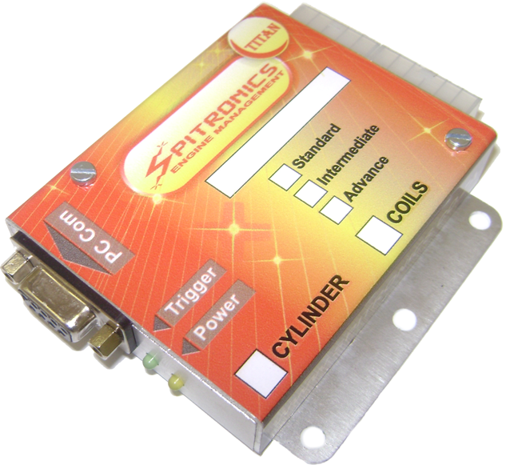

1.TITAN Introduction
1.1ECU Design Philosophy
1.2ECU Control Philosophy

The TITAN Engine Control Unit (ECU) was designed to be a cost effective replacement for high tech fuel managements systems. It uses unique features found in high tech systems, although it is still easy to install and program. It is designed with the novice and professional installer in mind. See the ECU Control Philosophy further in the manual to understand how it works.

TITAN is a South African made product and can be customized for dedicated engines and models. It can also be combined to form larger complex systems for racing applications. It is a reliable compact system which is easy to mount in the driver’s compartment. No external firing modules or converter boards are necessary.

The ECU is customized for specific applications and the installer does not have to pay for excess wires or unused features. Nor does he have to buy separate firing modules and MAP sensors which will increase the price. Instead it is compiled with the correct harness and equipment as well as software and maps to ease installation and setup. The software will also be calibrated for the sensors of the specific engine.

This ECU comes in three models with standard harnesses to accommodate most engine requirements namely Standard, Intermediate and Advanced units. The units are designed to be small and compact and use the latest in high speed micro controllers with surface mount technology. These units are machine soldered to minimize human error.

Firing modules that will reduce cost are incorporated in the ECU. Analog idle control is included on board for one and two wire idle valves. External Stepper idle control units can be connected with all three types of ECU’s.

The PC Tuning software is standard for all units. The specific ECU will blank out all tuning fields not applicable.
Other key features are variable charge times which are MAP (Mean Absolute Pressure) dependant, fuel cut-off features, launch control, lambda loop control, general purpose outputs, altitude correction etc.

The different models are as follows:

TITAN Micro Type 1
The Micro setup is used with the Titan electronic hardware for simple functions that does not justify the price for the more advanced systems. It will have certain firmware that can work in this configuration. It is not yet implemented.

TITAN Basic Type 2
The Basic setup is used with the Titan electronic hardware for certain functions that does not justify the price for the more advanced systems. It will have certain firmware that can work in this configuration. Examples are the Cam controller and Boost controller.

TITAN Standard Type 3
This is the most basic and cost effective form of the ECU. It is a single channel trigger, (Magnetic or Hall input,) one coil output and two batch injector outputs. The injectors are pulsed 180° out of phase. This ECU is suitable for cars with a distributor and single coil. Engines such as 3,4,5,6 and 8 cylinders can be used. For 12 cylinders the intermediate ECU is recommended for more injector outputs. Electronic distributors do not need to be modified for fazing. Idle control and launch control is standard.

TITAN Intermediate Type 11
This ECU is for more complicated trigger setups in distributors like Toyota 24T+TDC, Nissan Optic, all crank gears, and customized optic disks etc… It does Split-Sequential fueling on 4, 6, and 8 cylinder injector banks. It has one coil output. Idle control and launch control is standard.

TITAN Advanced Type 15
This ECU is designed as the intermediate but with the added feature of multi coil or wasted spark. The ECU has 6 trigger outputs which can be used for different combinations of injectors and coils. Sensor inputs can be 60-2, 36-1, 24T+TDC and just about any kind of hall or magnetic setup on the engine. Coil driver outputs can be for single or wasted spark coils. It can do idle control and launch control is standard.

All wiring harnesses use screened cables for neatness of installation and to prevent interference from other electronics or electromagnetic pulses, which may otherwise cause erratic behavior of the ECU.
External MAP sensors are used to reduce vacuum line length into the cab which will delay reaction time due to the mass of the air volume. It also makes the ECU more versatile to adapt for different aspirations on engines with or without turbo’s or superchargers.

1.1 ECU Design Philosophy

The ECU was designed with many factors in mind. First is that engine management does not have to be complicated and reserved for a selected few mechanical geniuses. Just like the old days, if you take some time to read a few books and dare to use a screwdriver and timing light, you could get to know you carburetor and ignition pretty well and become handy in tuning and servicing your own vehicle. If you ask me is that nowadays it is n lot easier. With all the information at your fingertips on the internet, and manuals teaching you what the pro’s had to find out over the years, there is no excuse for illiteracy. You plug a laptop into the Engine Control Unit ECU and use a lambda sensor and start playing around. The manuals will even explain how to do it. You don’t have to go and buy a set of jets and painstakingly change them around to get the desired effect. With the ECU you can change them while driving! However to get people to read the manual before picking up the phone or paying someone else, is quite a problem. Obviously not for you. Thanks!

Secondly is that only the necessary features are added and no gimmicks which make the ECU too complicated. No unnecessary load sites and too fine tuning sites which make the system slow and difficult to tune are added. If an engine has performance, economy and ease of use then that is all you require. Why make it complicated? All those unnecessary electronic components is just more things that can fail and escalate the cost.

Thirdly, no engine manufacturer uses the same equipment and sensors as the other. The car manufacturer’s systems even differ between models. So a one management fits all is not a good idea. You end up paying for a lot of things you don’t use and a lot of things on the engine that you can’t use, and it takes time figuring out what you need or don’t need for the installation. There is also a lot more components that can fail and take up space.

So what makes the TITAN ECU so different? Well look at some features. Very small, Split-Sequential, internal modules, customized firmware for most engines, use the sensors and equipment on the engine, easy to install and tune the enthusiast, maps included, no dynamometer required, easy to repair by local agents, - to name but a few.

The ECU is designed to be understood by mechanics and enthusiasts. Just like a carburetor it has a main jet and an idle jet. The ECU will calculate fuel from these settings using the MAP sensor. Only two settings and your car should be able to go. Again just like a carburetor the ECU has to compensate for cold starting, slow running, fast running power valve, acceleration and automatic gearbox damping and idling etc. Obviously we can add air temperature and battery voltage to it. We could even have the ECU do other stuff like fuel cutoff on down hill’s, fan control and air conditioner cut-out during up hill’s, rev limiters, launch control to name but a few.

On the timing side there was always the dynamic timing with the weights and the vacuum timing with the vacuum canister. You had to pay around 1k to have your distributor re-curved if you switch a cam or soup it up. How easy is it now with a laptop? You can even have a timing curve that goes up, down and up again. Impossible with weights! Also easy nowadays is to install a turbo. Now you have to retard the time under boost. Easy!

So please do a little homework and save yourself a lot of hassles and money of course. And please read the manuals!

Features
- Accurate batch- Split- and Sequential Fueling – Gives better performance and fuel consumption due to atomization on each cylinder is the same.
- Internal Coil & Injector Drivers – No extra cost for TP100 or custom firing modules.
- Single & Multi Coil Spark System – Use standard coil packs on the engine.
- Use Sensors on Engine – No need to do modifications on distributors or converter boards or TP500 modules.
- Custom Bolt-On Timing Gears – some engines require different gears to ease installation like the 36-1 for the Lexus Engine which comes as a bolt on unit. No modifications to fit these gears.
- Cold Start & Idle Control – This functions will ease with starting a cold engine and keep the RPM’s constant when air conditioners or automatic gearboxes draw power from the engine.
- Launch Control Standard – These are for racing applications to increase the boost pressure on the line and eliminate Turbo Lag. Note that the buttons are optional.
- Two General Purpose Outputs – This can be used for fan control, shift light, Aircon Cut-Out on Pull-Off or Up-Hill etc.
- Standard Harness – No need to keep several harnesses in stock for different engines.
- Compact Electronics – This will make the ECU easy to hide under the dashboard as it takes very little space.
- SA Design with Agent Repair Training – No need to send to manufacturer for repairs as the reputable agents will be equipped with repair training end test equipment.
- Complete Kits for Most Engines – Even rare combinations can be customized on request.
- Cost Effective – No need to buy expensive systems as all the necessary features are included with the ECU.
- Rotary Systems – The 2 & 3 rotor engines use a normal ECU’s.
- External Map Sensor – easy to change between 1Bar, 2.5Bar, 3Bar & 4Bar configurations
- Easy DIY Instructions – Save a lot of money on installation if you are a person who is up to the challenge.
- Start-Up Maps included – This will make for easy start-up & tuning with the help of a Lambda sensor
- User Friendly Tuning Software – You don’t have to be a specialist to understand how the software works. Just read the manual paying attention.
- Tuning map can be locked to prevent tampering. Useful for engine builders to give guarantees.
- No Dyno Required – Tune your own vehicle and save some more money. Just following the instructions in the manual carefully.

(Note that the last four points are for the person who is handy with tools and understand wiring and operation of an engine. You don’t have to be a Boffin though. If you are not sure, download the manual and drawing and read through it first. It’s free of charge!)

1.2 ECU Control Philosophy

If you read the design philosophy, then you know we designed this system better than a carburetor but not necessary more difficult. In fact I’m going to explain it around the trusty old Weber. As we market this system as DIY and self tune, I am going to explain some basics as well. Do not be scared of the terms and the electronics. If you worked on a program like Windows Excel, you should be able to breeze through this.

On a carburetor you had a low pressure fuel pump which only job was to fill the bowl with the help of a needle and seat. Then the fuel was drawn with suction through the jets into the intake manifold. With fuel injection you need a high pressure pump around 3.5Bar which can deliver enough flow to keep a constant pressure on the injectors. This is the job of the fuel pressure regulator. It is normally set around 2.5Bar, but will vary the pressure with intake vacuum. This means that if the vacuum drops to absolute the fuel pressure will also drop so that a pressure difference over the injector is constant. Remember the tip of the injector is subjected to vacuum which will suck more fuel through it at idle than at wide open throttle WOT. So the regulator must have a vacuum line connected from its diaphragm to the intake after the throttle body. This is also true for boost pressures with turbo’s and superchargers. So before you begin, power the fuel pump and check the pressure and leaks. The ECU will not know if this system fails except maybe a lean mixture indication on the air/fuel ratio sensor (lambda).

On the carburetor, fuel is metered by the main jet and ventury size. The jets are fixed and can be varied by changing them. This jet must be large enough to fuel the engine on normal load conditions. With the ECU Fuel is metered by opening the relevant injector for a specific time. The more air is let into the cylinder, the more fuel is required and the longer the injector is opened. The ECU uses the Map sensor signal to calculate how much air goes into the cylinder. Changing this amount is done by adjusting the main jet bar on the fuel maps. This value is the main fuel parameter and all other calculations are based around it. That is why we set it first.

On the Weber you have idle jets which ensure that enough fuel and air is supplied for idling. The ECU also has this Idle Jet. It is calculated with a portion of the main jet value and is faded off as RPM’s increase. This is the second setting to be made and is done with the engine idling in neutral with no load.

On automatic cars the air idle adjuster is made a bit larger to accommodate a richer mix if the car has to idle in drive. With the ECU you simply raise the dots around the vacuum bar on the Vacuum map under Fuel maps. The vacuum bar will settle on different values between neutral idle and drive idle. This means 2 idle jet configurations.

Normal running on the Weber is only done by the main jet and ventury size. On the ECU you have the main vacuum map and a cruise map to vary the fuel for different conditions. Higher gears will decrease the vacuum and lower the RPM’s. That means you can vary fuel ratios and even compensate for different gears.

For WOT the Weber sometimes had 2 tricks. One is the power valve which will enrich the mix at lower RPM’s and some had a separate jet on top to add fuel at high RPM’s. The ECU has a RPM Map just for WOT. Now you can adjust the mix through the whole of the RPM range.

Carburetors all have an accelerator pump. If you press the throttle too quickly, the manifold vacuum falls away and the flow over the ventury is for a moment not enough to suck enough fuel for the change. Also during the transition from idling to main jet create this problem. On the ECU vacuum is measured very fast and as the injector sits right at the intake valve, the ECU react almost instantly. There is however provision for extra fuel and two accelerator pumps is incorporated. One is working with vacuum signal and one working with TPS signal. If you have a slow vacuum signal it is better to use the TPS signal, as it is connected to your foot.

For cold starting the engine requires more air and richer fuel mixture. The Weber had a trick where you press the throttle once. The choke butterfly will close completely and the accelerator pump will squirt some fuel to prime the mix. The bottom butterfly will also be forced open slightly. If you start the engine, a vacuum will form in the ventury sucking harder on the idle jets and main jets and so make the cranking mixture rich enough for starting. The moment the engine starts, a vacuum canister will force the choke butterfly open slightly causing air to flow freely through the ventury. As the engine heats up the choke butterfly will open completely also releasing the bottom throttle to its normal position. The ECU does this by opening the idle valve to accommodate for more air. It will enrich the fuel using the temperature compensation map. It will squirt a set amount of fuel (Start Prime Pulse) the moment the engine starts to crank. When the engine starts, it will enrich the mix (Start Enrichment) for a few seconds fading it out. As the engine heats up, the ECU will lean out the mix on the water temp compensation map and reduce the idling RPM to the normal setting.

Furthermore the ECU can compensate for air temperature correction where hot intake air is thinner requiring a leaner mixture. It can also compensate for battery voltage deviation which would influence injector opening times causing mixture deviations. Electric idle valves help the engine not to pre ignite after the ignition is switched off. This is due to petrol spontaneously combust on hot carbons in the engine. With the ECU fuel is cut off immediately during power off. So no pre ignition here. On steep inclines the carburetor always have a problem where the bowls overflow or the main jets are exposed to air casing the engine to loose power or flood. This is no problem for the ECU as the petrol is in a closed pressure loop and the injectors can work upside down. Another problem of the carburetor is peculation due to engine compartment heat. The fuel simply starts to boil and then flood the carburetor causing the engine to stall. With fuel injection again the system is under pressure resulting in a much higher temperature for peculation. Also the fuel is circulated in the tank causing it to cool down.

On the timing side, the normal distributor had 2 dimensions for timing alterations. Firstly it had weights that did a single advance with RPM curve till a certain RPM and then it was a flat curve. This same curve was also programmed into later firing modules. For this dynamic timing the ECU can alter the timing in degree divisions every 100 RPM’s. It can go up and down which is of great advantage to top end camshafts.

For vacuum timing the mechanical vacuum canister was the norm. Some had an adjustable spring tension but they always followed a fixed curve in one direction. The ECU uses the Map sensor signal and the vacuum map to add or subtract timing especially for turbo engines. Again any combination in degree divisions can be adjusted making this a nice feature to add power and economy. It also helps to keep the plugs clean.

On the coil side, the ECU is far better than the old point condenser system. It uses variable dwell timing which means that the coils is always charged the same time to ensure that spark energy is at a maximum. Some systems may not have enough time at high RPM’s to achieve this. However faster coils may be used. The ECU will calculate when to start charging the coil to ensure it is fully charged before it will be discharged via the spark plugs. This method will prevent wasted energy which heat up the modules and also ensure a proper spark every time, even during cranking when battery voltage is low.

Now comparing the carburetor to a fuel management system we can clearly see the advantages. There are lots of other features like fuel cutoff during deceleration, idle control for automatic cars, and air conditioners, launch control etc. To successfully tune the engine yourself may take a bit of trial and error. Two conditions to always be careful of. Never go too lean on WOT mixtures and be careful of too much advance in the timing department. Your ear will tell you most of the time but it is not always possible to hear pinging. A good lambda sensor however will indicate if you are on a lean mixture.

2. Safety Precautions

The following guidelines will ensure proper operation the first time. Failure to install equipment correctly may damage it or other equipment permanently. These failures will solely be the responsibility of the installer and no guarantees will be given by us. Make sure you have read the Terms and Conditions on the website www.spitronics.co.za before you install this ECU. By installing the ECU you automatically agree to these conditions. All equipment is tested before it leaves the factory. We accept no liability for malfunctioning of the equipment, or to injury that may result from installation or the use of the equipment. We also accept no liability for costs of traveling of transportation of the equipment or parts or vehicle recovery due to failures of any equipment. Please read the instructions and drawing and make sure you understand before you begin.

2.1 Operator Safety
- Use only proper tools and products suited for auto installations. Sub standard products and installation procedures may cause failure to the equipment having your customer break down in dangerous areas.
- Use correct thickness of wire to carry the entire current requirement for that circuit. Too thin wires will heat up and may start a fire causing injury.
- Use fuses to protect each circuit separately. Joint circuits require large fuses which may heat and melt lesser circuits causing fires.
- Solder joints, and cover it with shrink sleeve to prevent loose connections which may cause fires. Space solder-joints so that they do not sit next to each other minimizing the chance of a short circuit.

2.2 Equipment Safety
- Never connect a TITAN ECU on the older EMU Hall cables without the cable modification. See Compatibility.
- If you have a firmware programmer, do not load Ver. E1 EMU firmware on the Ver. E2 TITAN ECU or visa-versa. It will damage the Micro because they are different.
- Never switch the power on, if the ECU enclosure is not grounded properly – this may destroy some sensors.
- Never switch the power on with the coil connected. If the Trigger Level Output logic is set wrong it may destroy the coil or driver. Leave the 10 way connector disconnected when you switch the ECU on the first time. Then set the coil logic right, save the data and switch off. Then connect the 10 way connecter and switch on. Ensure that the fuse is the minimum required value. Too large fuse will not blow resulting in driver or coil destruction.
- Test the installation with the test procedure before connecting the ECU – this will prevent damage due to faulty wiring.
- Connect the injectors to its own relay – other items will cause a voltage drop and result in leaner mixtures.
- Connect the relay supplies directly to battery positive via a fuse as shown in the drawing – otherwise voltage drops will still cause lean mixtures.
- Install the free-wheel Diodes on relays to prevent spikes from interfering with the ECU.
- Break out pins 1,4,6,7,8 & 9 on USB to RS232 converters and on serial cables. These pins are used for other inputs and outputs of the ECU. It will hang the ECU and damage coils or drivers. This does not apply to Spitronics USB converters.
- Make sure that relay pin numbers of the relay correspond with the drawing. A different relay may damage the ECU.
- Check that coil connections are secure. Loose connections will damage the internal driver Mosfets.
- Do not connect screen wires on the engine. The starter will draw current through then melting the harness.
- The TPS must be connected correctly as it may damage the ECU or TPS permanently.
- Ensure that wires are kept away from hot or sharp parts in the engine. Also ensure that engine movement does not put strain on the wires, as metal fatigue will break the wires in time, resulting in ECU failure.
- Ensure a proper earth between battery negative and chassis and also between battery negative and the engine. Do not earth the engine on the body or the body on the engine.
- Do not put cutout switches from coil negative to ground as this may burn the coil permanently. Rather break the supply line (Red Wire) through a switch so that the module does not have power.
- Do not disconnect the battery while engine is running. The alternator will create high voltage spikes which may damage the ECU permanently. Ensure that all connections from the battery and alternator are secure. Also connect the alternator charge wire directly to battery positive and not to the harness somewhere.
- Do not connect the ECU outputs directly to solenoids or fuel pumps. It is only strong enough to pull in 2 x DC 12V relays. It can draw only 2A to ground.
- Test the coil resistance to see which type coil you are using and if it is still functional. This is important to program the correct parameters. See Coil Selection. If you are not sure take it to your agent for a free test, or start with the lowest Coil Time value namely 2 milliseconds.
- Make sure of the type of injectors and connect them according to the recommendations. Never connect direct injection injectors to the ECU.
- The trigger input may not be connected to coil negative. The high voltage spikes on coil negative will damage the unit permanently.
- Make sure about the correct Jumper Settings before you switch the ignition on.

3. Requirements

3.1 Engine Requirements
We have to assume the vehicle you are using is either an existing electronic fuel injection model or has been converted to fuel injection by the addition of a throttle body, fuel injectors and high pressure fuel pump and filter.
You need to have the following components fitted: (Available from your agent)
- Fuel pump capable of a continuous pressure of 3.5 bar.
- Fuel pressure regulator.
- Fuel injectors matched to engine requirement.
- Throttle body with Throttle Position Sensor (TPS). (optional)
- Water temperature sender.
- A locked (no internal advance) distributor using either hall, magnetic or optical signal generation or any Crank Trigger device.
- Good quality suppressed HT leads.
- Air temperature sensor (optional)
- Lambda sensor (optional)
- Idle valve or stepper motor (optional)

Notes on Ignition System
The ECU can be used for fuel control only, provided an ignition pulse output is supplied to the ECU. This pulse must be a 12V to ground signal and may not be connected to coil negative. The high voltage spikes on coil negative will damage the unit permanently. Connecting to an ignition output is necessary to provide a signal for controlling the injector timing.
It can also be used for an advanced map-able ignition controller only. You can accomplish locking a conventional distributor by either welding or bolting the weights together and disconnecting the vacuum advance unit.

3.2 PC Requirements
- Pentium 4 Laptop
- Windows XP with service pack 2 or later, Vista or Windows 7. Note that Vista or Windows 7 do not operate with other than the Spitronics USB cable. Vista is also not as stable and some laptops struggle to communicate with USB converters.
- Serial Port or USB device with USB to RS232 Converter (19200 baud rate)
- Screen Resolution 1024*768
- Ensure that the latest drivers for the PC are installed.
This software is developed under the latest Delphi environment. It requires a lot of processing speed and may not run on older computers.

4. Hardware Installation
4.1 Compatibility to the old EMU series
4.2 Harness Selection
4.3 Jumper Selection
4.4 Installing Procedure of the ECU
4.5 Injectors
4.6 Sensors
4.7 Idle Control
4.8 Launch Control
4.9 Micro Fueling
4.10 Additional Wiring
4.11 Coil Selection
4.12 Setting Timing
4.13 Fuel Supply

This chapter tells the user how to install and wire the TITAN ECU. Be sure to read precautions before attempting installation. There are a few do’s and don’ts’ to consider as well.

4.1 Compatibility to the old EMU series

Note that the TITAN ECU may be connected onto magnetic EMU harnesses directly but that you have to modify all Hall harnesses. On the 12 way connector Pin 5 must be moved to Pin 11 and Pin 6 must move to Pin12. Failure to do this will damage your sensor permanently. The old EMU will still work with this cable modification.

The EMU series will not work on the E22 TITAN series cables. Thus backwards compatibility is possible but not forward compatibility.

4.2 Harness Selection
The TITAN ECU has two basic harnesses for all engine configurations. E22 is a 12Way harness that connects all the inputs or sensors to the ECU, and E21 is a 10Way harness that connects all the outputs to the ECU. These are the two harnesses to keep in stock if you don’t know which application it will be used for.
- Magnetic or Hall sensors are selectable on the ECU with addition of a load resistor to reduce interference.
- On the 10Way harness the combination of injectors and coils differ between engines. Connecting a coil on an injector driver will overcharge the coil and may destroy the driver or coil. Ensure correct wire selection according to the drawing.
There are also other harnesses for more customized applications that may ease with installation or simplify the number of wires to eliminate unnecessary wires. Some has the relays wired into them that make the installation faster. Other may combine the GP outputs to be sued as injector drivers or micro for fueling. Please see the drawings to view the different options. Also note that these cables have join fuses which are larger in value. Incorrect wiring will not protect the system against failure completely.

4.3 Jumper Selection

The TITAN ECU has standard harnesses for all engine configurations. The two basic groups of sensors require 12V for Hall and Optic sensors and 5V for Magnetic sensors. This selection between the supply voltages is done by jumper settings. There is also a stronger pull-up resistor required for the hall or Optic sensors and they are also selected with the Jumpers. See the illustrations on how to set these jumpers correctly for you application. You can look at the Trigger + TDC Wiring Diagrams.pdf for more detailed info.

4.3.1 Trigger Sensor

JP 1 and JP2 are used for this pickup.

4.3.2 TDC Sensor

JP 3 and JP4 are used for this pickup. If this sensor is not used take the Jumpers off or put them in neutral position.

4.3.3 Magnetic Sensors

With this sensor JP2 & JP4 acts as a filter resistor which is only used if interference is detected on the RPM signal.

JP1 & JP2 are always set to 5V as in the drawing.

4.3.4 Hall / Optic Sensors

With these sensors JP2 & JP4 acts as a Pull-Up resistor which is normally on. If the sensor has a weak signal these jumpers may be selected to Off to reduce load on them.

JP1 & JP2 are always set to 12V as in the drawing.

4.4 Installing Procedure of the ECU
- Locate a convenient mounting position for the ECU inside the cab for water protection. Humidity and heavy duty service units are available on request and will be custom made.
- Ensure that the enclosure of the ECU is grounded with at least two metal screws onto the metal body of the car. If the ECU is not bolted directly onto an earthed metal surface, you MUST make sure that you run a 4mm² ground wire to one of the ECU’s bolt holes, otherwise your ECU will not power up and you will damage the MAP sensor permanently. There may flow as much as 30A through the earth wire.
- Connect the two black wires firmly to the enclosure base. This is the screens of all the cables and also the ground wires of the TPS Lambda and temperature sensors. Bad connections may damage the sensors.
- Feed all wires of the harness, except the serial cable, through a hole in the firewall. A good seal around the wiring is necessary to prevent damage and engine fumes and water from entering the cockpit.
- Each cable in the harness is marked to where it has to go. The same name is on the electrical drawing. Wire colors are marked on the drawing for specific pin connections. Take special care for TPS wiring as a fault here may damage the voltage regulator on the ECU.
- Pull additional PVC sleeve over the cables for extra protection of the harnesses. This sleeve is customized on your installation and dependant on routing of the cables.
- Mount the MAP sensor on the back of the fire wall. It should be higher than the vacuum takeoff so that fuel condensate in the hose can run back into the engine and not to the sensor. Try mounting the inlet pipe downwards to keep the sensor clean.
- The screened cables for the sensors must go to the sensor and connected as close as possible. Connecting these wires to existing harness on the engine will cause the wires to pick up electrical interference and cause erratic behavior of the ECU.
- No screen wires may be connected or earthed to the engine. They are connected on the ECU side to the enclosure. On the Stepper Idle control board the screen wire is connected to 12V. Make sure it is not earthed.
- Test each harness according to the drawing or to the optional test procedure to ensure correct wiring, before connecting the ECU. This will indicate installation errors beforehand which may damage the ECU.
- Plug the harness into the ECU and taking care not to damage the pins and connectors. If it is sticky do not force it in. Rather move the connector slightly from side to side till it mates with the ECU connector pins.
- All power electronic components such as fuel pumps, coils fans etc must be wired via a relay circuit directly from the battery with separate fuses in the positive supply for protection. Do not wire any of these devices directly from the Ignition switch or on the same circuit as the ECU. This will cause spikes which may damage or influence correct operation of equipment. Earth connections must be as short as possible to earth and not connected to a common earth wire which is connected at a distant ground.
- Make sure that the correct wire thickness is used for each power electronic component. If wires are common ensure that the wire is thick enough to carry the total current. Too thin wires will heat up and may start a fire. The same goes for relays. Be careful of cheap relays. They can seize and start a fire. Use 0.5mm² of wire for every 5A of current. Also check pin numbers of the relays as they differ from one manufacturer to the other. This mistake may be costly!
- Solder each connection and use shrink sleeve rather than insulation tape. Stagger solder joins so that they do not sit next to each other. Cover connections and loose wires with PVC or pigtail sleeve rather than insulation tape.
- Ensure that all electronic settings are correct before connecting the 10Way connecter. Certain settings may damage equipment if not set to recommendations. Especially the coil output trigger level. Follow the start-up procedure.
- Ensure a proper ground from battery negative to the body and from battery negative to the engine. This wire must be thick enough to carry the current of all the equipment in the car.

4.5 Injectors

4.5.1 Wiring
The injectors have to be wired on the engine. Some of the kits include an injector harness like the Lexus V8. Make sure that the combination of injectors is correct as this will influence consistency between cylinders. On some engines the GP outputs may be used for injector drivers. Make sure you have the correct harness and drawings available for these options.
Injectors come in 2 groups. High resistance (12 to 18 Ohm) and low resistance (2 to 4 Ohm). For high resistance injectors you may add up to 4 injectors per channel. They are always connected in parallel. Low resistor injectors however should be limited to one per channel and add a series resistor. Or they can be connected 2 in series without the resistor. They should actually be connected to a different current limiting driver. They may heat up if not properly cooled and eventually self-destruct. For injector wiring on 4 Cylinder, 6 Cylinder and 8 Cylinder see specific wiring details on the relevant wiring diagrams on CD. Do not connect direct injection injectors to this ECU. It will destroy the drivers en injectors.

4.5.2 Sequential injection
There are enough outputs available for 4 cylinder engines to do sequential injection and wasted spark. Specific models only. This however will require a TDC signal indicating that cylinder 1 is on firing and is normally obtained from a separate cam sensor. Here fuel is injected once every 2 RPM’s and always start at Top Deck Centre (TDC). Since there is not much to gain over the next method, we design most of the software for Split-Sequential injection. Each injector has its own driver from the ECU. See the specific wiring diagram.

4.5.3 Split-Sequential injection
The ECU is designed to do split-sequential injection. This method will inject on the two cylinders that move up and down together. It will inject once per RPM and will start at BDC. Fuel is injected very accurately and excellent CO adjustments can be achieved. The advantage of this method is that each cylinder receives it fuel under the same conditions, resulting in very smooth idling and revving. It is definitely better on power and consumption than the batch injection method. Injectors are wired in the same sequence as wasted spark. Split the firing order in 2 and write se second half next to the first half. See example. Then group the injectors using the first of both halves, then the second then the third then the fourth. Two injectors are wired on each driver from the ECU. On the CD are drawings for these injector combinations. See the chart below:
Injectors | Driver Color | 3 Cyl | 4 Cyl | Subaru | 5 Cyl | V6 Cyl | V6 Cyl | Str 6 Cyl | 8 Cyl Chev | 8 Cyl Lexus
Injection Order |  | 123 | 1342 or 1243 | 1324 | 12453 | 123456 | 142536 | 153624 | 18436572 | 18436572
DRV 2 | Blue
DRV 3 | Yellow |  |  |  |  |  |  |  | 3 & 2 | 1 & 6
DRV 4 | Green | 3 |  |  |  | 3 & 6 | 2 & 6 | 3 & 4 | 4 & 7 | 8 & 5
DRV 5 | Black | 2 | 2 & 3 | 3 & 4 |  | 2 & 5 | 4 & 3 | 5 & 2 | 8 & 5 | 4 & 7
DRV 6 | White | 1 | 1 & 4 | 1 & 2 | 12345 | 1 & 4 | 1 & 5 | 1 & 6 | 1 & 6 | 3 & 2

Ex: Chev V8 Firing order: 1 8 4 3 6 5 7 2

1 8 4 3 is 1&6 = White, 8&5 = Black, 4&7 = Green, 3&2 = Yellow
6 5 7 2
Note that the Lexus differ from the Chev because it has an injector harness that was pre designed.

4.5.4 Batch fire
With this method, two injector drivers are being pulsed 180° out of faze. Although not preferred, fuel metering and timing is done very accurately and should still give excellent results. Split the injectors in two groups to divide the current on the 2 driver outputs. Put alternate numbers on the firing order together to ensure a more even fuel distribution. For bigger engines keep the mean supply current below 7A. More outputs are available in the intermediate and advance units. See the specific wiring diagram.

4.5.5 Throttle Body Injection
With this method, injectors are situated at the throttle body. Spitronics do a Weber 2 Injector and a Holley 4 Injector conversion. With these conversions injectors is situated on the top of the butterfly. The ECU also has a special program to pulse these injectors in sequence and vary the pulses per RPM to get a much smoother distribution of the fuel mixture. See the specific wiring diagram to ensure the correct injectors are on the correct drivers. On the CD are drawings for this injector wiring.

4.5.6 Micro Fueling Injector
The ECU allows for the use of dual injectors per cylinder as explained in the Setup. Wiring is done in two ways which differ also with the firmware loaded into the ECU.

If it is set to Driver, then the ECU has drivers available to operate the extra injectors. Then they are connected in the same manner as the primary injector. This system is only available for four cylinder engines with wasted spark coils. Then there are two injectors spare that can be used. See the Micro Fueling Drawing supplied on CD.

If it is set to GP 1 or 2 then they are tied into the primary injector on the negative pins. Then their positive pins is powered vie a separate Mosfet on the positive pins. See the Micro Fueling Drawing supplied on CD.

On some engines the GP outputs may be used as injector drivers, then the GP outputs
will not function as usual.

4.6 Sensors

There are three groups of sensors for crank angle sensing. Magnetic, Hall and Optic sensors. Hall and optic sensors both give a square wave output and are treated exactly the same. They have electronic components in the sensor which convert the signals to square wave. The Hall sensor uses magnetic field where optic uses infrared light. In both cases a beam is broken and detected. Magnetic sensors are just a magnetic coil around a magnet. The metal point passing this sensor induces a spike which has then to be converted to a square wave so that the processor can work with it. On the TITAN ECU the all the sensors use the same inputs. They have different supply voltages which is selectable with jumpers on the PC Board. See the drawing for correct settings.

4.6.1 Magnetic sensors
- These sensors provide only a voltage spike to the ECU. The ECU will convert this spike to a usable square wave to be used by the micro processor.
- Each sensor has its own positive and negative wire from the ECU. Do not connect magnetic sensors with common ground wires. The negative is connected to 5V and will damage the ECU if connected to ground. Disconnect and isolate it first.
- Make sure that the positives and negatives of the sensors are connected correctly. Changing them around will retard the timing with revs or may cause the ECU to miss or backfire.
- The ECU has an extra pull-up resistor of 2.2KOhm set with the jumper which can be set to reduce interference.
- In certain cases a 1 K ohm resistor may be connected between positive and negative to reduce spikes in the signal.
- Connect the screened cables from the ECU as close to the sensor as possible. Do not let single open wires run along the spark plug wires or the coils as this will induce interference in the ECU causing erratic firing.
- Do not connect the screen to the engine. It is already connected to the body at the ECU.
- Do not connect other devices to this pickup as it will interfere with the signal to the ECU.

Testing a Magnetic sensor
These sensors have a wired coil with a magnet. They normally have two wires. Some do have 3 wires which have an earth which is not connected to the coil. The Coil resistance vary from 150 ohm to 1200 ohm typically. If you swap the tester wires around you would measure the same resistance value. To test for positive put the meter on milli volts DC. Connect the wires to the coil of the sensor. Move an iron object to the sensor and look closely at the polarity indicator. If it indicate positive when moving closer to the sensor and negative when moving away from the sensor, it means that the red wire of your meter is on the positive of the sensor. If it is the other way round, then the black wire is on the positive of the sensor.

4.6.2 Hall & Optic sensors
- These sensors already provide the ECU with a square wave.
- Hall sensors work with magnetic fields but it does not mean it is a magnetic sensor. Failure to identify this will cause incorrect wiring and no operation.
- They have three wires. Each sensor has a positive (12V), earth and signal out pin. Connecting these wrong may damage the ECU or the sensor permanently. If you are not sure which pin is which, ask your agent to bench test it first with protection resistors to get correct pin-outs.
- The ECU has an extra pull-up resistor of 2.2KOhm set with the jumper. If erratic misfires occur, another 1K Ohm resister may be connected between the signal and 12V wire on the sensor.
- If the sensor requires a resistor in the positive wire to limit current, it must be put in separately.

Testing a Hall or Optic sensor
- These sensors normally have 3 wires. A supply wire, normally 12V, an earth wire and a signal out. This sensor has electronic components that require power to operate. Connecting this sensor wrong my damage it permanently. First test for resistance on all the pins and swap the test leads around to make sure it is not a magnetic sensor. Put the meter on diode test and measure voltage drops over all the pins. You should get V drops between 0.5V to 1.9V. This is your indicator that you have an electronic unit.
- Now take 2 x 1K resistors and tie one end of each to the +12V. This will ensure that if you connect the supply wrong you will not damage the component as the resistor will limit the current to 10mA. Now put the ground on one pin and the 2 resisters on the other pins. Put the meter black wire on earth for the remainder of the tests. Connect the meter red wire to any of the other pins. Now move an iron object to the sensor or in the gap and away. If the signal varies between 0V and 12V then this pin may be the signal output of the sensor. Now put the red wire on the other pin and repeat the iron process. This voltage should not change. It may be less than 12V due to the drop over the resistor. If so then this is the supply pin. With other words one of the resistor pins should respond rapidly to iron pulses while the other one remains fairly constant.
- Now change the earth pin to the next and repeat the process. Note that you may get a similar reaction if you have the earth and the signal pins wrong. The indicator to see which one is which is to see which pin reacts the most to the iron pulse. That pin is the signal output and the other one the earth.
- Remember this is a guideline to black box testing and not a failsafe operation. Note point 4 above and rather consult the specifications from the manufacturer or vehicle diagrams.

4.6.3 Throttle Position Sensor
- The TPS must operate through the whole range of the throttle movement to ensure that the ECU can measure the whole of the movement.
- The TPS must be calibrated in the PC software as certain features like idle control, prime pulse, flood control and fuel cutoff require certain positions of the throttle to operate correctly. This is done in the setup menu before starting the engine. (see TPS calibration under Active Sensors)
- The sensor is connected to 5V, ground and signal input. Connecting it wrong may damage the ECU or TPS as you may short the 5V to ground. Test it before you connect it to the ECU.
- On certain vehicles the TPS may function in reverse polarity. This means the 5V and ground signals are changed around. The ECU can be set for reverse polarity.

4.6.4 Testing a TPS for the Correct Pin-Outs
  - Test the resistance with an Ohm Meter between 2 pins at a time. Each time move the throttle open and close. If the resistance do not change and is approx 5000 Ohm, then you found pin A & C. The remaining pin is B which is the wiper. Mark it as B.
  - Now test the B pin with one of the other pins. If it is below 500 Ohms then that pin is C. If it is above 4500 Ohm that pin is A.
  - Now to double check. Measure between B & C. if the throttle is closed the resistance is below 500 Ohm. If you open the throttle the resistance increases to above 4500 Ohm.
  - If you measure between A & C the resistance is around 5000Ohm and does not change with throttle movement.

4.6.5 Lambda Sensor
- For the one wire lambda sensor, connect it to the red wire of the lambda cable only. For the four wire sensor, connect the sensor wires to the red and blue wire of the lambda cable. Sensor positive to the red wire and sensor negative to the blue wire. The element is connected to ground and the 12V supply from the fuse box that supplies the injectors. (See drawing). Do not earth the screen or connect the element ground to the screen. This will induce voltage drops resulting in faulty fuel ratio readings.
- The lambda sensor used by the ECU is a narrow band sensor. See the settings in the software for the correct setup.

Testing a Lambda Sensor for the Correct Pin-Outs
Test the resistance with an Ohm Meter between 2 pins at a time. The element normally has the same colors and has a resistance of 6 to 12 Ohm. When you find the element connect it to ground and 12 volt as above. It does not matter which wire is which as it is only an element. The sensor part can only be measured on the car when it is working. So connect the two remaining wires to the lambda cable as explained above. Test it when the engine is hot. If it does not work swop the sensor wires and test it again. This will not damage the sensor if connected wrong.

4.6.6 Water and Air Temperature Sensor
Always use a 2 wire sensor and connect the one wire to the sensors cable white and the other to the relevant sensor input wire. This will prevent ground interference with the engine currents. It your sensor is broken you can replace the water temperature sensor with a 2K NTC Resistor and the air temperature sensor with a 10K NTC Resistor. To test them have them at a temperature of 20°C and then they should read the resistance they are specified for.

4.6.7 Map Sensor
The map sensor is an external unit and can be any variety. We supply one type of sensor with three basic packages depending on stock availability or pressure value required by the customer. The sensors have different values and must be calibrated. The vacuum or boost rating of the sensor must be entered in the software to get the scales correct. (See Map calibration under Active Sensors) always use the lowest pressure rating for the best accuracy.

Connect the Map sensor as close to the engine as possible. Do not join it to other vacuum lines. It would delay the vacuum signal and cause flat spots or over fueling. Connect it to a 3 mm minimum ID pipe directly to the intake manifold. Mount the sensor higher than the vacuum pipe on the engine so that any petrol moist can run back into the engine and not accumulate on the sensor.

- The Map sensor is the Motorola series sensors. These are 5V sensors and come in 1Bar and 2.5Bar 3Bar and 4Bar arrangements. The 1Bar and 2.5Bar can be purchased with or without the plastic enclosure. For the enclosure option, the wires is soldered on and sealed with silicone for water proofing. This is the preferred sensor to use.
- The 3Bar and 4Bar sensors come only in an aluminum machined enclosure. This enclosure is manufactured to handle the pressure with reliability. The 1Bar and 2.5Bar are also available in this option. The pressure value of the sensor is stamped on the back of the housing.
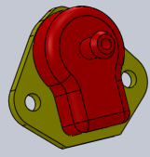
- You may also use existing map sensors of various engine manufacturers. Ensure that you have the correct wiring and calibration.

4.7 Idle Control

The ECU has idle control capabilities. The settings for valve and stepper motors are different. Valve control is done with the ECU GP outputs while stepper motors require a separate stepper control unit.

For 2 wire idle valves found on most cars, the GP 2 output will be pulse-width controlled and no separate hardware is required. Only a free wheel diode that goes over the two pins must be connected. See the drawing supplied on your CD. There is a black 1N4007 diode supplied in each ECU pack.

Some 3 Wire valves require GP 1 & 2 outputs. These valves have on coil to open and one to close. It does not have a spring system. These ones can also be done with the ECU. This type is popular for BMW. See the drawings on the CD for correct wiring.

Other 3 wire valves have a spring which keeps it in a certain position. The one coil opens the valve completely and on coil closes it completely. Here a resistor is connected to the closing coil and ground to close the valve to reach minimum idling RPM’s when hot. Then only GP out 2 is used on the coil that opens the valve. This type is popular for Toyota. See the drawings on the CD for correct wiring.

There is a back feed Diode required in the ignition supply wire of the 12 Way connector.
Warning! Make sure the stripe side of the Diodes is wired to the positive as this may damage the driver of the ECU.

4.7.1 Stepper Idle Valve Computer
This stepper controller has two types for the two different motors. Bi-Polar Type 2, and 4 Coil Common Type 1.
This controller is connected to ignition 12V (Red wire), earth (Black wire) and the ECU GP output 2 (Green wire). It has 5 wires which connect to the stepper motor of the idle valve. Note however the screen wire in the cable is connected to 12V ignition and not earth as normal. This is due that there are only 4 wires in the cable. See the different wiring diagrams on the CD.

On the idle controller is a LED. When the ignition is switched on the led will be on for a second. If the engine is started the LED will flash indicating that the ECU request for the idle valve to open or close. As soon as the set RPM in the PC software is reached the LED will stop flashing and go off. If RPM’s are more or less than the set point, the LED will flash again. Note that the TPS must be calibrated and the throttle must be in closed position (0%) for idle control to be activated. The TPS value at closed throttle must be lower than the Idle Cut-off TPS setting. If the RPM’s fall below the set point, the ECU will pick it up immediately regardless of the TPS setting.

4.7.2 Throttle Adjustment
The throttle must be adjusted mechanically to let the engine idle at 100 RPM’s below the Idle RPM at normal operating temperature. This will ensure that the engine always have enough air to keep idling to a minimum, even if the idle valve is completely shut. To do this you can blank the air intake to the idle valve or stepper motor off and adjust the mechanical position of the throttle. Or you can enter a value of 100 RPM below mechanical idle RPM into the PC software at Idle RPM so that the idle control does not interfere with adjustments. Then adjust the throttle to the desired value. Reset the PC Idle RPM to the normal RPM’s again. The engine must be hot and in neutral or park for this adjustment.

4.8 Launch Control

Launch control is standard software on all 3 ECU boxes. The buttons however can be bought optional or made up by you. The launch limits consist of an additional rev limiter which is lower than the engine protection limiter. It will retard the timing to a value near TDC and will enrich the fuel mixture by a set percentage. These three values can be set to the customer specs. The launch limits are only applied when the engine RPM goes above the Launch Limiter - 500 RPM’s. This will ensure that the engine revs up properly. If launch is activated in the software, it can operate on 3 ways:
  - If only the dashboard button is connected, it activates while the button is pressed and deactivate when the button is released.
  - If the clutch pedal switch with the 10K resistor is used with the dashboard switch, the clutch is first pressed to the floor activating the switch. Then the dashboard switch is pressed latching the launch software. The moment the clutch is released, launch control is deactivated and normal management presumes.
  - The dashboard switch is pressed and released latching the launch software. If the throttle is pressed more than 90% the launch control is deactivated.

4.8 Micro Fueling

This feature allows the user to use dual injectors on an engine. Only the primary injectors operate at low load to ease tuning in town driving or low throttle driving where on high load the both the primary and secondary injectors operates to add more fuel for racing or full throttle driving. The TITAN ECU has only 6 drivers, so to activate this feature it uses one of the GP outputs to switch the power to the secondary injectors on or off. This is done with an external Mosfet which is purchased separately from the agent. The secondary injector negatives are connected with the primary injector negatives on the same cylinders. Note there is a difference in wiring between low and high impedance injectors. See also the different Software Settings further in the manual. Some firmware programs of the Titan will use the two GP outputs as injector drivers. Note that these drivers can only be used with high impedance injectors and you will lose the operation of the GP outputs for other functions. Below is a sample of the wiring required for high and low impedance injectors with the Mosfet switch. See your CD or contact your agent for more drawings on other engine combinations if required.

4.10 Additional Wiring

Connect all wires as per wiring schematic and according to the labels on the wiring harness.

You need to get an ignition positive from the cars existing harness and connect that to the 2 RED power wires of the ECU (one on each of the two connectors), the gearbox computer (12 way connector) and the Idle computer. Make sure this is Ignition power and not accessory power. Also ensure that there is no voltage drop when the system runs.

Connect the green and yellow wire to the green and yellow wire of the Gearbox computer.

Rev-Counters
Electronic Rev Counters must be connected to the green rev counter output wire of the ECU on the 10 way connector. You may also need to add a pull-up resistor to get it to work correctly. See the drawing below. Also see the software setup for this output. Note that only on the old Lexus V8 Firmware the rev counter works differently than other programs. The RPM output pulses may be calibrated in the software for using a different rev counter on an engine.
Coil Negative Rev Counters may not work with the above connection because they require a spike rather than a ground signal. In this case the rev counter must be connected to coil negative. Then you will have to calibrate the rev counter or try the circuit below. This circuit will generate a spike for the rev counter and will work in most cases. If it still does not work try a 220 Ohm 5 watt resistor instead.
Run a 2.5mm² wire from each of the supplied relays pin 30 directly to the battery positive. Do not common these wires. Now run a 2.5mm² from pin 87 to the fuse box and then to the injector positives. Do not connect anything else on this relay or it may lean out fuel mixtures. You may connect the 4 wire Lambda to this relay as it has a consistent power. Run a 2.5mm² to the fuel pump and coil positives. Use separate fuses in this wire for protection in component failure and to protect the ECU. See the wiring diagrams.

Now check each wiring circuit with your multi meter as described in the test procedure for each engine on the two harness connectors. This will indicate faults in the wiring that may destroy the ECU.

Ensure that the ECU is grounded properly as per specification. Now only connect the 12 way harness and proceed with the PC setup. After you have wired everything in as per the schematics, you may now connect your battery’s positive terminal and turn your ECU on. Again follow the start-up procedure carefully.

Pin References for the ECU

The ECU has two connectors for all wiring combinations. A 12 way connector for power and sensors, and a 10 way connector for all the outputs to the engine. Note that the ECU connects to ground via the aluminum enclosure. It is not necessary that all the pins will be used. There may be additional wires on the drawing that cannot be found on the pin descriptions. This is due to other connections in the harness to ease with installation. The pin-outs are just for reference. Please follow the labels on the wiring harness when connecting up your new ECU. All wires are grouped together for ease of installation.

Figure shows a view of the 12pin Female Plug on the ECU harness. Note the retaining clip on top and how the pins are numbered.

12 way connector
1 | Air temp sensor
2 | TPS sensor
3 | MAP sensor
4 | Signal Ground
5 | Sensor2 Supply +
6 | Sensor1 Supply +
7 | Water Temp Sensor
8 | Lambda Sensor
9 | 5 Volt Output
10 | 12V Ignition In
11 | Sensor 2 Input
12 | Sensor 1 Input

Figure shows a view of the 10pin Female Plug on the ECU harness. Note the retaining clip on top and how the pins are numbered.

10 way connector
1 | Coil 2 -
2 | Injector 3 - (Coil 4 -)
3 | Injector 1 -
4 | Fuel Relay -
5 | Gen Purpose Out 1 -
6 | Coil 1 -
7 | Coil 3 - (Injector 4 -)
8 | Injector 2 -
9 | RPM Trigger Output to ground
10 | Gen Purpose Out 2 -

4.11 Coil Selection
It is important to know which coil is on the engine as a faulty setting here may destroy the ECU driver or coil. Always start the ECU with a disconnected 10Way connecter till you set the Trigger Level Output to the correct setting. Also start with a 5A Fuse which will blow quickly if you have the setting wrong. If you have coil packs with a common positive, insert 5A fuses in each driver signal to protect the coil against damage.

4.11.1 Basic Coil
This ignition is designed to use electronic as well as external ballast resistor coils as is found with the point-condenser systems. This point-condenser coil has a resistance of +/- 1.5 ohm and a charge-time of 7 m/s. Do not connect the ballast resistor.
Electronic ignition coils were designed for variable dwell systems to improve spark at high Rpm’s. They have a resistance of +/- 0.8 ohm It will improve over the spark of the ballast coil with this ignition especially for V8’engines. It has a charge time of 3 to 5 m/s.
Another coil on the market has the ballast resistor built in (+/- 3.5 ohm). This will give a poor spark at cold starting or high Rpm’s. These coils are not recommended for performance engines and 6 Cylinders or higher. These coils have a charge time of 9 m/s. For all of the above coils the ECU Trigger Level Output must be set to ECU Driver so that the ECU charge the coil with a negative pulse and fire it with a positive going pulse.

4.11.2 Composite Coil
These hard resin coils consist of single, wasted spark combination or multi coils in a single housing, and some have built in driver electronics. If it has no driver there is usually a common pin and one pin for each coil. To measure this coil put the meter on Ohms and measure all the points. You should get a 0. 8Ohm reading for each coil. If you measure over the two coils it should read 1.6 Ohm. For all of the above coils the ECU Trigger Level Output must be set to ECU Driver so that the ECU charge the coil with a negative pulse and fire it with a positive going pulse.

4.11.3 Electronic Coils
If you measure high resistances or open circuit, then the coils has an internal driver. These coils normally have a positive, ground and trigger input for each coil. These coils are normally charged with a positive pulse and fired with a negative going pulse. Using these coils with the ECU requires an external resistor between the trigger and positive of the coil. The reason is that the ECU only gives a ground signal for normal coils. For all these coils the ECU Trigger Level Output must be set to External Driver so that the ECU charge the coil with a positive pulse and fire it with a negative going pulse. These Coils with internal drivers can be connected two coils per output. You must add a pull-up resistor per driver and make sure on the firing order that these coils move up en down simultaneously.

4.11.4 Driver Selection
The Titan ECU can use any number of drivers in combination for coils and injectors. There are six high current drivers and two low current GP Output drivers. On some firmware may use the GP Outputs for injector drivers. This is popular for Rotary and V8 engines. The chart below indicates the most popular combinations. See your specific drawing for the right combination.
Coils | Driver Color | 3 Cyl | 4 Cyl | Subaru | 5 Cyl | V6 Cyl | V6 Cyl | Str 6 Cyl | 8 Cyl Chev | 8 Cyl Lexus
Firing Order |  | 123 | 1342 or 1243 | 1324 | 12453 | 123456 | 142536 | 153624 | 18436572 | 18436572
DRV 1 | Red | 1 | 1 & 4 | 1 & 2 | 1 | 1 & 4 | 1 & 5 | 1 & 6 | 1 & 6 | 8 & 3 & 5 & 2
DRV 2 | Blue | 2 | 2 & 3 | 3 & 4 | 2 | 2 & 5 | 4 & 3 | 5 & 2 | 8 & 5 | 1 & 4 & 6 & 7
DRV 3 | Yellow | 3 |  |  | 4 | 3 & 6 | 2 & 6 | 3 & 4 | 4 & 7
DRV 4 | Green |  |  |  | 5 |  |  |  | 3 & 2
DRV 5 | Black |  |  |  | 3

Ex: Chev V8 Firing order: 1 8 4 3 6 5 7 2

1 8 4 3 is 1&6 = White, 8&5 = Black, 4&7 = Green, 3&2 = Yellow
6 5 7 2

4.12 Setting Timing

4.12.1 Setting Distributor Timing and Rotor Fazing
This setup for distributors with Rotors requires 2 settings. One is to align the rotor with actual crank degrees and the other is to align the software with the sensor timing.

Rotor Fazing
Rotor fazing is a mechanical adjustment to ensure that the Rotor is under the relevant high tension pole during the spark generation. If it is not under the pole, the spark will have to jump the gap in the distributor which will cause less energy at the spark plug. It will also generate interference on the sensors causing erratic misfires. As most cars operate between 14 and 36 °BTDC you must ensure that the Rotor is under the pole during this span. That is why we use 25° to place the Rotor under the Pole. Then it can advance a total of 11 degrees, up to 36° or retard a total of 11 degrees, down to 14° and still have contact between rotor and pole. See Illustration below:
Rotate the engine so that the static timing mark is at 25° BTDC. If the marks does not go that far take the 12° mark and multiply the distance on the pulley or plate by 2. If you are not sure if No 1 piston is on fire, unscrew No 1 plug and blow through a rubber pipe into the cylinder. If no air can be blown into the cylinder then both valves are closed and the piston is on fire stroke. Otherwise turn the crank on full turn to the timing mark and check again. Put the distributor into the hole and ensure that the rotor is positioned under plug wire of piston No 1. If the distributor does not want to go in completely, it may be stuck on the oil pump shaft. Rotate the engine it a bit holding the distributor in place till it mates with the oil pump. Also note that the rotor rotates in one direction as it is inserted. Take it back to the 25° mark. Now turn the distributor till the rotor is exactly under the no 1 pole. Lock the distributor nut properly and ensure that wiring is tied in the correct manner to prevent damage or strain due to engine movement. NB! Do not adjust the distributor again. Rotor fazing is now complete.

Software Sensor Timing
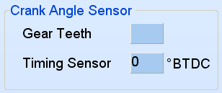
This setting, Timing Sensor °BTDC, will tell the software at what degrees the sensor is situated. The ECU will calculate from this position where to advance or retard the timing to ensure that the Map Timing is accurate with the actual timing on the engine.
In the PC software you must enter the Timing Sensor °BTDC for the specific distributor. If it has a standard magnetic pickup it usually is around 24 ° BTDC. Note however that if you are converting your distributor then a 0 or 1 ° fazing for the sensor is preferable.

To check if this setting is correct disconnect the injector fuses and crank the engine with a timing light. See if the light flashes between 5 and 10°. If not adjust the value till it does.
Now you can start the engine. It should start easy and run smoothly. Should the engine tend to stop during cranking, it means the timing is too fast. Increase this value 10° at a time. Should it sound as if it wants to start but dies, it means that the timing may be too slow. Decrease this value 10° at a time. If there is a misfire of any sort, stop immediately and do faultfinding. It may be that the magnetic pickup is wired wrong causing the spark to fire between the poles. If it is a hall or optic sensor the timing edge may be wrong. See edge setting under active sensors.

After the engine has started, check with a timing light that your engine timing correlates with the software timing block. If not adjust the Timing Sensor °BTDC value until they match. Now perform a normal timing adjustment according to the PC timing on the timing maps. Note that adjustable timing light can be misleading on wasted sparks system. Divide the timing light degrees by two.

Listen for spark in the distributor cap. If you hear a spark then the fazing degrees are wrong and there is a gap between rotor and pole. An old cap with a hole across one of the poles can be used. Flash the timing light into the hole to check for correct rotor position. Incorrect fazing will also hang the Laptop and freeze the PC Software.

4.12.2 Setting Crank Trigger Timing
This trigger consist of a single sensor and some form of crank gear like 60-2 or 36-1 etc. this setup requires 2 kinds of settings. One is on which teeth after the slot, TDC is located. The other setting is a fine tune setting between the teeth to correctly align software timing with engine timing.
If you can see the gear put the engine on TDC. Count the number of teeth from the sensor to the slot in a clockwise direction. Enter this number of teeth in the software under Gear Teeth. Enter 0 in Timing Sensor °BTDC field. The car should start. Check with the timing light to see if the software timing correlates with the engine timing. If the difference is less than the tooth pitch degrees, adjustments can be made on the Timing Sensor °BTDC field. Otherwise add or subtract one tooth and try again. If you can’t see the gear you can enter speculative values in Gear Teeth. Disconnect the injector fuses and crank with a timing light. Start with 4 and increase 2 at a time. When it flashes around 10 degrees save and proceed with starting.

If a magnetic pickup is used, ensure that the positive and negative of the magnetic sensor are correct. If they are connected wrong way round, the timing will retard instead of advance and the fazing will be wrong. Sometimes the engine will start but it may not rev up. You can also see this on the software if the rpm bar jumps erratic between two values not next to each other.

In some cases the teeth count between the slot and the sensor on TDC may be larger than crank fire pitch. The crank fire pitch can be calculated by the total teeth of the gear, (missing ones included) multiply by 2 divide by the no of cylinders. This means that a 60-2 gear for a 6 cylinder engine is 60*2/6=20.
If the teeth between the sensor and slot is ex 25 then you set it at 5 (teeth – pitch) and change the coil wires in sequence. Coil 1 connects to driver 2, coil 2 connects to driver 3 and coil 3 connects to driver 1.
If the teeth between the sensor and slot is ex 47 then you set it at 7 (teeth – 2*pitch) and change the coil wires in sequence. Coil 1 connects to driver 3, coil 2 connects to driver 1 and coil 3 connects to driver 2. For more info in this please see the drawings for 4, 6, and 8 cylinders supplied on CD.
The trigger point of the sensor is the centre of the sensor to the last edge of the tooth or trigger plate (Trigger Edge 0°). On a 36-1 gear the pitch is 10 degrees. To ajust the Timing BTDC block you can guess a setting for the centre of the pickup between the trigger edges of the adjacent teeth. See the sketch below. When the engine is running, adjust it till the software correlates with the timing light.
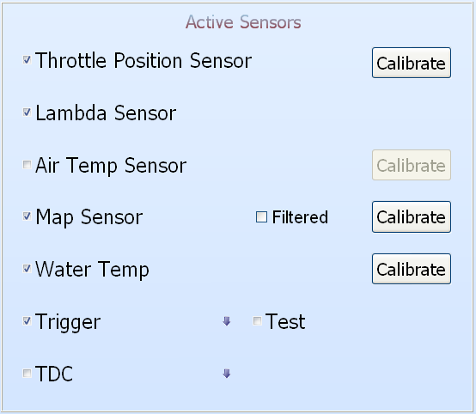

4.12.3 Setting Toyota 24Pulse + TDC Timing
This is a standard setup for most Toyota engines. There is a 24 teeth gear and a TDC reference signal. If it has a Rotor and single coil, first do rotor fazing as described above under Rotor Fazing. Then put the engine on the TDC mark. Now count the number of teeth that passed the 24 Pulse-sensor since the TDC teeth past the TDC Pulse-sensor. If it is difficult to understand rotate the engine anti clockwise until the TDC tooth is across the sensor. Now turn the engine clockwise and count the number of teeth that passes the 24 Pulse-sensor, till you reach TDC mark. Enter this value in Gear Teeth. To check if this setting is correct disconnect the injector fuses and crank the engine with a timing light. See if the light flashes between 5 and 10°. If not adjust the value till it does.
The car should start. Check with the timing light to see if the software timing correlates with the engine timing. If the difference is less than 30°, adjustments can be made on the Timing Sensor °BTDC field. Otherwise add or subtract one tooth and try again. If you can’t see the gear you can enter speculative values in Gear Teeth. If the engine stops suddenly when cranking, it means that timing is too fast. Increase the number of teeth and try again.
If the engine has coil packs then rotor fazing is no problem. If the trigger system can be adjusted, put the engine on TDC and align the TDC mark on the dizzy, up with the TDC sensor. Enter 1 in Gear Teeth and 0 in Timing Sensor °BTDC field. Start the engine and adjust the dizzy for timing alignment of the software and engine. If the trigger system cannot be adjusted, put the TDC trigger in line with the sensor and turn the engine clockwise to TDC marks as the above setup procedure of counting the teeth and fine adjustment.
Ensure that the positives and negatives of the magnetic sensors are correct. If they are connected wrong way round, the timing will retard instead of advance and the fazing will be wrong. Sometimes the engine will start but it may not rev up. In some cases the teeth count may be larger than crank fire pitch. Then you may have to change the coil pack wiring sequence to remedy the problem.
Sometimes the gap in the pickup and rotor needs to be smaller. Adjust it so that it just clears the rotor without touching. In case of 2 TDC pickups, they can be put in parallel as on the drawing. In some cases the signal may be week and requires you to disconnect 1 of the pickups.

4.12.4 Setting Nissan Optic Slots Timing
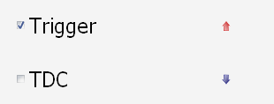
This is a standard setup for most Nissan engines. There is a metal disk with 360 fine slots and large slots equaling the number of cylinders. It has two optical sensors. The ECU uses only the large slots. If the system has a rotor and single coil, do the setup and rotor fazing as described above under Rotor Fazing.
If it has coil packs put the engine on the TDC marks. Adjust the dizzy to be in the middle of the fasten bolt and slot grove. Now adjustments can be made on the Timing Sensor °BTDC field to get the engine to start. Remember that under active sensors set the trigger level to positive edge. To check if this setting is correct disconnect the injector fuses and crank the engine with a timing light. See if the light flashes between 5 and 10°. If not adjust the value till it does.
If the engine stops during cranking it means the timing is too fast. Increase the value and try again. Once the engine starts, check with the timing light and fine tune this value so that the ECU timing correlates to the real timing. If the engine back-fires the coil sequence may be incorrect. Check the wiring diagram and change the wiring on the coil packs.

4.13 Fuel Supply
Fuel supply is mostly mechanical and not really part of the ECU. It is a vital system which is the cause for many problems in the operation of the fuel injection system. Please take time to ensure this system is properly set up as the ECU has no control over it. The only indication for problems here is the Lambda sensor. If the fuel pressure drops, or becomes erratic due to air in the system, the Lambda value will go lean. This will cause power loss and slight backfires which may sound like timing.

This system also requires a fuel pressure regulator. Again it is mechanical and accuracy is not always repeatable between systems. So a slight calibration on the ECU side is required for correct air-fuel ratios.

When converting an engine from a carburetor normally present a problem. The pipe from the tank is too thin and fuel must be sucked from the top. Fuel injection systems are normally gravity feed and have poor suction capabilities. This system requires a lot of fuel to maintain a constant pressure of 2.5 to 3.5bar on the fuel rail. A lot of fuel is returned to the tank via the pressure regulator. Do not T the fuel return line into the supply line before the pump. The fuel will heat up due to the energy put into the pump. It will then overheat the pump and damage it.
If the pump has enough pressure but lacks in flow rate due to a thin supply line, it will cause the fuel mix to go lean and loose power under heavy load conditions or at high RPM’s. If the lines are too thin, rather install an internal push pump in the tank.
These pumps get damaged by dirt, water and air bubbles. It is good practice to put an inline filter in front of the pump to ensure that dirt does not go through the pump. This will also indicate if air is in the system as most filters are see-through.
Do not install the pump next to the exhaust for it will run too hot.
Ensure that return lines are thick enough.

In some models the pump is speed controlled by the ECU and fuel pressure is sensed via an electronic pressure sensor. These systems do not have the mechanical regulator and return line.

5. Software Installation

5.1 PC Software installation
The PC Software does not require installation. It is an executable file and can run from any memory medium. See PC Requirements however. The software will create an ecu.ini file in the same directory where your software is run from. This is to save your preferred settings in the software. It cannot be run from the CD. You need to copy it to the hard drive or flash drive. When you start the software for the first time, it will prompt you to accept the Terms & Conditions as laid out by Spitronics Micro Ignitions cc. Read these conditions carefully and if you agree you may except the terms and continue to work on the ECU. If you press cancel the program will close. If you load a new manual it will ask you to agree to the terms and conditions again.

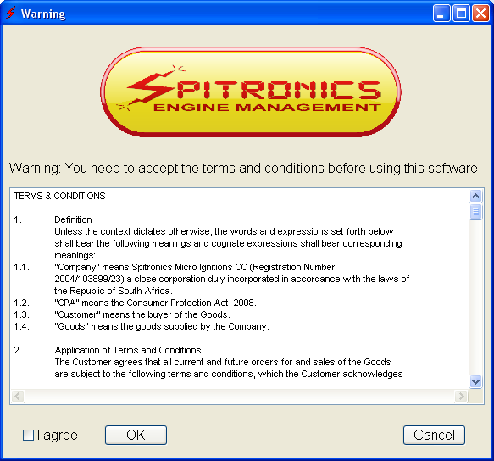
There is also an html help file. When you click on manual button, guide the software to this file and then you can access the manual from the PC software.

5.2 Spitronics USB driver installation
Go to the Spitronics USB Driver file on the CD. Activate the USB Setup.exe file. The software will install automatically. It may take a couple of minutes on slower laptops. Now insert the USB cable into the PC. Windows will detect the cable and install the driver for it. If it does not connect to the ECU see Changing the Com Port Settings below.

5.3 RS232 Computer to ECU interface
The ECU communicates to the computer via the serial RS232 interface. It operates at 19200 baud rate. See the drawing for connection diagrams.
Communication can also be achieved by USB via a USB to RS232 converter cable. Ensure that the drivers for the cable are installed according to manufacturer specifications. When using other than Spitronics cables, you have to break out pin 1,4,6,7,8 & 9 as they are used for other inputs and outputs such as for programming the ECU as well as the launch control buttons. See drawing. On a serial connector provision is made for hardware handshaking on printers etc. It is not used for these management electronics. The Spitronics USB converter you do not have to break out the pins as they are internally disconnected.
Note: These cables are optional and can be bought from the agent, computer shop or made in some cases.
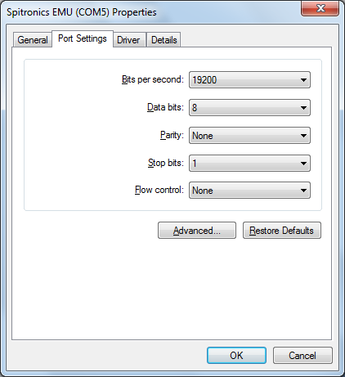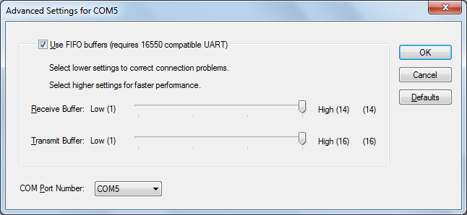
The settings in the Windows Device Manager for the USB cable must be the same as above. Note that the Com port must be Com 1 to 10. Higher numbers will not be detected.

6. Software Operation and Setup
6.1 Button Description
6.2 Connecting a PC to the ECU
6.3 Changing the USB Comport in Windows Device Manager
6.4 Memory operation of the ECU
6.5 Security and Passwords of the ECU
6.6 Selecting Different Pages in the Software

This chapter will explain how the software operates and how to set it up for your specific engine. The ECU comes preconfigured so that you don’t have to go through the tedious process of configuring all the different parameters, to get the engine to start. There are however certain checks on different engines to get the ECU to work properly. Failure to do this may damage the ECU or components of the engine which will solely be your responsibility. Refer to the drawings of your model to see if your engine has a special setup procedure.

6.1 Button Description
 Open a saved MAP from the hard disk into the PC Software.
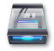 Save MAP data from the PC or ECU on the hard disk.
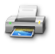 Print MAPS to a printer. (Not used currently)
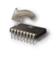 Read the data MAP from the ECU into the PC Software. (Not used currently)
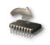 Write to ECU – Write de ECU data into the Flash memory to make the changes permanent.
 Lock the Data Maps and change the Customer Code.
 Enable or disable the mouse pad for adjustments on the tuning graphs.
 Developer and ECU Information.
 Quit the Program.

Change the tuning maps on the active real-time value of the graph.
Change the graph to the right simultaneously
 ECU is Online and can be adjusted.
 ECU is offline.
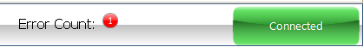 Errors in the ECU indicate certain problems

6.2 Connecting a PC to the ECU
Connect the optional serial cable or RS232 converter cable to your laptop or PC and to the ECU. (Remember to break out pins 1,4,6,7,8 & 9 if it is not a Spitronics USB converter)
Switch the ignition on and check if the yellow LED is on. Open the ECU PC software. If the ECU is connected the PC software will detect it on the Com port automatically and connect to it. If it did not, check your connections again. Note that if you use the USB converter cable, that the com port must be Com 10 or lower. You can correct this in the Device Manager of Windows. You are now ready to begin with the tuning on your ECU.

6.3 Changing the USB Comport in Windows Device Manager
One some laptops, Windows will install the USB on a Com Port higher than 10. This is a Windows driver problem and then the Com Port is not detected automatically. You need to change it to lower than 11. Follow these steps:
- Left click on Start (left bottom)
- Right Click on My Computer (or in desktop My Computer)
- Click on Properties
- Click on Hardware
- Click on Device Manager
- Click on Ports (Com & LPT)
- Right Click on Prolific USB to Serial Com Port (Com 11or higher)
- Click on Properties
- Click on Port Settings
- Click on Advance
- Select a Com Port lower than 11 (if all is in use choose 5 to 10 and press OK)
- Click on OK and close

6.4 Memory operation of the ECU
The figure below indicates how the ECU operates with temporary and permanent memory. When the ECU is powered up, it will take the data maps from the permanent FLASH memory and save it in the temporary RAM memory. This RAM is used by the processor for operation and the Laptop for tuning. When the user changes the maps, the processor will immediately start working with the new data changed in the RAM.

6.4.1 Saving data in the ECU
Once the user is satisfied with his changes he must save his changes in the FLASH memory in the ECU, by pressing the Write to ECU button. Now the data is stored permanently and the ignition can be switched off. If he does not save this data in flash, all his changes will be lost when the ECU power is switched off. When data is written to the ECU flash, the processor will cut-out for about half a second causing the engine to lose power. This will not happen during normal tuning. This is done so that the user knows his data is saved.

The laptop memory will have the same information in its RAM when the maps are uploaded after the PC software is started. If the car is switched off without saving, the operator may switch the ECU on and press the Write to ECU button. This will save the copy of the data in the Laptop RAM into the ECU FLASH memory. This is also how you can save your map in another ECU if you don’t want to save to hard disk first.

If you changed data and quit the program or switch the ECU off without saving the data in the flash, the software will prompt you to take action with one of the following blocks so that the data will not be lost. Switch the ignition on and press the required button.

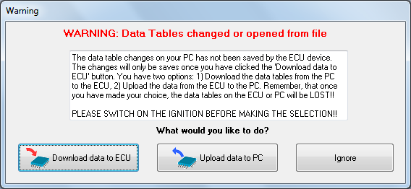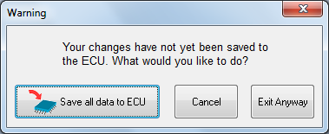

6.4.2 Saving a Map to the PC
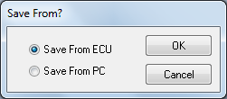
The user may also save the Laptop RAM or ECU data to the hard disk so that the maps maybe recalled later or if different settings are desired. This is done by pressing the Save Settings button.
The user has the option of saving the Ram data on the PC or the real-time ECU data. This feature is useful if you want to change Map data offline. Simply open a Map file, edit it and save it back to the hard disk.

6.4.3 Loading a Map from the hard disk onto an ECU
First connect to the ECU. Then press the Open file button. Press the button to connect to the TCU. Select Down Load to TCU button and then press the Write to ECU button. The data will now be written into the ECU flash memory. Note that the serial number is not written in the process although for this session the serial number is the same as the Map serial number. Once the software is closed and restarted, the ECU serial number will be displayed. Also note that if an incorrect version of the map is loaded, a check box will warn you of it.
NB! Make sure the map that you load into the ECU has the same Coil Driver Trigger Level as the current map in the ECU. A change here may damage the ECU or coils.

6.5 Security and Passwords of the ECU
The ECU has built in security functions to protect tuning Maps, the Customer Code and to unlock features which were not required at the purchase of the ECU.
- The tuning MAP on the ECU can be locked to prevent other users from copying it or changing settings on it. This feature is to let engine builders install protection settings on the ECU for guarantee purposes. Note however that you can overwrite the code by loading another MAP onto the ECU. This would however indicate to the agent that tampering took place and may void warrantees.
- The Agent has the option of changing the customer code for his reference. He can protect it with a password and leave the maps open. It would mean however that the customer cannot lock his own maps under the code as they use the same code for protection.
- The customer may upgrade the ECU Type or unlock features that have to be paid separately. He will require a password which can be purchased from the manufacturer, which he then enter and upgrade the ECU automatically.(Not in use currently)

6.5.1 Locking a MAP on the ECU
Press the button and enter a password twice. Select which protection is required. Press Lock, Exit and then press the Write to ECU button to save it to the Flash memory.
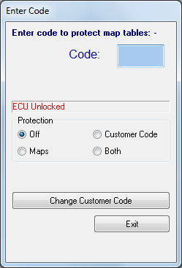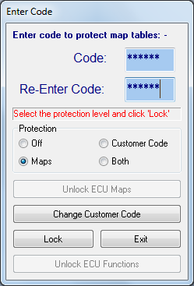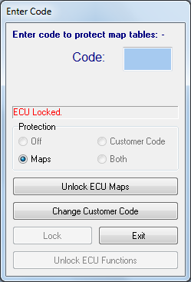

6.5.2 Change the Customer Code on the ECU
To change the Customer code, you need to put in the Agent Password in the Code block only and then click on Change Customer Code tab. This password is only supplied to the agents by the manufacturer.
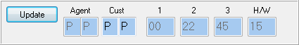

6.5.3 Tuning a Locked ECU
Each time you connect to the ECU the following message will appear and you need to enter the Lock password to enter into the tuning maps. If you don’t have the password, you can press the Clear Maps tab and load an open map into the ECU. Press the Write to ECU button to save the new map in the ECU. Note that the current tuning maps will be erased permanently. All the passwords will be cleared when you restart. Remember this may void any warranties from the agent as he will see that there was tampered in the software.
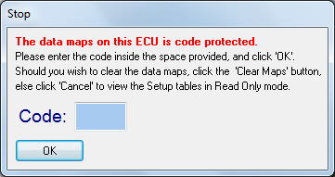

6.5.4 Un-locking a MAP on the ECU
To unlock the ECU, enter the same password that you used to lock it, in the Code block. Press the Unlock ECU tab and then Exit. If you press the Write to ECU button, the maps will stay open at the next restart.
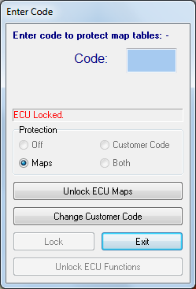

6.5.5 Upgrade or Unlock ECU Features (Not in use currently)
This Unlock ECU Functions feature will activate or upgrade certain features of the ECU. First enter the activation password and then press the Unlock ECU Functions button. Now enter the functionality password obtained from the manufacturer. Restart the ECU and software and ne new features will be enabled.
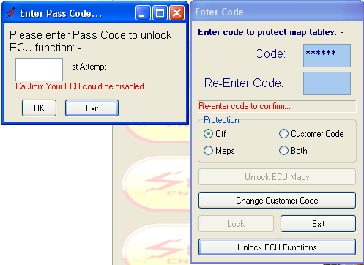

6.6 Selecting Different Pages in the Software
6.7 Start (F1)
6.8 Setup (F2)
6.9 Maps (F3)
6.9.5 Logger (F4)
6.9.6 Manual (F5)

Press on any of these buttons to activate the different pages in the software. By pressing the alt button you will see the hot keys for these buttons.

The hot keys are easier to press during driving.

6.7 Start (F1)
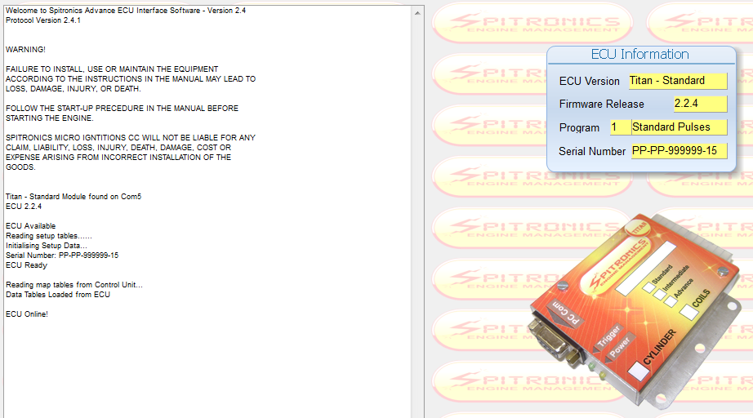
This is where the program will start the first time. On this page all the action events is logged for information. It will also display the ECU information of the current ECU. Take note of the Warning as it is important and binding by Law. See the Terms & Conditions on the CD.

6.7.1 Version Numbers
The designer reserve the right to do changes to existing designs and harnesses as he keeps on developing software and hardware. The market change all the time as new ideas submerges. The ECU has a version number system so that the user knows which drawings, and also which Tuning MAP goes with which ECU firmware. There is also a document on the CD which explains about the hardware and software changes made between different versions TITAN Version Changes.pdf.

ECU Version will indicate the product namely TITAN and which model is connected. Models are Micro, Basic, Standard, Intermediate or Advance.

Firmware Release is the software, hardware, Protocol and firmware release information. This is very important as it must coincide with the PC software. It is also written with a permanent marker on the enclosure but this my rub off during installation.
2.2.4.A In the sample means: PC Software Ver. 2, Hardware number 2 (Titan), Protocol Ver.4, Firmware Ver. A.

The PC software also has a version number in the name part of the file or on the Top information bar. Keep older versions for old ECU versions. ECU firmware can be upgraded by an agent to accommodate changes in the latest PC software. Version 2.4 ECU must be programmed with Ver. 2.4 PC software. Older version software than Ver.1.13 will open and change parameters but will not be able to save the data. From Ver.1.14 software will also warn if incompatible ECU firmware is used. The alphabetic number will indicate later version changes in the ECU or PC but does not change the protocol of Ver.2.4 software. This may differ from Software to ECU but it does not matter.

Program is a number given to each ECU firmware program to identify them apart. Behind the number is a short explanation of the type of program On the CD a list of these numbers available (ECU Program Numbers.txt).

Serial Number is to keep track of each ECU sold. It is also engraved on the enclosure of the ECU. The number for ex PP-PP-999999-15 means as follows:
PP – Agent which this unit was distributed to
PP – Customer which this unit was sold to – this can be changed by the Agent for his own reference.
999999 – unique serial number
15 – model function no

ECU model function numbers are as follows:
1 Micro ECU
2 Basic ECU
3 Standard ECU
11 Intermediate ECU
15 Advance ECU

6.8 Setup (F2)
6.8.1 Engine Setup (Alt 1)
6.8.2 Timing Setup (Alt 2)
6.8.3 Fuel Setup (Alt 3)
6.8.4 Sensor Setup (Alt 4)
6.8.5 Turbo Setup (Alt 4)
6.8.6 Real-Time Data and Bars

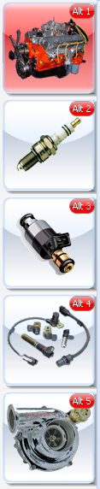
Click on the setup tab to get information on the configuration of your engine. Most parameters are being preset before the ECU has been shipped. Ensure that these settings are correct as some may damage components on your engine or the ECU itself.

Click on of these icons to adjust different settings in the setup page. Activate the Hot-Key by pressing the Alt button plus the correlating number as in the icon block.

6.8.1 Engine Setup (Alt 1)

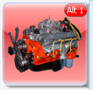

6.8.1.1 Map Information
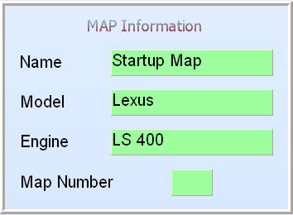
The Map information screen contains info for which customer and vehicle the maps have been done. It saves in the ECU and PC. This is used to identify different tuning maps from each other. It does not affect any tuning on the engine.
The Map number will indicate which Map is loaded. This will only function in certain firmware which has the ability to run duel Maps for different fuels.

6.8.1.2 Engine Configuration
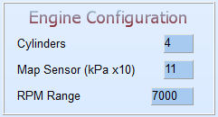
Cylinders – 2,3,4,5,6,8 or 12 cylinders can be typed in this block, depending on the engine specific ECU. Most ECU firmware will over-write this block at start-up.
Map sensor – adjusts the map sensor range that you use e.g. 1bar = 11, 2.5bar=25. If you have a 2.5 bar sensor but you only use 0.5 bar boost, enter a value of 16 for 1.6 bar scale and calibrate the MAP sensor so that you are able to make full use of the complete vacuum range for correction adjustment. Note that the 1bar sensor is actually 1.15bar so we set it at 1.1bar to accommodate high pressure days at sea level. See Active sensors and Calibrate further in the manual. These changes only take effect when you Exit and start the PC software again.
RPM range – set the rpm maximum RPM that you want to map the ECU at e.g. redline starts at 6500rpm add 500rpm and type in 7000 for the rpm range. These changes only take effect when you Exit and start the PC software again.

6.8.1.3 General Purpose Outputs
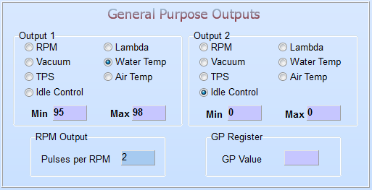
There are two general outputs to configure for several different functions. These outputs can be configured to use one of the analogue signals and switch a relay on or off when certain limits have been reached.
Example: RPM for a shift light, RPM or TPS to switch nitrous on, water temp to control a fan relay. Also set the appropriate values in the min and max blocks e.g. shift light – min 5000 max 8000. The light will switch on at 5100 RPM’s and switch off at 8100 RPM’s. If the min value is smaller than the max value, the relay will switch on between the limits. If the minimum value is higher than the max value, the relay will switch off between the limits. Note also that the relay will switch on at the value + 1 increment and off at the value – 1 increment. Thus for example if you select RPM and set 4000 and 5500, it means that the relay will switch on at 4100 and 5400 and off at 3900 and 5600 rpm’s.

Note that on GP 1 the water temp works different from all the other logics. The output will go on when Max + 1 is reached and go off when Min – 1 is reached. This is to allow the tuner to set a dead band value for the fan to start and stop. This will prevent the fan from start and stopping too much.

Note! The idle control also uses these outputs. For idle control the setting must be set to Idle Control and then the parameters will be set on the Idle Control field. The Min and Max values does not affect the idle control operation. They are not used.
Note! The Micro Fueling can also use these outputs and the take priority. If it is activated there the selection will be off and the values ignored. The Min and Max values does not affect the Micro Fueling operation. They are not used.

Note! Only on the Lexus program GP 2 can be used for RPM calibration for different rev counters. This is due to the fact that the gearbox and idle control use the normal RPM output. Set it to RPM and then set the Pulses / RPM for the required rev counter. The Lexus SPCL program operates as all the other programs.

The following values need to be set for the different conditions:

RPM – RPM/min 100rpm increments
Lambda – voltage 0.01volt increments
Vacuum – pressure 10 KPa increments
Water temp – degrees at 1°C increments
TPS – percentage at 1% increments
Air temp – Degrees at 1°C increments
Idle Control – if idle control is used

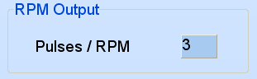
This block is for Rev counter calibration. You can adjust the number of pulses per revolution which is handy for engine conversions. On some engines you may enter 0 which will then tell the ECU to divert the trigger signal and copy it on the RPM output. This is handy if the standard ECU is still live and doing other functions in the car. Then it requires its original trigger sensor.
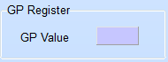
This GP Value is used on certain firmware to achieve certain functions. See the specific instructions for that engine type.

6.8.2 Timing Setup (Alt 2)

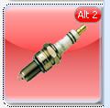

6.8.2.1 Timing Configuration
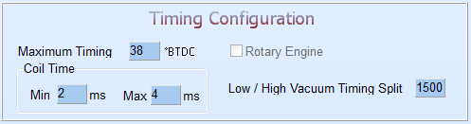
Maximum Timing – this is the max timing allowed by all the timing maps combined.
Coil time – 2ms to 5ms. This is the minimum and maximum charge time which the user can select. The ECU will vary the charge time automatically according to vacuum load from the minimum to the maximum value. If the ECU heats up it is a result of too large charge times. 2.0 min and 3.5 max is a preferred starting value. Can be adjusted in 0.5 milli second intervals.
Rotary Engine – this is checked when rotary firmware is loaded into the ECU. At the same time a timing graph will be displayed on the Timing RPM map to adjust the timing split with RPM.
Low / High Vacuum Timing Split – this sets the RPM split between the Low & High Vacuum Timing maps.

6.8.2.2 Crank Angle Sensor
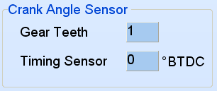
Gear Teeth – set the amount of teeth to align the crank sensor with ignition timing. Refer to the installation section “Setting Crank Trigger Timing”
Timing sensor °BTDC – set the correction factor here to line timing up with timing light. Refer to the installation section “Setting Distributor Timing and Setting Crank Trigger Timing”

6.8.2.3 Coil Combination
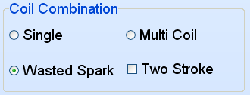
Coil combination – indicates the type of coil combinations used by the firmware and it cannot be adjust.
Two Stroke – this will select 2 or 4 stroke to correct the injector % indication bar. If it is on 4 stroke the injector time is calculated over 2 RPM’s while on 2 stroke the injector time is calculated over 1 RPM. If you have an engine that does not rev high and the injectors is too small you may put it on 2 stroke to double the injector time. Note however the injector % during tuning must not go over 100% as this will occur at a lower RPM.

6.8.2.4 Coil Driver Trigger Level
Coil Driver Trigger Level– this setting is very important and a mistake here can damage the ECU or Coil.
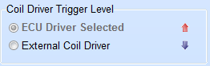
If you have a coil with no driver in the coil, use ECU Driver setting.
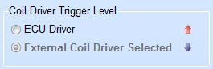
If you use a TP100 or have a driver in the coil use External Coil Driver setting with a pull-up resistor. The example above indicates that it is selected.
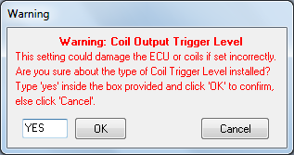
To change this setting, click on Internal or External and type in YES. Press OK and then save the data to the ECU.
NB! This setting must be done before the ECU 10 way connector is connected.

6.8.3 Fuel Setup (Alt 3)

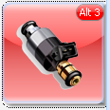

6.8.3.1 Fuel Configuration
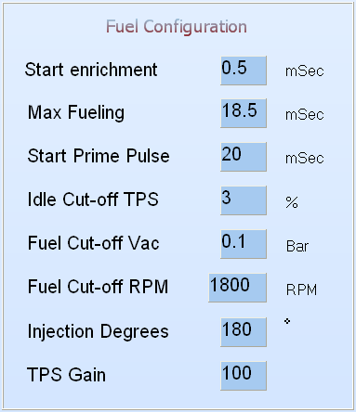
Start enrichment – Set a value in milliseconds here for start enrichment. This enrichment is added to the calculated fuel when the engine is started. It will then be phased out in a few revolutions.
Max Fueling – Set a value in milliseconds here for the max amount of fuel allowed to your engine during running. This value is calculated as the time it takes for 2 crank revolutions at maximum RPM. The example is an engine doing 6500 RPM max. For Two-stroke engines this value will be half. If the main jet is high like 200, you may need to increase this value to allow for the accelerator pump function.
Start Prime Pulse – This setting in milliseconds is the initial fuel that will be squirted in the engine to ease starting. It is only injected once the engine start to crank and not when the ignition is switched on. Half of this value will be squirted every time the fuel pedal is pressed more than 25%. This feature is handy on very cold days for starting.
Idle Cut-off TPS – This setting is used for the idle control. The ECU will not control the idle motor if the TPS value is not below this value. It would however raise the RPM whenever the engine RPM falls below the set point under idle control. It is also used for TPS blending. The bar will stand at this value when the throttle is released.
Fuel Cut-off RPM – This feature will cut the fuel supply when the engine is running against compression. This is useful in town and downhill driving and will save fuel. It will also prevent flaming in the exhaust during accelerator blip. Fuel Cut-off will only be activated when both of the following criteria are met. There is a dead band feature built into these settings to prevent jerking when cruising close to the parameters.
Fuel Cut-off Vac –The MAP sensor value must be less than this setting.
Fuel Cut-off RPM –The engine RPM must be more than this setting.
The TPS value has no affect on this function unless if it is in blending mode.
Injection Degrees –This setting will adjust at which degrees injection will begin. Not all firmware will allow this value to be changed. It is mainly for full sequential applications.
TPS Gain –This setting will adjust the rate at which the bar will move to the right of the graph during TPS Blending mode. It is to simulate the MAP sensor signal for correct fueling during pull-off. It is only used in Map + TPS mode.

6.8.3.2 Fuel Map
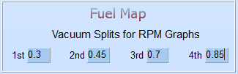
These limits are used to select between the five RPM fuel correction maps. They are displayed on the vacuum map as four blue arrows. When the vacuum signal passes these arrows, a different RPM correction map is used.

The RPM correction maps are divided in four groups of Map sensor values. A low, cruise, high cruise and high map.
The Low map – this is the map for low throttle cruising or idle
The Low Cruise map – this is the map for light cruising
The Cruise map – this is the map for normal cruising
The High Cruise map – this is the map for high throttle cruising
The High map is used for Wide Open Throttle (WOT) conditions.

6.8.3.3 Injection Type
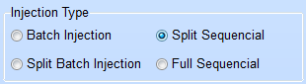
Injection Type – This setting is an indication of what type of fuel injection setup the ECU was programmed for. On some models this may be adjustable depending on the firmware.
- Batch Injection will pulse all the injectors for all the cylinders at the same time.
- Split Batch Injection will pulse two sets of injectors 180° apart from each other.
- Split Sequential Injection will pulse two injectors per driver together for the two cylinders that move at the same strokes. It will follow the sequence of the firing order.
- Full Sequential Injection will pulse one injector per driver in the same sequence as the firing order. Here a cam pulse or home signal is required.

6.8.3.4 Fuel Calculation
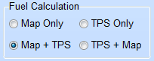
Fuel Calculation – This setting is to allow the tuner to choose Map sensor calculation or Throttle sensor calculation or a split of both signals.
- Map sensor is the preferred one as it is a direct representative of the air intake and load of the engine. It can also compensate for sea level differences. It is also the easiest way to tune the engine. This mode is used for normal engines with decent vacuum signal during idling.
- Map + TPS sensor is used for normal engines with long duration cams which overlap with both valves open at the same time. This creates a poor vacuum signal due to exhaust gas being sucked into the intake manifold because of the overlap. Then the ECU cannot calculate accurately what the fuel requirement is. In this case the TPS is used to calculate air-fuel mixture.
- TPS sensor is used when performance cams are used for racing or if the engine has separate throttle bodies and no mean engine vacuum chamber. Here the throttle position in conjunction with RPM is used to calculate engine vacuum. The TPS signal is modified and used as a Map signal. A disadvantage is that it cannot compensate for sea level correction. The TPS is calibrated as normal to allow the tuner to make use of the full graph.
- TPS + Map sensor is the popular setting where the engine has racing cams and does not generate low manifold pressure during low RPM’s. Here you can blend the TPS signal and Map signal in at a certain RPM’s to get the correct A/F mixture during idling without losing the economy at normal driving. It is also used for turbo engines to compensate for boos pressure.

6.8.3.5 Accelerator Pump
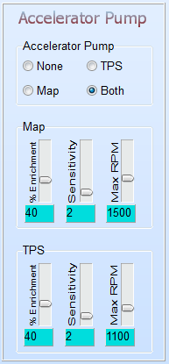
The accelerator pump setting is used to richen the fuel mixture when accelerating to avoid flat spots or bog. Here you can select not to use it, use either the TPS or MAP or both.

The Accelerator pump settings are done for Both the MAP and TPS sensors.
Enrichment % - Use the slider to richen the fuel by a given percentage when accelerating. A standard is 40 or 50%.
Sensitivity - Set this slider from 1 to 10, starting at 10 for the least sensitive, until you are comfortable with the response you get out of your acceleration. If the setting is too sensitive (1), then your car will jerk and over fuel with the slightest movement of the throttle. Tune this setting from a flat spot side till it’s gone. Otherwise you may over fuel without knowing it. A standard is 2 to 4.
Max RPM – This is the maximum RPM that the pump settings will be active. At high RPM you do not need an accelerator pump. A standard is 1500 to 2000 RPM.

6.8.4 Sensor Setup (Alt 4)

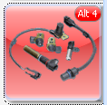

6.8.4.1 Active Sensors

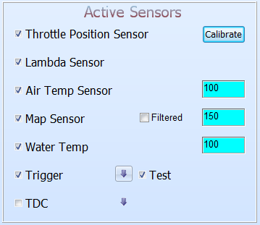
Select the different sensors that are to be used for your engine. If a sensor is not to be used, leave the block unchecked. Also make sure the cable for it is properly isolated as there is power on the leads that could short circuit, damaging the ECU as a result. Some of the sensors cannot be altered or will be forced on by the firmware.

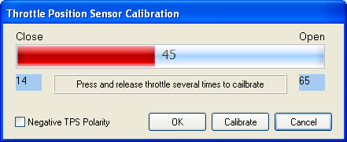
The TPS sensor needs to be calibrated. To calibrate the TPS, click on the Calibrate button. If the TPS is working the wrong way round, click on Negative TPS Polarity. This feature is normally used where the existing ECU is still connected. Now click the Calibrate button. The current TPS value will be written into the two blocks. Press the fuel pedal in completely and release the pedal completely. The minimum and maximum values will be set into the two registers. Click the OK button. Then click on the Write to ECU button. When you switch the ECU off and on again, the TPS bar should indicate 0% when pedal is released and 100% when pedal is pressed. Remember that idle control will only take place when the TPS value is less than the value set in the Idle Cut-off TPS block.

The water and air temperature sensors can be calibrated by giving it a percentage offset. Normal setting is 100%. These sensors are pre calibrated on the ECU. If the error is large you may need to replace it or get the correct sensor. Water sensor is a 2K NTC resistor and the Air Sensor is a 10K NTC resistor.

The MAP sensor can be calibrated to accommodate all the different types and to expand the working range to make full use of the tuning maps. To calibrate the sensor, first set the Map Sensor Value under Engine Configuration. If you have a turbo with a 2.5 Bar map sensor and you are only going to boost 0.8 Bar, set the scale to 2 Bar (value 20). Then click on the Write to ECU Now close the ECU software and open it again. The vacuum range should be set to 2 Bar on all the vacuum graphs. Now calibrate the map sensor so that it read the atmospheric pressure for your area. If you are at sea level, calibrate it at 1.0 Bar. Gauteng Region is around 0.85 Bar. If you increase the calibration value the measured map sensor value will decrease. When you have the desired value, press Write to ECU to save it. The Filter block will average the current reading with the previous reading. This will create a dampening effect for throttle bodies where the map signal is erratic. Do not use it if it is not necessary. It will make a flat spot which must then be tuned out with accelerator pump.

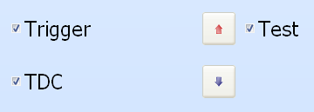
The Trigger and TDC inputs can be selected on or off. You always require at least the Trigger on. Then you can click on the arrow next to it to select leading edge (arrow up) or trailing edge (arrow down). Most triggers are trailing edge but triggers like the optics of Nissan and a few others are leading edge. On magnetic pickups this setting is useful if the positive and negative is swopped around. Then you can click the arrow and the ECU will swop it with software. Note however that if you load a new map, this setting must be changed afterwards. Some firmware programs will force these sittings in a certain pattern and even if you change it, it will keep changing back when you restart the program.
The Test function is always used for first startup of the ECU. This will test the trigger signal to ensure that it is the correct one and wired correctly. If not, it will generate some error code to indicate the installer to what the problem might be. It will also use one more revolution before starting the engine if the signal is correct. Once the trigger is sorted and no errors occur after stating, you can switch it off and starting will be after the first revolution. If it is left on, it may in some instances induce interference at high RPM’s. So it’s best to switch it off.

6.8.4.2 Pot Input
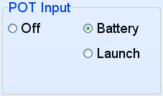
The Pot Input can be used for one of the following. Battery input or use as a launch control. For a normal car, set it to battery so that battery voltage compensation can be adjusted. If any other function is selected, a fixed battery voltage of 12.7 volt is forced into the ECU. For racing cars you can use the launch control function. See Launch Control on how to use the launch buttons.

6.8.4.3 Idle Control
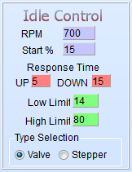
Before adjusting the idle control you must select which type of valve is on the engine. Remember if it is a stepper control (4 to 6 wire), then you require the external electronic driver. Also remember to set the relevant GP outputs to Idle Control.

Idle control can be used for two-wire and non spring loaded three-wire valves. Other idle valves with stepper motors will use these settings but with external electronics. Stepper motors will not use the Low Limit and High Limit settings as they keep their position when there is no signal present. For two-wire idle valve GP output 2 must be set to Idle Control and for three wire valves both GP Outputs must be set to Idle Control.

RPM – this setting is the preferred target RPM’s when the engine is on running temperature. When it is cold the ECU will automatically increase engine RPM’s with up to 300 RPM’s. This is calculated according to fuel enrichment on the water compensation map.
Start % – this setting is used to increase the air intake when the engine is started hot or cold. The ECU will open the idle valve with this % and when the engine is cold, the ECU will increase this setting automatically according to the water temp compensation graph.
Response Time Up – this setting will determine the rate at which the valve opens when the actual RPM’s fall below the set point in Idle RPM. The further the RPM fall below the set point, the faster the ECU will open the valve to let in more air. Low values will create a faster the response time and high values will create a low response time. This setting must prevent the engine from stalling when you switch the aircon on or put it in drive.
Response Time Down – this setting will determine the rate at which the valve closes when the actual RPM’s go above the set point in Idle RPM. The further the RPM goes above the set point, the faster the ECU will close the valve to decrease airflow into the engine. This value is set higher than the Response Up value, to eliminate hunting. Low values will create a faster the response time and high values will create a low response time. This setting must bring over RPM down as fast as possible without hunting the engine.
Low Limit – this setting will preload the spring in the valve so that the valve starts to open immediately when the ECU starts increasing the value. It can also be used to set minimum idling RPM for throttle valves that closes completely. To set the value start with a larger % and decrease until the desired idling RPM is reached. When you adjusted the value you need to accelerate a little so that the ECU can bring the value from the top.
High Limit – this setting is used to limit the maximum idle RPM’s. No need to open the valve more than necessary. It also allow for the use of large valves in smaller engines. Just make sure that when the engine is cold, it can still lift the RPM up to approx. 1500 RPM. This can be tested by entering a large Idle RPM value and see to where the ECU can increase the RPM to. You need to lower the RPM first when you changed the value.
Type Selection – this setting is used to select which type of idle control valve is on the engine because the software is different for the two main types.

6.8.4.4 Lambda Configuration
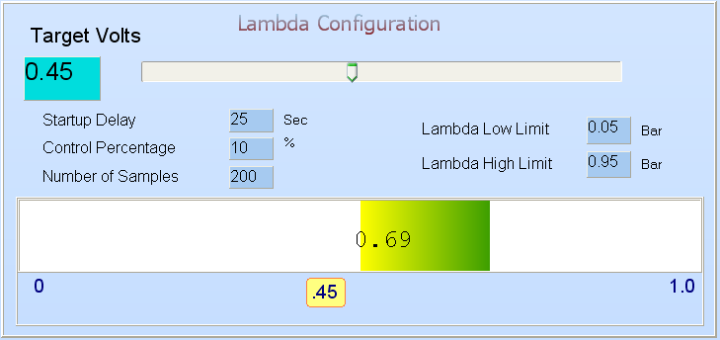
This block is used to set control parameters for the ECU to use the lambda signal to adjust fuel enrichment while driving. Note that lambda sensor correction will only operate when the engine temperature is above 30°C.
The Target Volts are the set point for the ECU to achieve during fuel correction. This limit is different for the different types of fuel and vehicles. For normal pump gas the target voltage should be around 0.45V (14.7 air/fuel ratio) and for methanol and alcohol between 0.75V and 0.85V. Note that the narrowband sensor is only accurate around 14.7 AF.
Startup Delay – This setting will let the ECU give the lambda sensor time to heat up until it is ready for use in fuel correction.
Control percentage – This setting will give the ECU the ability to enrich or lean the fuel amount by this %. This value will be implemented gradually over 0.4 milli-volt movement away from the set point. It can be adjusted from 0 to 20% max. A value of 5% is standard. Always tune the ECU first without the help of the lambda sensor and then activate it afterwards. This will get the best out of the lambda sensor.
Number of Samples – This setting is the number of samples from the lambda sensor that the ECU will average out. Then it will use this average to make adjustments in the fuel enrichment. A typical a value of 100 is used. This setting is to create a damping effect to the ECU to prevent hunting. When set correctly the lambda signal should not hunt more than 0.2 volt while driving.
Lambda Low Limit – This setting is to set the lowest RPM value that the ECU is allowed to adjust the fuel. A standard here is 300RPM above idling RPM. When the RPM falls below a certain value, the mixture has to be richer than 14.7 then the ECU are not allowed to adjust the fuel. This setting will be indicated as a red bar on the RPM graph.
Lambda High Limit – This setting is to set the highest vacuum setting that the ECU is allowed to adjust the fuel. A standard here is 0.75 for normal aspirated engines. When the vacuum goes above a certain value at wide open throttle position, the mixture has to be richer than 14.7 then the ECU are not allowed to adjust the fuel. This setting will be indicated as a green bar on the vacuum graph. This means that lambda loop control is only allowed between the low and high limit settings. For turbo engines the high limit is normally set at the start of high boost.

The Lambda bar indicates from 0 volt to 1 volt from left to right. This bar is used to tuning the ECU for correct fuel levels under all conditions. The right green side is richer than 14.7 A/F ratio while the left Red side is the lower than 14.7 A/F ratio. Stoichometric is at 0.45 volt or 14.7 A/F ratio.

6.8.5 Turbo Setup (Alt 4)

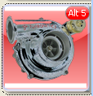

6.8.5.1 Launch Control
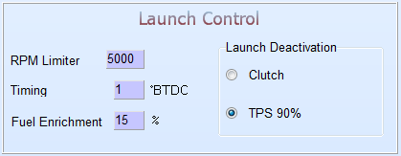
Clutch
The launch control is activated by a push button on the dashboard and an optional button on the clutch pedal if automatic latch up operation is required. Once the engine RPM’s go over the RPM Limiter minus 500 RPM, the 3 parameters will take effect. 4500RPM in this example above. This Rev Limiter will cut the fuel and spark. The timing will be retarded to the set degrees and the fuel mixture will be enriched with the set %. The moment the clutch or the button is released, everything will go back to the normal settings.
TPS 90%
The launch control is activated by a pushing the button once and then press the throttle pedal below 90%. Once the engine RPM’s go over the RPM Limiter minus 500 RPM, the 3 parameters will take effect. 4500RPM in this example above. This Rev Limiter will cut the fuel and spark. The timing will be retarded to the set degrees and the fuel mixture will be enriched with the set %. The moment the throttle pedal is pressed more than 90%, everything will go back to the normal settings. If it is an On-Off switch, launch limiter will activate the moment the RPM’s falls below 2000RPM.

6.8.5.2 Engine Limiter
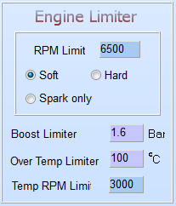
RPM limit – This feature will prevent the engine from over-revving and can be adjusted in 100 RPM intervals. RPM limit can be achieved by three methods.
Soft – This mode will retard the timing in three stages and then cut the fuel completely. Each 100 RPM over the limit the timing will be retarded further. First retard is 15 °BTDC, then 10 and then 5 °BTDC. Then after the third stage, fuel will be cut but not the spark. This will prevent fuel from entering the exhaust and backfire there. This is the preferred method for engine over rev limiting.
Hard – This mode will cut the fuel and spark completely.
Spark Only – This mode will cut only the spark. This will give the backfire sensation when unburned fuel is ignited in the exhaust. Remember that damage to the exhaust system might occur.
Boost limiter – This feature will cut the injectors clean if the MAP sensor detects a manifold pressure that is higher than the set value. It is not a boost controller but it is to protect against boost controller or waste-gate failure. It can be adjusted in tenths of a bar resolution. The spark will not be cut.
Over Temp limiter – This feature will cut the injectors clean if the engine temperature goes higher than the set value, and the RPM’s is higher than the next setting.
Temp RPM limiter – This is the maximum limp mode RPM’s when the engine is over temperature.

6.8.5.3 Micro Fueling Injector
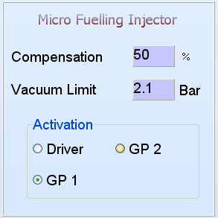
The TITAN ECU has the feature to use two injectors on each cylinder. It will use a primary injector at low manifold vacuum and when the manifold pressure goes high, it will add a secondary injector to increase the fuel amount to the engine. This will allow the engine to be tuned more optimized on low and high loads. It will calculate the difference in injector time interval to compensate for the extra fuel that will be added by the secondary injector. This method should make the transition as smooth as possible.

The Compensation % field is calculated by the primary injector cc divided by the total injector cc multiply by 100.
Example: Injector 1 = 100cc, Injector 2 = 200cc.

Compensation = Primary Injector x 100 = 100cc x 100 = 33%
Primary + Secondary Injectors 100cc + 200cc

The Compensation field must be set to 0% if this feature is not used in order to free the GP outputs to other tasks.

If you are not sure on the injector sizes set the Vacuum Limit field high so that the secondary injectors stay off. Tune the engine with the primary injectors up to a load where the injector % is between 70% and 80%. Note what the A/F Ration at this point is. Now start with 50% Compensation value. Decrease the Vacuum Limit below this load value so that the secondary injectors start to operate. Reduce or increase the Compensation % so that the same air fuel ratio at the same load is reached. You may need to reduce the vacuum with the throttle to stop the injectors, while changing the Compensation %.

The Vacuum Limit field is at which manifold pressure the transition must take place. This is normally when injector percentage goes over 65% opening. If the secondary injectors are very much larger than the primaries, try to switch at 85% opening.

The Activation block will activate the different Hardware Circuits to power the extra injectors. If it is on Driver then separate drivers on the ECU will be used and wired to the separate injectors. The injectors will be connected to the same positive supply. If GP 1 or 2 is used, an external Mosfet Switch will be used to switch the power to the secondary Injectors. In this manner the injectors is joined with the primary drivers. Setting GP 1 or 2 will take control of that GP output and disable the normal GP output settings. See the Wiring diagrams for wiring info. If the GP outputs are used as injector drivers for specific firmware, then this setting must be set on Driver.

6.8.6 Real-time Data and Bars
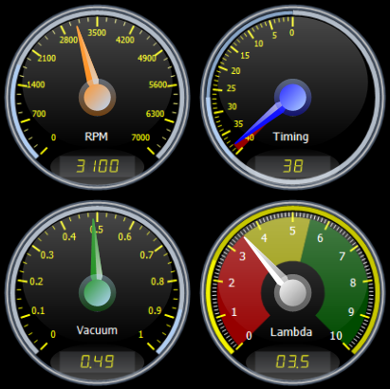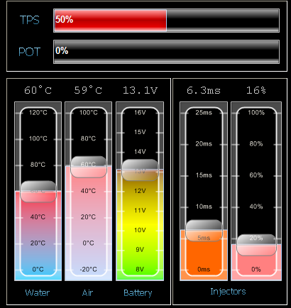
This block displays the current analogue data as it is measured by the ECU for while the engine is off or running. These values are used to set and tune the ECU correctly for all conditions.

Double click on the gauges to change their appearance between digital and analog.

6.8.6.1 RPM Gauge
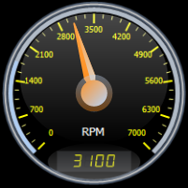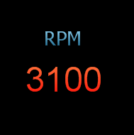
RPM - This is the current engine revolutions. Double click will toggle between the two options.

6.8.6.2 Time Gauge
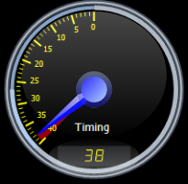
TIMING - This is the calculated timing of all the timing maps and will be the same as seen on the timing light. Double click will toggle between the two options.

6.8.6.3 Vacuum Gauge
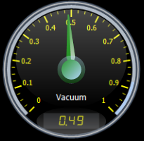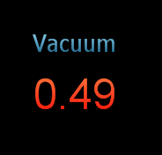
VACUUM - This is the vacuum value from the MAP sensor. It is measured from Absolute vacuum to atmosphere and also boost pressure for Turbo engines. Double click will toggle between the two options.

6.8.6.4 Lambda Gauge
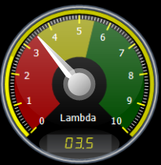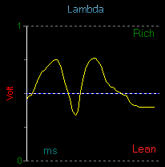
LAMBDA - This is the Lambda value read from the Oxygen sensor. It is measured in volts from 0 to 1Volt. Where 0 Volt is lean, 0.45 Volt is Stoichometric or 14.7 air-fuel ratio and 1 Volt is rich. Double click will toggle between the two options.

6.8.6.5 Water Air & Battery Indicator Bar
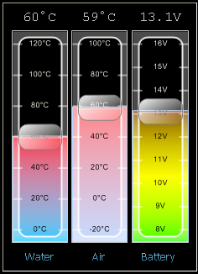
These 3 bars will indicate water and air temperatures and also the battery voltage as it is supplied to the ECU.

6.8.6.6 Injector Time and % Indicator Bar
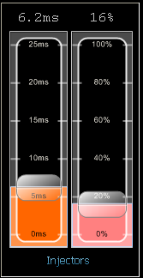
This ms bar indicates the time in milliseconds that the injectors are opened. For a 4-stroke engine this is measured over 2 revolutions and for a 2-stroke engine it is measured over 1 revolution.

The % bar indicates how long the injector is open in relation to the time of 1 revolution. If it indicates 100% it means the injector is open for the whole revolution and that is the maximum fuel that can go into the engine. A supplier recommendation is not more than 85%. This will indicate that the injectors are too small.

6.8.6.7 TPS & POT Indicator Bar
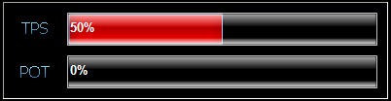
The TPS% bar indicates the throttle position at that stage. If it is calibrated, it will indicate from 0 to 100 % between closed and open throttle.

The POT% bar indicates the optional input signal voltage. No calibration here.

6.9 Maps (F3)
6.9.1 Timing Maps (Alt 1)
6.9.2 Fuel Maps (Alt 2)
6.9.3 Lambda Maps (Alt 3)
6.9.4 Correction Maps (Alt 4)
6.9.5 Data Logger (F4)
6.9.6 Manual (F5)

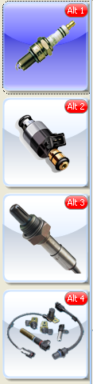
Click on the Maps tab to get information on the tuning maps of your engine. Startup Maps are being preset before the ECU has been shipped. These maps may require to be adjusted to suit your engine. Some maps for tuned engines are also supplied and may only require minor adjustments.

Click on of these icons to adjust different settings in the setup page. Activate the Hot-Key by pressing the Alt button plus the correlating number as in the icon block.

6.9.1 Timing Maps (Alt 1)

6.9.1.1 Dynamic Timing Map
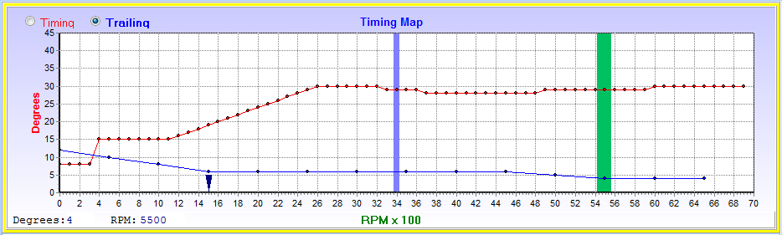
This Red Timing graph is the wide open throttle map. Here you set the maximum timing of the engine trough the whole RPM range. If the engine ping or detonate, see at which RPM’s it happens and bring the graph 3 to 4 degrees down at that RPM range.
The dynamic timing curve can be adjusted every 100 RPM’s in steps of 1° between 0 and 45°.

Notice the graph below 400 RPM’s is set to the cranking timing. Then the next step is for idling. The split for vacuum timing is the blue arrow at 1500 RPM. When the RPM is below this limit the low vacuum timing graph is active and above this value the high vacuum timing graph will be active.  This setting is adjusted in the timing set-up.

This Blue Timing graph is the timing split for leading and trailing degrees on Rotary engines. For all the other engines this graph will be hidden.

This will select which graph will be adjusted. This will also be hidden on other engines. The Blue vertical bar is the Real Time RPM value and the Green bar is your cursor position for adjustment.

See Key Instructions on how to adjust the graph.

6.9.1.2 Vacuum Timing Map
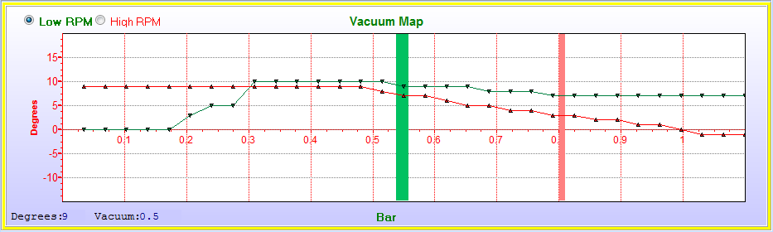
On this map you can set the amount of ignition advance and retard for a specific vacuum or boost pressure value. There are 2 maps with 32 divisions for the map sensor which can be adjusted from -15° to +20° in 1° intervals.

The degrees you set here will be added or subtracted to the dynamic timing map. Note the -3° from 0.85 to 1 bar. This will compensate for sea level and inland timing.

The Pink bar is the Real Time Map value and the Green bar is your cursor position for adjustment.

See Key Instructions on how to adjust the graph.

6.9.2 Fuel Maps (Alt 2)

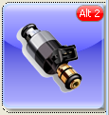

6.9.2.1 Main Jet Setting
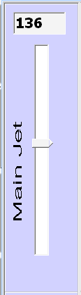
The base line fuel is calculated by the ECU and not mapped in a look-up table like matrix systems. Calculations alone cannot compensate for all deviations in and engine. The ECU uses correction graphs to compensate for all kinds of deviations. The Main Jet adjusts global fuel supply to the injectors much like the main jet in a carburetor would. This is a constant dependant on fuel pressure and injector size. If all the maps are zero, you can use this setting to adjust the base line fueling for the ECU. A standard to use is normal load on the freeway at normal cruising speed for instance 120Km/h. Your total vacuum range can be divided into two and use this setting if you are on a Dino. Drag the slider up or down to increase or decrease fuel till the desired air/fuel mixture is obtained. Normally around 14.7 or 0.45Volt on the lambda slide bar. Now stop, put the car in park and adjust the Idle jet till it idles smoothly and the desired air/fuel mixture is obtained. Now memorize the digital value above the main jet slider and always go back to that value if you use the slider for tuning. If you change this value, all the other settings will change accordingly. That is why it is the first to adjust.

If starting for the first time you may adjust the slider slowly up while cranking, until the car starts. As the engine warm up to normal temperature, lower the slider to keep the engine running smoothly. Start with an idle setting of 70.

See Key Instructions on how to adjust the graph.

6.9.2.2 Idle Jet Setting
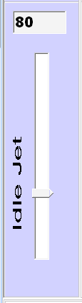
The Idle jet setting adjusts global idling fuel supply to the injectors much like the idle jet in a carburetor would. Calculations at idle uses a part of the main jet setting, and gradually fade away as the vacuum signal decreases under load. It is important to set the main jet first then the idle jet. Start from a lean mix and increasing till hunting fades. Use the Lambda slide bar for accurate setting. Remember that idling mix are normally richer than cruising mix. You can adjust the slider to achieve the maximum vacuum when the engine is at normal running conditions.

See Key Instructions on how to adjust the graph.

6.9.2.3 Vacuum Fuel Map
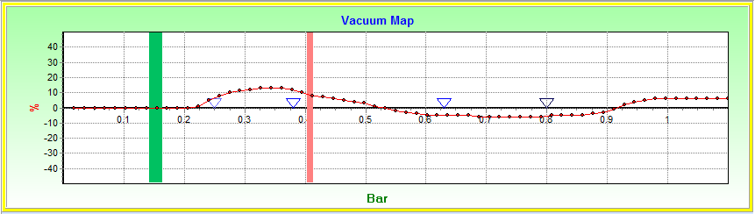
This is the main vacuum correction map. Use this map to adjust enrichment deviations for the specific engine. Also use this map on the left side to adjust idle mixtures for an automatic gearbox when selecting drive.

The 4 blue arrows indicate the 1st, 2nd, 3rd and 4th vacuum settings which select between the 5 different RPM maps underneath. These limits are adjustable on the Fuel Setup page.

When the Pink vacuum bar moves between these zones, a different graph is selected on the Fuel RPM Map below.

The Pink bar is the Real Time Map value and the Green bar is your cursor position for adjustment.

See Key Instructions on how to adjust the graph.

6.9.2.4 RPM Fuel Map
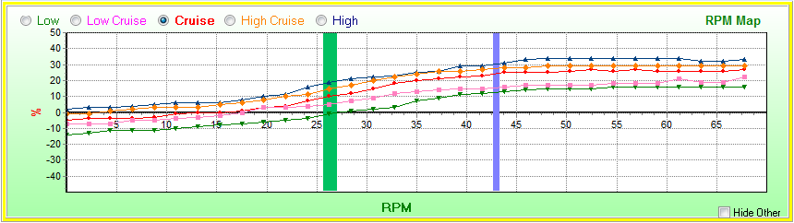
This graph is used to adjust enrichment in different vacuum zones. Note that this graph is only set up so that all the graphs are visible. On the real graph they will fall over each other in most places. The graph is divided in five divisions on the top graph with the four blue arrows. Select the Low, Low Cruise, Cruise, High Cruise or High setting and adjust the fuel enrichment over the rpm range for the specific graph.
Use the Low map for slow town driving and idling deviations. This will be a fuel saver map in urban conditions.
Use the Low Cruise map for light cruise values on the engine. This map is used for setting the fuel for urban roads.
Use the Cruise map for normal deviation in fair load values on the engine. This map is used for setting the fuel for open roads.
Use the High Cruise map for normal deviation in higher load values on the engine. This map is used for setting the fuel for acceleration and uphill roads.
Use the High map for full throttle condition (WOT). This map is to get the maximum power from the engine. It is normally set in the richer side on the Lambda slide bar. The engine should not run lean through the RPM range.
Blue bar is the engines current RPM and the Green bar is where your cursor is and where you can change the values.
Press this button to hide the graphs that is not selected. If Real Time Tracing is on, the graphs will be hidden automatically. This will give a better view of the graph to smooth it out afterwards.

The Blue bar is the Real Time RPM value and the Green bar is your cursor position for adjustment.

See Key Instructions on how to adjust the graph.

6.9.3 Lambda Maps (Alt 3)

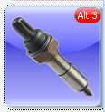

These two graphs will adjust the target voltage for the Lambda control with the total graph % correction of both graphs. This feature requires a 4 Wire Lambda sensor with element. It will not manipulate the fuel if the water temperature is below 30°C or if the startup delay time is not over. It has a low RPM limit and a high Vacuum limit to control in between. Outside these values will stop lambda control.

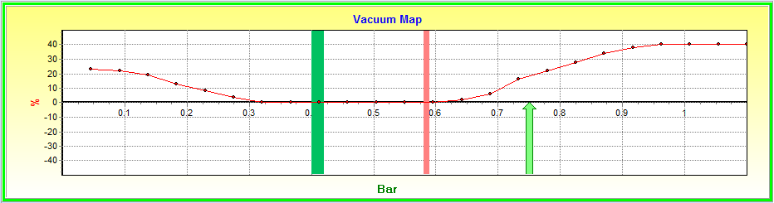
The Pink bar is the Real Time Map value and the Green bar is your cursor position for adjustment.

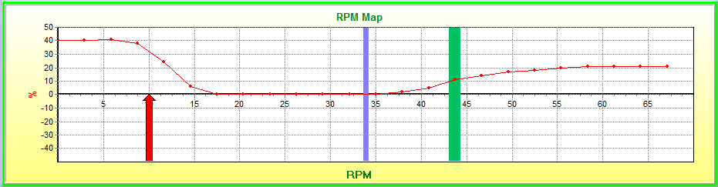
The Blue bar is the Real Time RPM value and the Green bar is your cursor position for adjustment.

See Key Instructions on how to adjust the graph.

6.9.4 Correction Maps (Alt 4)

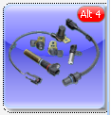

6.9.4.1 Temperature Correction map
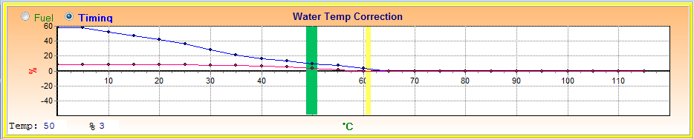
This map is to set the water temperature correction for cold starting. A cold engine requires a richer mixture and slightly more timing. It is also used to adapt the prime pulse and idle target RPM’s for cold starting. Click on and adjust the appropriate graph.

The Yellow bar is the Real Time Water temperature and the Green bar is your cursor position for adjustment.

See Key Instructions on how to adjust the graph.

6.9.4.2 Air Temperature Correction map
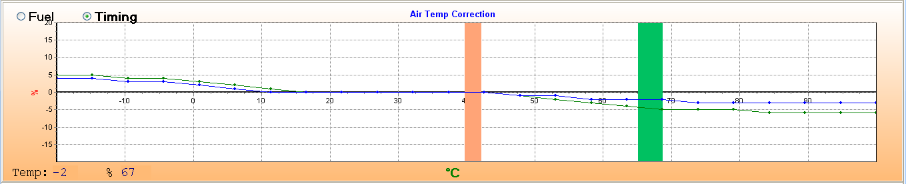
This map is used to set the air temperature compensation for Fuel and Timing. On very hot or cold days when the mix should be leaned out or richen a bit. The timing may also have to retard on hot or cold days. The colder the air temperature is, the richer the mixture must be and the faster the timing. To select between timing and fuel check the select box on top of the graph first to ensure that the correct graph is adjusted. Blue is for timing and Green is for fuel compensation.

The Orange bar is the Real Time Air temperature and the Green bar is your cursor position for adjustment.

See Key Instructions on how to adjust the graph.

6.9.4.3 Voltage Correction map
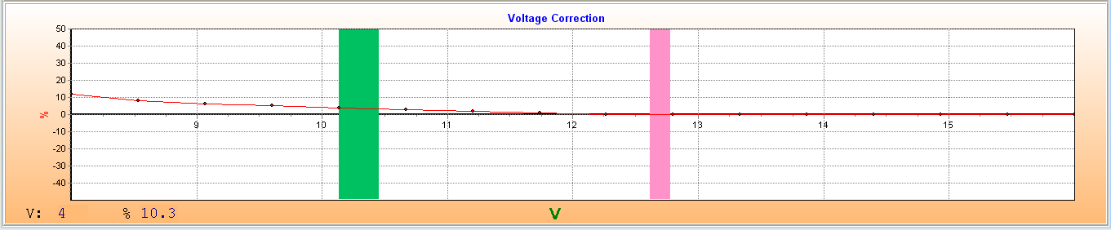
This map is used to set battery voltage compensation. During cranking the injectors react slower to the lower battery voltage resulting in a leaner mixture. Increase the fuel to compensate for the leaner condition.
In most instances it’s not necessary to adjust these values if the wiring is done according to specifications. Note that this value is read from the ECU supply and not the injector supply where the volts are critical.

The Pink bar is the Real Time Battery voltage and the Green bar is your cursor position for adjustment.

See Key Instructions on how to adjust the graph.

6.9.5 Throttle Correction Maps (Alt 5)

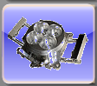

6.9.5.1 TPS Gain map
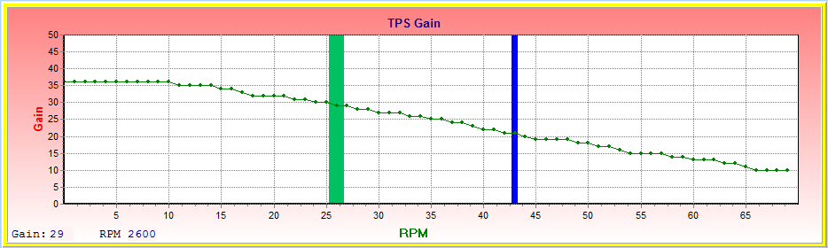
This map is only active in TPS and TPS + Map fuel calculation modes. During these modes, the TPS value is used and manipulated, to represent the map sensor value. The current TPS value is multiplied by the graph value, divided by 10. This example is TPS 45% (bottom Graph) at 4300RPM (top graph), multiplied by 21 (top graph value), divided by 10 will result in a 94% Map signal. This means that a map signal of 94% of full scale will be used on all the graphs.

The Blue bar is the RPM value and the Green bar is your cursor position for adjustment.

See Key Instructions on how to adjust the graph.

6.9.5.2 TPS Compensation map
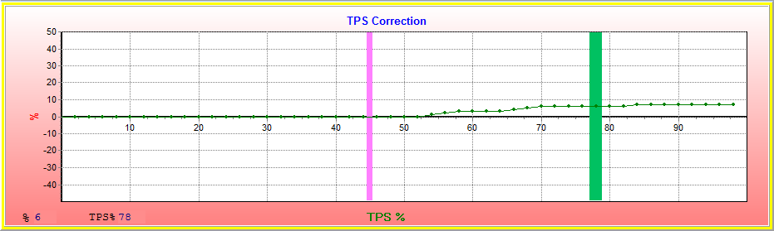
This graph is used where TPS compensation is required.

The Pink bar is the TPS value and the Green bar is your cursor position for adjustment.

See Key Instructions on how to adjust the graph.

6.9.6 Data Logger (F4)

The data logger is a valuable tool in diagnostics to tune your ECU and engine and identify problems easily and quickly. It helps to record data while driving and view them afterwards, then use your time to do adjustments in the maps.

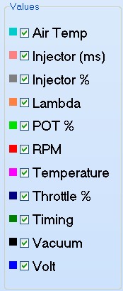
First select the appropriate signal you would like to record by checking the box next to it.

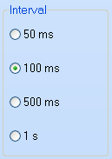
Check the Interval block to decide the resolution of the samples.

For quick real-time logging you can log the data on the map by pressing the  buttons. The data will be recorded and saved in the PC RAM. See the graph below. After logging you can grab the log sheet with the right mouse button and go to different times in the graph to see what happened and do alterations on the graphs.
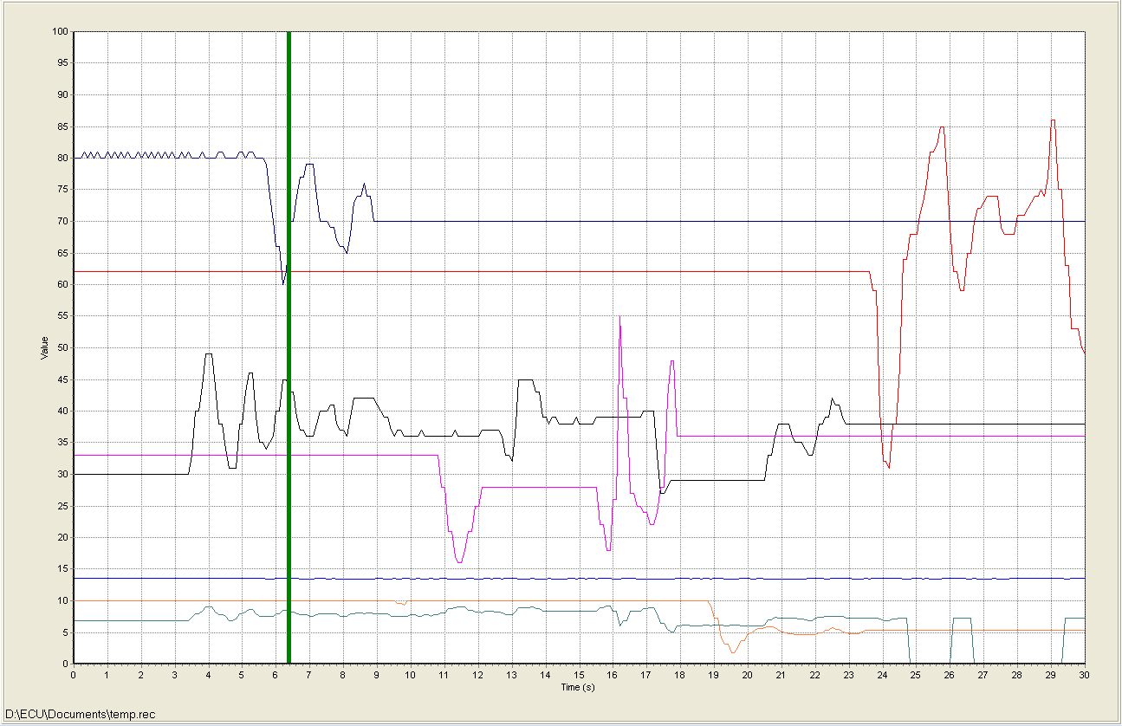

Alternately you can record the data to a file by pressing the  button. Select a filename which the data must be saved in.
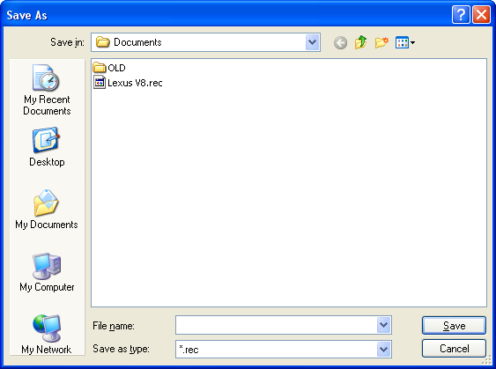

Once a recording file is active or a Log file is opened, this bar will be displayed on all the map pages. You can now replay the data and see how the lambda value was recorded for different conditions on the engine. When a file is played back, the ECU will be. Once you finish your changes you can connect and press 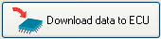 to save the changes in the ECU.
When a recording file is selected, you can press the record button  when ready and record the relevant signals to a Log file. When finished press the stop button. Now you can move forward or backwards  and move the bar 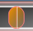 by dragging it with the mouse or arrows and play the data from that position by pressing the play button. The real time data will then be replaced with the data in the recorded Log file. Now you can go to the different maps and see how the signal values changed while you were driving. By looking at the Log data you can do adjustments on the Maps and save it. Then you can do another test run and see if the engine performed correctly on the lambda value.
The Log file can be opened and replayed at a later stage by pressing the  button. This feature will also allow the file to be mailed to the tuner for remote fault finding.
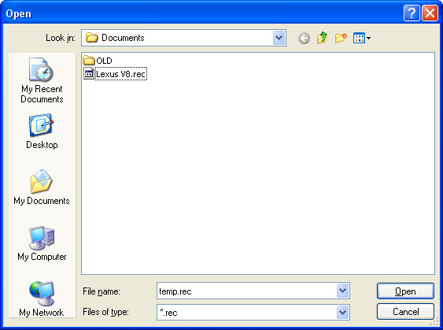
To do adjustments remotely first load in the engine map and then open the file. Play it back and do adjustment. Then save the Map file by pressing save from PC.
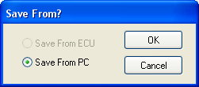

6.9.6.1 Error Codes

The ECU has error codes to help with diagnostic or troubleshooting. If an error is detected by the firmware, it will be displayed on the bottom information bar.

You may then click on the error and it will open the data logger where the error code number is displayed.
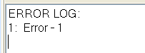
Look in the Error Code File supplied on CD to see what each code means. The error codes are not saved and can only be displayed when a Laptop is connected at this stage. It is the first version of error codes and is mainly for the crank and cam trigger sensor at this stage. It will be developed further and for long term storage.

6.9.7 Manual (F5)
When you use the manual for the first time the program will prompt about the location and filename of the help file. The help file normally comes in PDF format for standalone use and HTML format (ECU User Manual Ver2.2.3.0.mht) to work in the tuning software. Click on Browse and guide the explorer to the .mht file. Click OK and the file will load. This program will store this file location in the ecu.ini file so that the next time you don’t need to repeat the process.
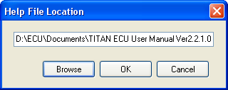
If you want to load n newer version of the manual, delete the old manual file first or delete the ecu.ini file and copy the new one to the hard disk. Close the program and reopen it. Repeat the above process.

7. Other Setup duties and Information

7.1 Jump Starting the Engine
This is always a bad condition to put any electronics through. The reason is that battery voltage is too low for the electronics to work properly and very large current and voltage spikes are induced on the system. It may cause the ECU to erratic behavior and to switch outputs on at the wrong time. It may also “hang” the micro causing outputs to stay on and damage coils or driver outputs.
If you must jump start follow these rules and you should be save from damaging equipment:
- Never jumpstart a car without a healthy battery intact. This will cause erratic voltages over 40 volts which will damage most electronics and light bulbs.
- Make sure that terminals are properly connected and will not come loose.
- First leave the engine off. Connect the cables and leave them on for a couple of minutes to let the good battery charge the flat one.
- Start the master car. End let it idle at 1500 RPM’s for at least 2 minutes. This will give the alternator a change to bring both batteries up to 13.8V and put some charge in the flat battery. If you don’t have thick jumper cables increase this time to 5 minutes.
- Now start the other engine. If it does not crank easily, charge a little longer. If you engine does not start, give ample time between cranking cycles to let the flat battery recover every time.

8. Startup Procedure

8.1 Engine and system preparation.
Before you connect the ECU do the following:
- Install new spark plugs on engines that were stored a long time.
- Service and test the injectors to ensure they all have the same fuel delivery and that the filters on them are clean.
- First ensure that the installation is correct according to the Hardware Installation procedure.
- Test the electrical wiring a multi meter according to the Installation Testing Procedure file provided on the CD.
- Power up the fuel pump by loosening the fuel pump positive from the relay circuit and connecting it to 12V battery positive. Check the fuel pressure is around 3.5Bar and check for fuel leaks. Reconnect to the relay.

8.2 Connecting the ECU for the first time
Now you can proceed with the following steps. If any steps do not correlate with the ECU operation, stop and look for the faults. Ensure that the ECU is earthed!!!
- Remove the coil and injector fuses.
- Ensure that the Jumper Settings are correct inside the ECU.
- Connect only the 12 way connector leaving the 10 way connector open. Switch the Ignition on. Do not start the engine. The yellow LED on the ECU must come on. Also the green LED on the Idle control board must come on if one is installed. If the yellow LED does not come on switch off immediately as there may be a short on the 5Volt output that will damage the ECU.
- Ensure that the pins 1,4,6,7,8 &9 are broken out of the communications connector if you are not using a Spitronics USB Converter cable.
- Now switch the Ignition off and connect the Laptop to the unit. Switch it on again. Start the PC software and connect to the ECU. The engine data like the water temp sensor should be displayed. It should read more or less correctly for the cold engine.
- Go through the setup page and ensure all the settings are correct for the engine. Especially the Trigger Level Output. This setting may damage the ECU or coils if set incorrectly!!!
- Ensure that timing triggers from the distributor or crank are set up correctly. Also the Trigger Levels, leading or trailing.
- Check Rotor Fazing it you have a distributor system. This will make Laptop interference is set incorrectly.
- Calibrate the TPS and Map sensors and save the calibration as described under active sensors.
- If you changed the RPM range or the Map sensor value, save the data to the ECU, close the PC software and start it again. Then the new values for the graphs will be loaded to the correct scaling.
- Make sure the Test function next to the trigger is on.
- You may now crank the engine without the 10 way connector. Check that the Green LED flashes. Also look at the RPM signal on the timing map. It should show 200 to 300 rpm constant. If it shows erratic and run wild, do not try to start. First find the fault. It must be constant.
- Look if any error code is displayed.
- The vacuum should be reading the atmospheric pressure of your region. Check the Altitude chart for the correct pressure in your area.
- Save the data if it has been changed.
- Switch the ignition off and connect the 10 way connector.
- Remove all the fuses. Switch the ignition on. The relays will come on for three seconds the fall out again. If not check the relay wire according to the drawing.
- Switch the ignition off and insert the fuel pump fuse. Start with 5A. If it blows check the wiring and try 7.5A as some pumps draw more power than others. Do not go to larger amp fuses as there may be short somewhere.
- Switch the ignition on, the fuel pump must start for three seconds and switch off.
- Switch the ignition off and insert the coil fuses of 5A. If it blows check the wiring.
- Now crank the engine with a timing light and check if the spark timing is in the 10°BTDC region. If not check the Timing Chapter for the correct setup. Do not attempt to start if the timing is not right or erratic. You may need to loosen the plug wire a bit to make a small gap so that the timing light picks up the pulse of the spark plug. For coils that are bolted onto the plug try using the trigger wire from the ECU. If this does not work, take a separate wire and wound it three times around the inductive pickup of the timing light and then insert this wire between the trigger wire and the coil. This will amplify the signal three times so that it will trigger the timing light. Set the timing light to zero timing as wasted spark systems read double the degrees.
- Switch the ignition off and insert the injector fuses of 5A. If it blows check the wiring.
- Crank the engine. It should start. If the engine backfires or misses stop and do some checks. See the Faultfinding chapter to guide as to what the symptoms may be.
- The vacuum bar should move to the left of the map while cranking at closed throttle. If your setup is correct it should start and idle smoothly.
- Make sure the RPM is constant before revving the engine. If it jumps more than 300 rpm intervals, recheck the trigger polarity. It must be steady.
- Look at the exhaust. If there is black smoke, it is very rich. Try leaning it out on the water temp graph by lowering the dot on the right side of the yellow bar.
- Once the engine idles, calibrate the timing so that the Timing gauge and the timing light is on the same value.
- During the heating up faze, blip the accelerator from time to time. If the engine has a flat spot it may be lean and need some more fuel. Adjust the main jet till the flat spot reduces.
- The green LED in the Idle control should go off once the target RPM is reached. If it flashes then the ECU is trying to control the idling but nothing happens. It means the fault is to the idle motor side. Maybe a wiring fault or sticky motor or valve. It may also be a blocked airway or the throttle opening is too large. Remember for every 19% of enrichment on the water correction graph, the ECU will raise the set RPM’s by 100.
- As the engine heats up, the water sensor value must increase. Adjust the mix on the water graph or by lowering the main jet slider till the engine is at normal temperature.
- The water graph should now be around 85°C with no fuel enrichment. If it is not, you can calibrate the sensor on the setup page. The engine should rev up smoothly. If it has a flat spot it requires more fuel. Increase the main jet slightly till the flat spot is about gone. Also check that the timing is not the result of the flat spot. Check with the timing light that the timing increase as the software indicates.
- Let the engine idle and adjust the idle jet till it idles smoothly. Always try to make the mixture as lean as possible because it is difficult to feel when it is too rich.
- Save the data to the ECU. The car may stutter and die. Restart again and proceed with tuning.

9. Key Instructions

There are a few Hot-keys that make tuning easier. It is not always easy to use the mouse pad in a moving vehicle so we added key functions on the keyboard for easy tuning.

Navigating through the manual may take time so we inserted Hyperlinks to jump to relevant information elsewhere in the manual. Just click on the blue highlighted words. To go back to your last page, press thekeys. Some Hyperlinks may open other documents also supplied on the CD. It is important to copy all these documents in the same libraries otherwise the Navigator may not find them. If you receive new files from the supplier, copy them over the existing files so that you always have the latest information available.


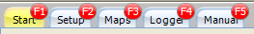
The Function keys are handy to select between different pages. Pressing them will jump between these pages.


Pressing the Alt + Number button will select between sub menus on a specific page. If you hold the Alt button down, you will see the hot key become visable.

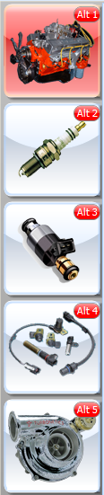


Mouse Button You can click on the mouse button and adjust a graph with the mouse by simply dragging it on the graph. The mouse will also set the active graph by placing the cursor over it. The Yellow line around it will indicate that it is active.

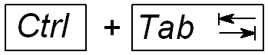
These buttons is used to select between the graphs on a page. The graph that is selected is surrounded by a Yellow line. The graph must be selected for before tuning can be done.

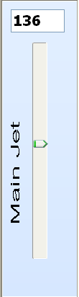
Q=1 up, A=1 down, W=10 Up, S=10 down

Alternatively you can click on the slider button with the mouse and use the Up and Down arrows to adjust one increment or the Page Up and Page Down to adjust 10 increments per keystroke.

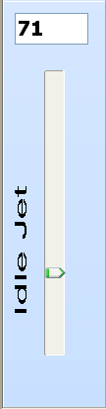
D=1 up, C=1 down, F=10 Up, V=10 down

Alternatively you can click on the slider button with the mouse and use the Up and Down arrows to adjust one increment or the Page Up and Page Down to adjust 10 increments per keystroke.

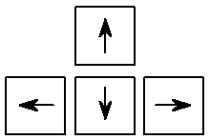
The arrow keys are mostly used during adjustment. Left and Right is to move the bar left or right while Up and Down is used to change the graph dots higher or lower. If Real Time tracking is On the Left and Right button will not affect the adjustment cursor. Adjustment will always be on the Real Time value for that graph.


R= Toggle Realtime Tracking On or Off
When this function is On, any adjustments with the arrows will only take place only where the Real Time bar for that graph is at that instance. This is handy for tuning without having to adjust the curser bar from left to right. Only the active bar on the Fuel RPM Compensation graph will be active if Realtime Tracking is on.


T= Toggle Easy Tune On or Off
When this function is On, any adjustments on the graph will adjust all the dots on the right side of the adjustment bar simultaneously. This will be of a big assistance during initial tuning. It will also allow the Shift + Z function to be active.


H= Toggle the Hide button on or off. If it is on and you click on one of the specific graphs to tune, the rest of the graphs will be hidden from view. This is handy to smooth a graph from spikes after tuning.


This function allows the Tuner to clear all the dots on the right side of the adjustment bar, to the same value as the dot under the Adjustment bar. It can also zero the graph by adjusting the left hand dot to zero and then press the Shift + Z button. Note that Easy Tune must be On for this function to work.

10. Tuning

10.1 Tuning Basics
Tuning is basically getting the two main ingredients of fuel amount and spark timing correct. The instruments used for this is a timing light and the lambda sensor wired into the ECU. The reason why no Dyno is required is because you can tune the ECU with the help provided and the tools available. If you do not have a lambda sensor on the engine you need to put a lambda tuning instrument in the exhaust. You also need a good timing light. Rather mark the degrees on the engine pulley as some timing lights are not very accurate and cannot measure wasted spark coils accurately. However if you are not familiar with the terms and have a Turbo or racing engine, it is recommended to make use of one of our agents who has a Dyno and can tune your engine properly.

10.2 Fuel Settings before Starting the Engine
The ECU has n few sequences how to start the engine. An engine requires an initial prime pulse of fuel to start the moment the engine is cranked, then a richer mixture during cranking. Once it started, it also requires a certain amount of richer mixture than idling to get it going till normal idle settings can take over. For cold starting all these settings must be increased at a certain %. This is done automatically by the ECU by using the water temperature compensation Map. Adjust the following settings before starting and again when the engine is at normal operating temperature.
- 10.2.1 Start Prime Pulse This setting will open the injectors for 20 milliseconds when the engine reaches 100RPM during cranking. This will ensure that the fuel is not cranked through the engine befor ignition spark is started. When the engine starts look at the exhaust. If there is black smoke it is too much petrol. Try decreasing this value till the engine struggles to start. Then increase it slightly. If this pulse is too large, it may flood the engine.
- 10.2.2 Throttle Priming is a function to manually inject fuel into the engine on very cold days. The TPS must be connected for this feature. If you press the throttle more than 25%, the ECU will prime the injectors by half the value set in the Start Prime Pulse block. It will start the fuel pump for 1 second to get the fuel pressure up again. This function may be repeated if more starting fuel is required.
- 10.2.3 Flood Control is a function that clears a flooded engine. It is activated when the accelerator is pressed more than 80% during cranking. The ECU will cut the injectors and no fuel will be injected into the engine. The spark and clean air will eventually dry and ignite the remaining fuel and clear the plugs. When the throttle is released the ECU resumes normal fueling.
- 10.2.4 Cranking Fuel is calculated using the Map sensor signal. As you crank, the Map signal will creep to the left, increasing manifold vacuum, which requires less fuel. If you press the throttle the vacuum will stay right causing the ECU to continue with the large fuel mixture. During the TPS calculation modes, the ECU will use the Start Enrichment value as the Map sensor is not accurate during low RPM’s.
- 10.2.5 Start % If you have idle control, do not press the throttle as the idle control will ensure enough air at starting. This value determines how much air the ECU must add to the starting enrichment. If you don’t have idle control it helps to open the throttle slightly for starting. Do not rev the cold engine as oil pressure is still low. Rather let it heat up gradually. For cold starting you may need to keep the engine running with the throttle as it requires more air.
- 10.2.6 Start Enrichment This setting will enrich the idle fuel by adding 0.5 milliseconds to the injector time. This value will decrease with RPM counts, and should fade in about 8 seconds at idling to zero milliseconds. If you rev the engine after starting, it would be zero in 2 seconds. Try starting with a zero value. Do not press the throttle. If the engine dies after starting, increase this value till it keeps running. During the TPS calculation modes, the ECU will use the Start Enrichment value as cranking fuel.

The engine is designed for a certain torque and power curve. Inadequate mixtures and timing will only reduce performance. Timing is the easiest parameter to get in the right region, as you can use timing marks on the pulley and quality timing light. Also follow the guidelines for the specific type of pickup to get it more or less in the firing zone. If you are not sure try to go for a retarded time position. This will make the least damage and not break the starter.

To start the engine the first time, use the main jet slider. Start with a low value and increase it until the engine start. If it starts adjust the main jet so that it can idle. Always go for the leanest position (bottom) on the slider not to over fuel the engine. Verify the computer timing with the timing light to ensure that your spark setup is correct. Now you can concentrate on the fuel again. Let the engine heat to normal temperatures. First cancel all the compensation fields to zero and use the main jet slider. Use the lambda sensor as an indicator to see if you are more or less correct with the fuel. Now follow the guidelines below.

10.3 Tuning with a Dyno
Make sure all safety precautions are met as specified by the Dyno Safety rules from the manufacturer. Also remember to keep an eye on the water temperature of the engine. If at any time you hear Knock or pinging, back off the throttle immediately and lower the RPM timing in that RPM range about 3 degrees. If at any time the RPM bar becomes erratic, back off the throttle and do faultfinding for interference or faulty trigger signal.

10.3.1 Reset Maps
Ensure that the engine is at working temperature and all the sensors are calibrated. Disable Lambda Control until after the tuning is done.
Setup - Sensors
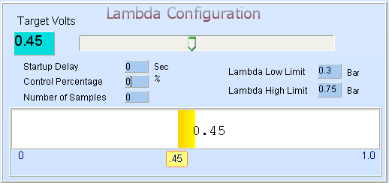

Calibrate the software timing with the timing light to ensure that ECU timing is the same as engine timing.
Maps – Timing – Vacuum Map
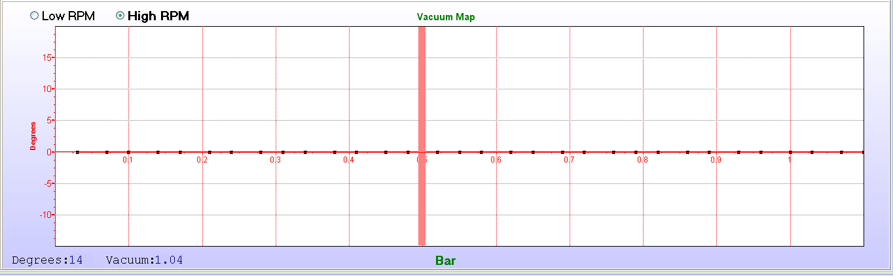
Zero the vacuum timing map as well as water and air correction maps. This will be tuned later.
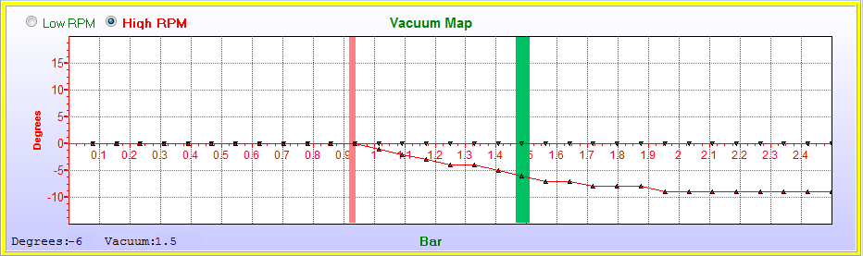
For a Turbo engine set the High RPM timing to subtract 8 to 10° degrees to retard the timing under boost pressure.

Maps – Timing – Timing Map
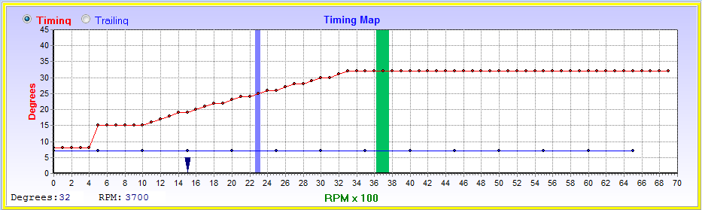
Set a basic RPM timing map to start at 8°BTDC degrees and idle at 15 to 17°BTDC degrees. Increase the timing from 1000RPM to 3500RPM up to 32°BTDC. Keep it flat till maximum timing.
If it is a Rotary engine, ensure that the trailing degrees graph is drawn in and start with 7 °BTDC if you are not sure.

Zero all the vacuum and RPM fuel maps.
Maps – Fueling – Vacuum Map
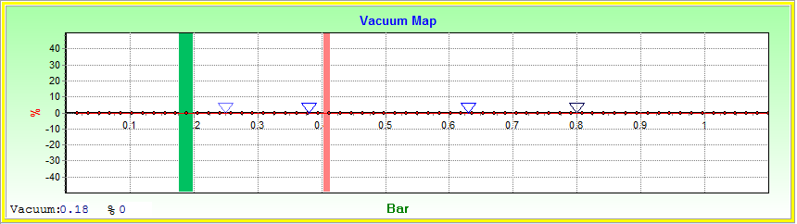
Maps – Fueling – RPM Map
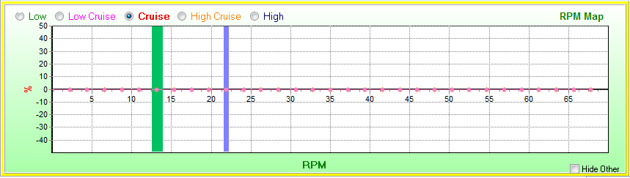
Zero all the TPS correction fuel map.
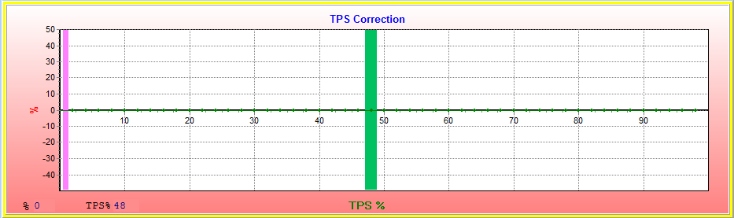

10.3.2 Main Jet Setting
Now start the engine and set the Dyno RPM at the middle of the engine max RPM, around 3200 RPM for a 6500RPM engine.
Take the engine load up to half scale by pressing the accelerator pedal. Around 0.5 Bar for a normal aspirated engine. If you hear detonation or pinging go to the RPM timing map and retard the timing by about 3 degrees.

Set main jet slider till the lambda reaches 0,45Volt which is Stoich or lambda 1. This will ensure that the graphs are evenly spaced over the zero line. Note that for a high performance engine the air-fuel ratio may need to be higher. You can press the Q & A keys for 1 increment or the W & S keys for 10 increments.
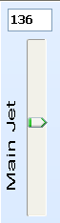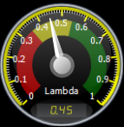
Remember this main jet value so that you always end with this value during tuning. The main jet slider is used during tuning to see if you are close to the right air-fuel mixture. All correction calculations are made around this setting. So adjusting it will alter the whole range afterwards.

Let the engine idle and adjust the idle jet till the engine run at just higher than Stoich or 0.45Volt. If you decrease the idle jet by 3 increments the engine should go lean become erratic. Use the D & C keys for 1 increment or the F & V keys for 10 increments.
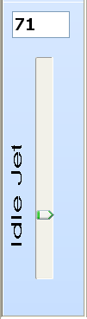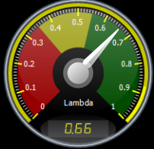

10.3.3 Setting the Fuel Vacuum Map
Put the Dyno on 3200RPM and adjust the vacuum fuel map through the whole load range, by pressing the accelerator pedal to achieve the vacuum value. You should end up with a graph that looks like this. Remember that the air-fuel ratio will vary according to the load on the engine. Light loads have a leaner mixture than high loads. If you hear detonation or pinging during this faze go to the RPM timing map and retard the timing by about 3 degrees.
Maps – Fueling – Vacuum Map
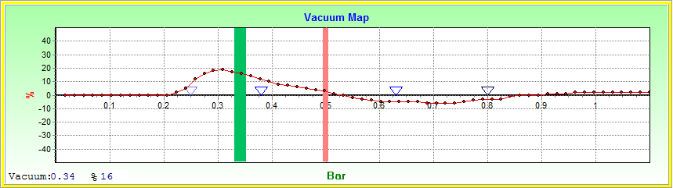

10.3.4 Setting the Fuel RPM High Map
Now press the accelerator pedal in completely. The vacuum should move to the right and stand on a value that will vary according to the height above sea level. At sea level it should be around one bar pressure.
Maps – Fueling – Vacuum Map
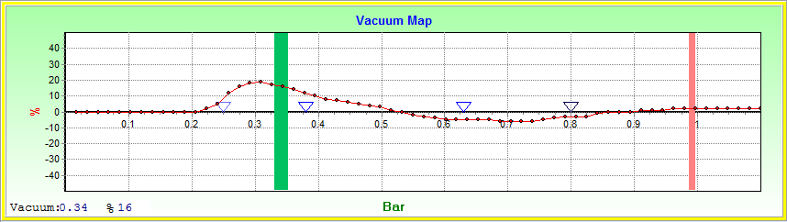

Now by adjusting the Dyno RPM’s plot out the RPM fuel map. Again use the right air-fuel mix required for the different RPM’s. Normally on this map you should be on the rich side. If you hear detonation or pinging go to the RPM timing map and retard the timing by about 3 degrees. You should en with a map like this.
Maps – Fueling – RPM Map
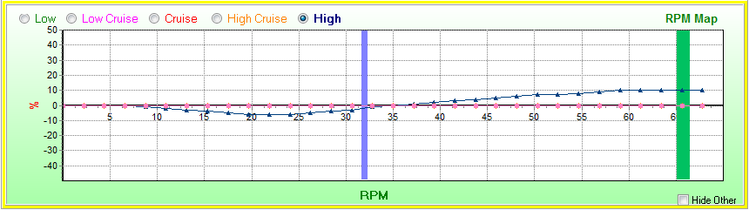

10.3.5 Setting the Timing RPM Map
Now go to the timing map and adjust the WOT timing on the top graph. Press the accelerator in completely. Now that the fueling is more or less correct you will see a variation of timing required for the different RPM’s. Adjust for maximum power but no detonation or pinging. If you hear detonation or pinging you can retard the timing by about 3 degrees around the tuning bar.
Maps – Timing – Timing Map
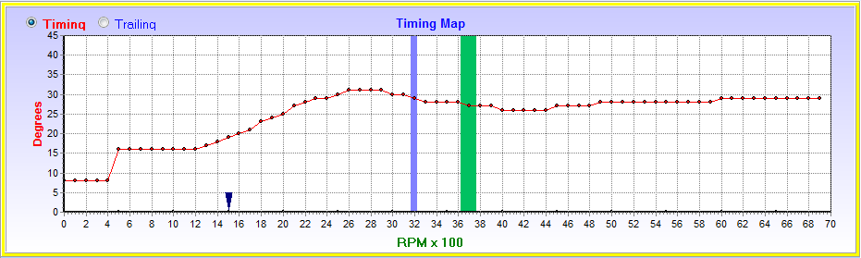

10.3.6 Reset the Fuel RPM High Map
Now that the WOT timing is more accurate, redo the RPM High fuel map. If you hear detonation again, redo the timing map again. The fuel and timing goes hand in hand and as the power reaches optimum, the timing tends to go down. Once you are happy that detonation is intact and optimum power is reached, you can proceed to economy tuning.
Maps – Fueling – RPM Map

10.3.7 Setting the Vacuum Timing High Map
Set the vacuum split between idling and running to determine the field for the two vacuum timing graphs. This is normally at 1500RPM where the engine becomes in a stable running state.
Set a basic High RPM vacuum map of 8°BTDC max as in the picture. Now put the Dyno on 3200RPM again and adjust the load through the whole range. Each time adjust the high vacuum to see where the maximum power is without detonation. Leave the Low RPM for later.
Maps – Timing – Vacuum Map
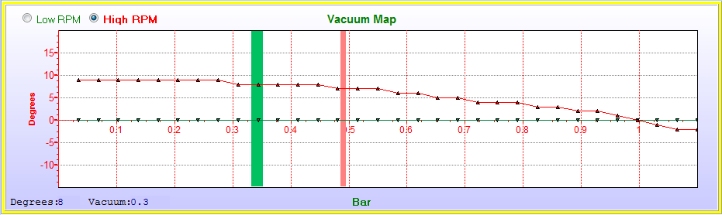
Example for Turbo engine below.
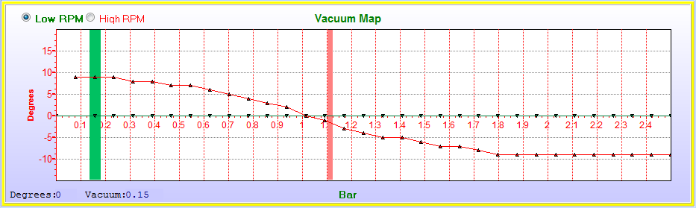

10.3.8 Setting the Fuel RPM Low, Low Cruise, Cruise & High Cruise Map
Go to fuel maps and set the other three rpm correction graphs. First determine RPM graph splits at top vacuum map.
Put real-time function on. At RPM intervals of 500 to 1000 RPM, adjust each map where the load is in the center of the map range or two limits of that map. Remember that the air-fuel ratio increase as the load increase. For the low map use the center of idling vacuum and the limit. As the load increase the graph adjustment will shift automatically so that you only have to adjust the arrows up or down. You should end up with a graph that looks like this.
Maps – Fueling – RPM Map
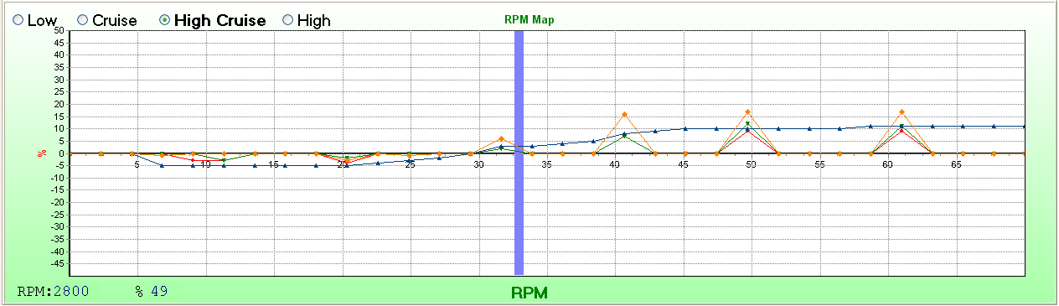
Connect the dots on each map together. Your main fueling for driving is now set up. The following steps concern idling and starting.
By switching on the graph will take shape as you progress and the dots will be connected automatically.

Maps – Fueling – RPM Map
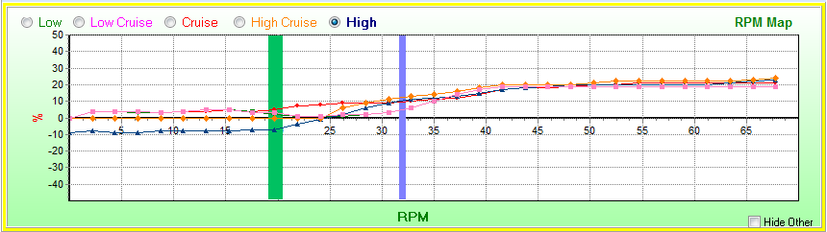

10.3.9 Setting the Idle Jet for Time & Fuel
First adjust the Idle Jet so that the engine has just enough fuel to idle constant. Do not make it too rich. It should be 3 counts higher than the avalanche point where the engine wants to stutter. Set the Low RPM vacuum timing on the graph at zero degrees up to 1 or 2 dots to the right of the idling bar.
Maps – Timing – Vacuum Map
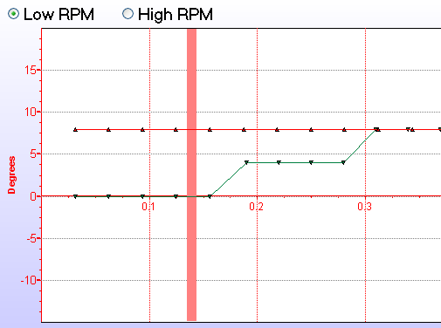
Also make sure that the Fuel Map Vacuum correction is on a flat graph during idling as with timing. If the engine hunts it is most probably a lean mixture at the Idle Jet.
Maps – Fueling – Vacuum Map
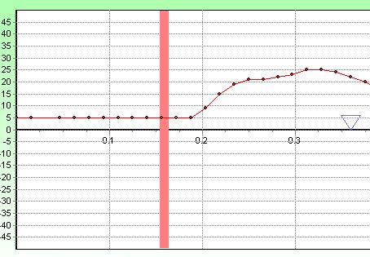

If it is an automatic car put it in drive and do the following two adjustments. Then if it has an air conditioner, switch it on and repeat the steps while in drive. A Manual car only requires one step.
Now see where the vacuum bar stabilize and adjust a step in the graph to add about 4 degrees of timing.
Maps – Timing – Vacuum Map
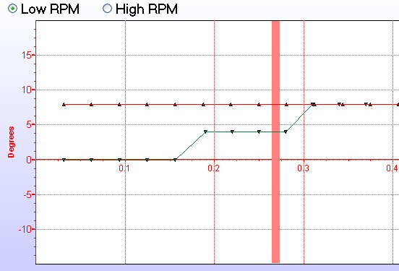
Adjust the dots on the Fuel vacuum graph to achieve a air fuel ratio the same as for no load idling. These setting will let the engine idle stronger when more power is used for automatic transmissions and air conditioners or power steering.
Maps – Fueling – Vacuum Map
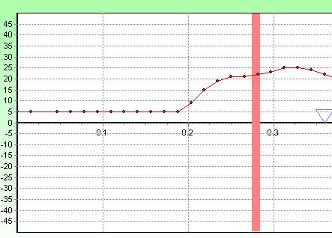

10.3.10 Setting the Vacuum Timing Low Map
Now you can add more timing on the Vacuum Timing map as the green graph. Note that with more load during acceleration the timing is increased to around 10 degrees. This will give more power for a better pull-off. And at WOT we also give a bit more timing op to 1500RPM’s to get the engine going faster. Again too much timing here will cause detonation which must then be decrease by three degrees.
Maps – Timing – Vacuum Map
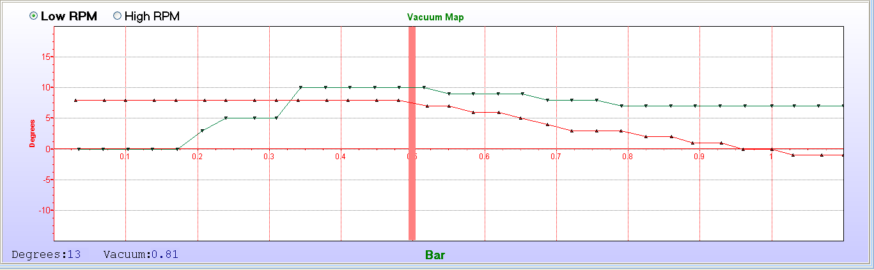
Note that for Turbo cars the green graph is used the same way as above. Make sure the RPM selection for the two graphs is not too high as it may encounter boost pressure there as well. Otherwise drop the graph below zero as well.
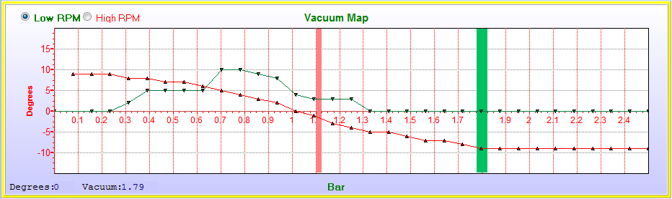

10.3.11 Setting the Air Temperature Correction Map
Not all engines have air temperature sensors mounted on them. Most sensors were incorporated in the MAS meter. However it can be installed and utilized effectively. It is however difficult to tune as you need controlled environment to do so effectively. Cold air is denser and requires more fuel. You may be required to do adjustment tuning in the winter and then in the summer. The air temperature sensor is situated just before the throttle body (if installed). Remember to enable it on the active sensors page. When the engine is used in the winter, you may advance the timing slightly as the fuel burn at a slower rate. It may even require a richer mixture for these conditions. In the hot summer the engine may tend to detonate as a hot mixture burns more rapidly and the air is thinner. Then you may require to retard the timing slightly and lean out the air-fuel ratio. Remember if you tuned in the winter or summer your graph may tend to slope just on one side.
Maps – Sensors – Air Temp Correction Map
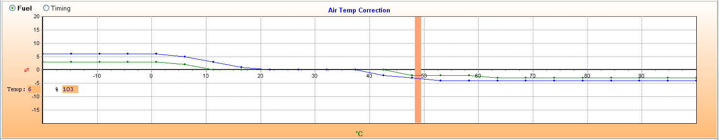

10.3.12 Setting the Voltage Correction Map
Battery voltage has an influence on the opening and closing time of the injectors. This will make a deviation in the fuel quantity especially at high RPM’s. It is a difficult parameter to adjust because the moment the engine runs the battery voltage is held constant by the alternator. During cold starting as well as winter starting, the battery volts will drop considerable. It may be necessary to add fuel to compensate at this voltage for the injectors that open at a slower rate. Then at higher voltages you may reduce the voltage for the same reason. This condition is very difficult to measure with a lambda sensor as starting mixtures are very erratic. You may disconnect the alternator so that the voltage drops to only battery voltage. Then adjust the graph so that fuel mixture is running in the same mix as with the alternator charging. Never disconnect the battery with the alternator running!
Maps – Sensors – Voltage Correction Map
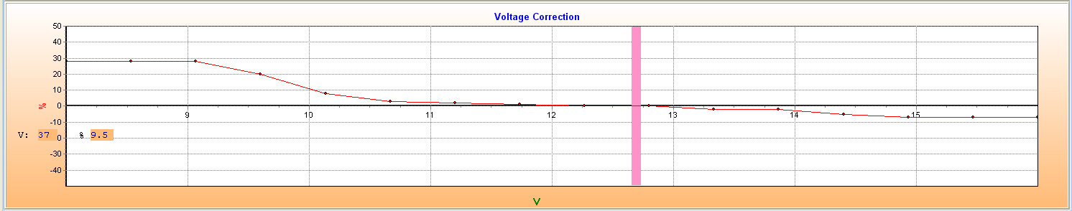

10.3.13 Setting the Water Temperature Correction Map
Water temperature correction can only be done in the morning when the engine is at its coldest. To set this graph, start with the example below. Now start the engine and let it idle. The idle control should increase the idling by two or three hundred RPM’s. Now push the accelerator pedal in quickly to about 50% TPS and release it again. Decrease the graph till the engine gets a flat spot and then increase the graph slightly. Wait till the temperature goes past the next dot and then repeat the action till the whole graph is plotted. A cold engine may like an additional 5 degrees timing. Do listen for detonation and see if it is better with timing or worse. You may also decrease the fuel and timing when the engine overheat.
Maps – Sensors – Water Temp Correction Map
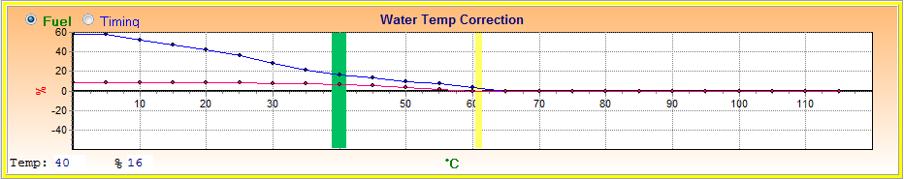

10.3.14 Setting Lambda Loop Control
Once the ECU is tuned properly in open loop mode, you may activate the lambda closed loop control. In this function the ECU will look at the lambda sensor constantly and make corrections for air-fuel ratio whenever the engine is running too rich or too lean. This is a very useful sensor as it will compensate automatically for atmospheric pressure and hot or cold air conditions. Adjusting the graphs will add or subtract the % correction from the lambda target volts. This means that although ideal mix is set at 0.45 Volts, under higher load the target volts can be set at example 0.63 Volt. Ensure that the lambda sensor is a good quality sensor, preferably four-wire, and that it is operating correctly. Remember the loop control will only become active if the engine is above 30°C and the start delay time has elapsed.
- The lambda target volts are set at 0.45 Volt which is an air-fuel ration of 14.7 or lambda 1.
- The start delay time is set at 30 seconds to give the sensor time to heat up and operate correctly. This may differ between sensors.
- The control percentage can be adjusted between 0 and 20%. If the ECU was tune properly you may give it 5% control. If the sensor fails it may change the air-fuel ratio to dangerous levels so check it regularly and go for the least amount of control.
- The number of sample per revolution is used to smooth out fluctuation in control. Too little will have the ECU control at erratic ratios.
- The Lambda low and high limits is to stop loop control outside these perimeters. For high power engines and high compression pistons or Turbo engines, it is best to disable the control at higher loads. This is to protect the engine should the sensor fail. Also at idling you may require the engine to fuel at fixed settings. Especially if TPS idling is used.

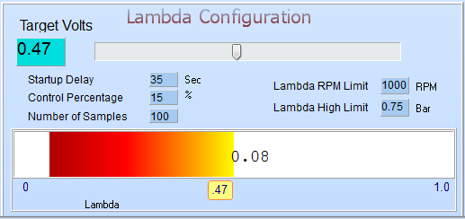

Start with the middle RPM’s at 3200 and then adjust the top Vacuum graph at different loads with the throttle. Keep in mind what the air-fuel ratio should be for the different loads. Adjust the graph till you achieve the correct mixture.
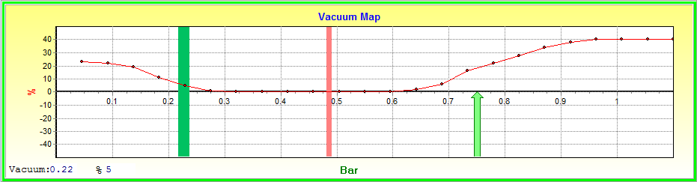

Now keep the load in the middle of the graph and adjust the bottom RPM map at different RPM’s to achieve the correct mixture.
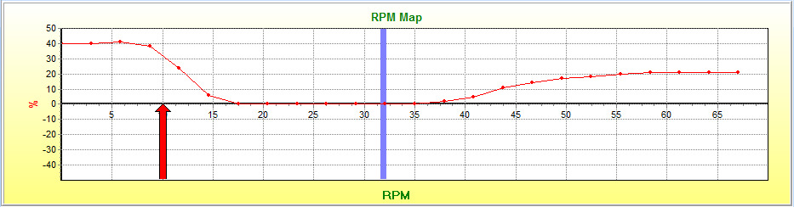

The ECU will now control on different air-fuel ratio’s to let the engine run from rich to lean.
Rich
Stoich
Lean

10.3.14 Idle Tuning for an engine with a hot or long duration Cam

When a cam has valve overlap, the manifold vacuum at idling is very erratic or none existing due to exhaust gasses that backflow into the cylinder and sometimes also into the intake manifold. Then the ECU cannot use the MAP signal effectively because it is no longer a representation of how much air is going into the cylinders. To correct for this, there are two ways to tune the ECU to compensate for these out of balance situations.

Option 1, RPM Compensation
In the example the engine loses vacuum at 1500 RPM and lower. Then the vacuum bar on the top graph moves to the right. This means that the Low cruise and cruise map below is active. Now lower the graph below 1500 RPM to compensate for the over fuel condition. This option works well with mild cams. It is used for fuel calculation Map only.
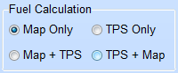
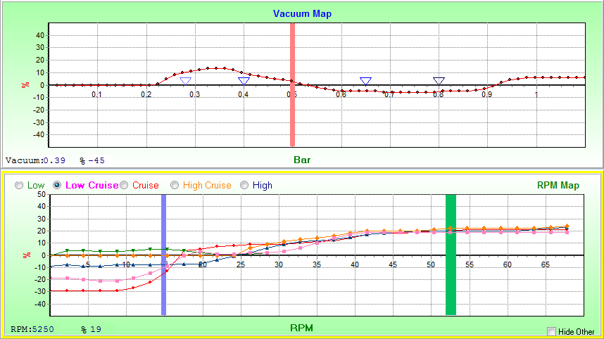

Option 2, TPS Blending
In this option we use the TPS signal for the fuelling signal at low RPM’s and the MAP signal for high RPM’s. First determine at which RPM’s the engine loose the vacuum signal. Put the engine in neutral and increase the RPM’s till it has a good vacuum signal. Now reduce the RPM’s while looking at the orange bar on the Fuel Vacuum graph. The bar should move to the left until vacuum becomes a problem. It will then move to the right again. If it happens let’s say at 1600 RPM adjust the following settings on the Setup Fuel setting.
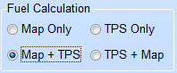
Put the Fuel Calculation on Map + TPS.

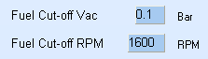
Put the critical RPM value in the Fuel Cut-off RPM block. Put the Fuel Cut-off Vac on 0.1 Bar. Start with the TPS Gain at 100. Now if the RPM signal falls below 1600 RPM, the TPS signal will be diverted as a MAP signal on the vacuum graph. When the TPS is at 0% it will stand on the 0.1 Bar position and move from there. If the RPM go higher than 1600 RPM, the map signal will be used for fuelling again.

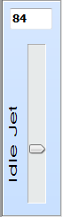
Now adjust the Idle Jet when the TPS is released so that the Idle fuel is correct. Now press the throttle at different opening speed with your foot. The vacuum bar will move from the 0.1Bar position to the right side of the graph. The speed of movement is adjusted by the TPS Gain value. If the bar moves to slow you will have a flat spot under acceleration. Increase the Gain value till a smooth acceleration is achieved. Start with a low value to ensure that the mixture is not too rich.

10.3.15 Tuning for racing engines with a hot or long duration Cam

This tuning is used for engines with wild cams, throttle bodies, high compression, alternate racing fuels or high boost turbo engines. Mostly racing applications where standard map sensors or mass flow meters fail to represent an accurate means of calculate air-fuel mixture. It is also used where fuel consumption is not critical but performance needs to be at maximum.

Explanation of TPS gain graph
Instead of using a matrix map, Spitronics has developed firmware that would simulate a map sensor signal using TPS and RPM signal. The ECU will then calculate what the Map signal would be. The TPS signal is modified and used as a Map signal. To understand this operation lets use an example. If you press the throttle 20% open and the engine is at idling, there is not much airflow through the throttle body. This will result in a high manifold pressure (close to atmospheric pressure). As the RPM’s increase, more air is drawn through the throttle resulting in a lower manifold pressure. The TPS is still 20%. A lower manifold pressure requires less fuel.
What the TPS gain map is doing is to manipulate the gain of the TPS signal to the Map signal. If the gain is zero, it means that 20% TPS signal equals 20% Map signal. If the gain is 100, it means that 20% TPS signal equals 40% Map signal. If the gain is 200, it means that 20% TPS signal equals 60% Map signal.
So you can see that at low RPM’s n slight throttle movement will result in a large Map signal movement. And as the RPM’s increase the same throttle response will result in less Map signal movement. See the following pictures of the graph.

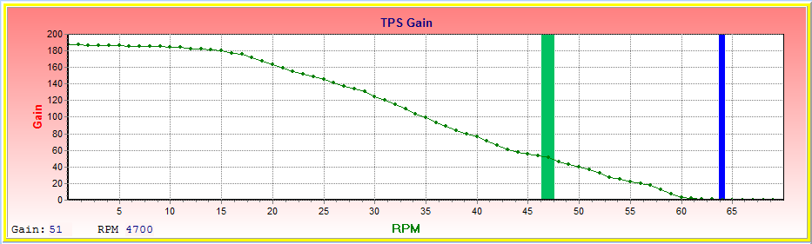
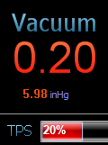

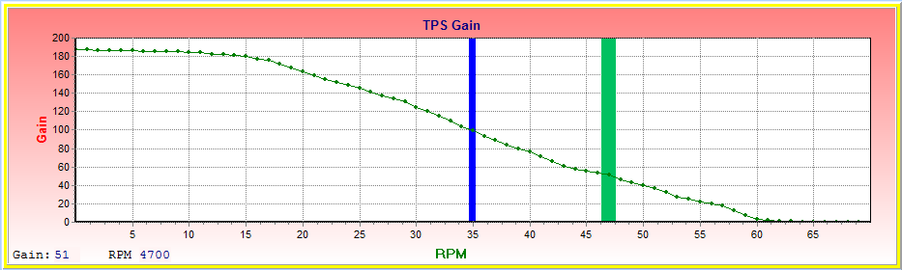
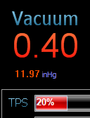
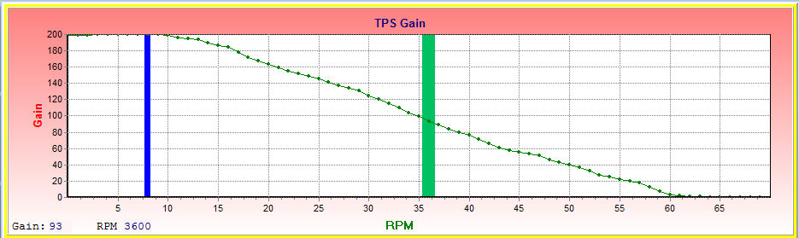
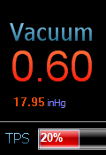

Option 1, Tuning with TPS Only
Here there is absolutely no map sensor which has an accurate reading like with multiple throttle bodies. It is used only for normal aspirated engines. It may not provide the best fuel economy so do not use it for normal engines. Note also that idle control will not function properly in this mode.

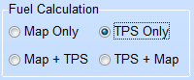
Set Fuel Calculation on TPS Only.

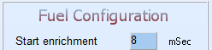
Set the start enrichment to a value which is required for starting during engine cranking. The reason is that there is no map sensor to measure the required cranking fuel. Start with a small number and increase till the engine starts easy. The moment the engine start it will use the map values.

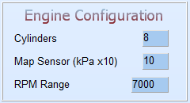
Set Map Sensor on 10. Save 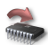the data to the ECU. Close and open the software to except the new scales. Calibrate the TPS and make sure it operates properly as this is now the most important sensor to the ECU.

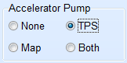
Set the accelerator pump to TPS.

First zero all the graphs and set the timing as for normal tuning on a Dyno until 10.2.3 main jet tuning.

Now start with a basic graph like below. On full RPM’s the gain should be zero. This means that 100% TPS will result in 100% Map signal. Take the engine up to full RPMs and 50% TPS value. Ensure the lambda does not go lean. Use W and S keys to step the Main jet 10 increments at a time till you reach 50% TPS value. Now adjust the Main Jet in 1 increments to ensure the engine runs at the right air-fuel mixture.

Now keeping the Dyno at max RPM, start at the light throttle and plot the vacuum Map right through to full throttle. This map will represent how manifold pressure correlates with throttle position. In other words it is an indication of airflow through the throttle versus the butterfly position. Or simply the flow profile of the throttle.

Now reduce the Dyno speed and plot the rest of the gain map. Use 50% TPS or throttle opening. Adjust the gain till the air-fuel ratio is correct for that power. Once this graph is set the engine should perform very close to best performance. Now commence with fine tuning as from chapter 10.3.4 Timing Map.

Option 2, Tuning with TPS Only
This mode is used for racing engines that has manifold pressure at high RPM’s or positive air induction like turbo’s and superchargers. It may not provide the best fuel economy so do not use it for normal engines. Note also that idle control will not function properly in this mode.
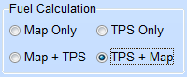
Set Fuel Calculation on TPS + Map.

Set the start enrichment to a value which is required for starting during engine cranking. The reason is that there is no map sensor to measure the required cranking fuel. Start with a small number and increase till the engine starts easy. The moment the engine start it will use the map values.

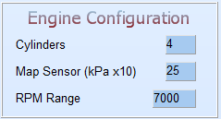
Set the Map Sensor as for normal Map Only systems. Even if it is a normal aspirated engine. Save the data to the ECU. Close and open the software to except the new scales. Calibrate the TPS and make sure it operates properly as this is now a very important sensor to the ECU.

Set the accelerator pump to TPS. Although there is a map sensor it becomes erratic during TPS sensor domination.


Set the Idle Cut-off TPS value. If the throttle is pressed above this TPS value, the calculation is forced to only the Map sensor.
Always try for the lowest value where the Turbo will create boost into the manifold. If it is chosen too high, the engine may run lean before the RPM Cut-off catches it.

Set the Fuel Cut-off RPM value. This value is chose at the RPM where the vacuum signal becomes trustworthy. With other words this will be the limit where the engine loose vacuum at lower RPM due to overlap cams.

Tuning this configuration is a mix between Map only tuning above the Cut-off RPM and then TPS only tuning below the Cut-off RPM. First do the Map tuning as discussed in chapter 10.3.3. Then Proceed with the TPS gain tuning in chapter 10.3.15. Note that this map only needs to be tuned up to Fuel Cut-off RPM value. This map is only used to get an out of control engine to a steady RPM where the signal becomes accurate.

10.4 Tuning without a Dyno
Spitronics startup maps are not far from the real maps required by the ECU. Note however that fuel pressure and injector size play an important role in where the main jet and idle jet must be set. This you may require to set according to your lambda sensor. If you don’t have a lambda sensor and timing light, you need to take your vehicle to one of our agents for setting it up properly. Flat spots or black smoke is an indication that adjustment is required.

10.4.1 Preparation
Ensure that the engine is at working temperature and all the sensors are calibrated. Disable Lambda Control until after the tuning is done.

10.4.2 Timing Calibration Setting
Start the engine and let it idle. Calibrate the software timing with the timing light to ensure that ECU timing is the same as engine timing. See Timing Setup earlier in the manual. Do not adjust the timing maps for this.
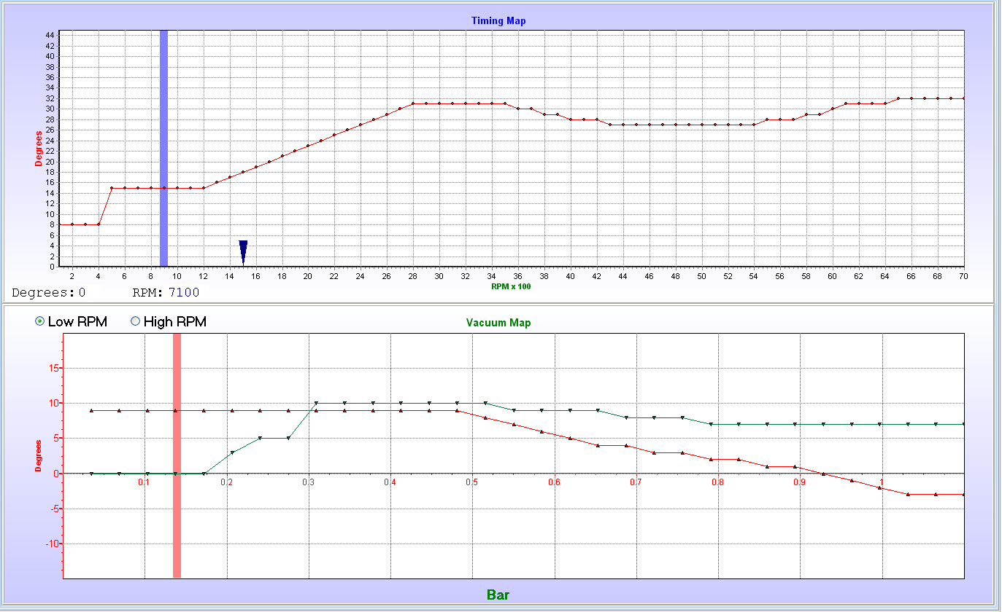

10.4.3 Main Jet Setting
Now you need to get a setting for the main jet to get a baseline fuel setting under normal load conditions. Firstly set the main jet to a value where you can drive with the vehicle. Go on the open road and cruise at around 120 km/h. Try to get a flat road where you can have a constant supply of fuel to the engine. Also aim to have the Map sensor value in the middle of the graph on the vacuum map. If the engine works hard like for an elevated 4x4, you may not reach 120km/h under half load.
Maps – Fueling – Vacuum Map
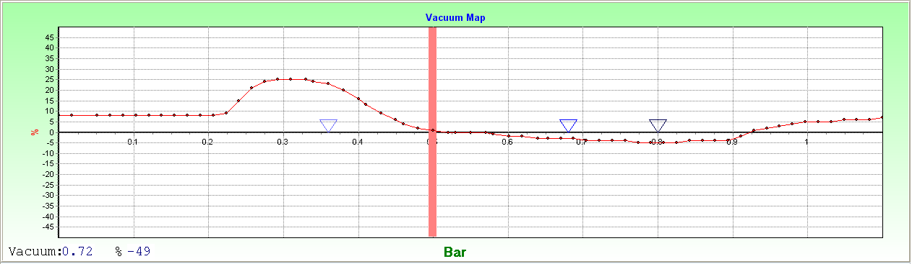
Maps – Fueling – RPM Map
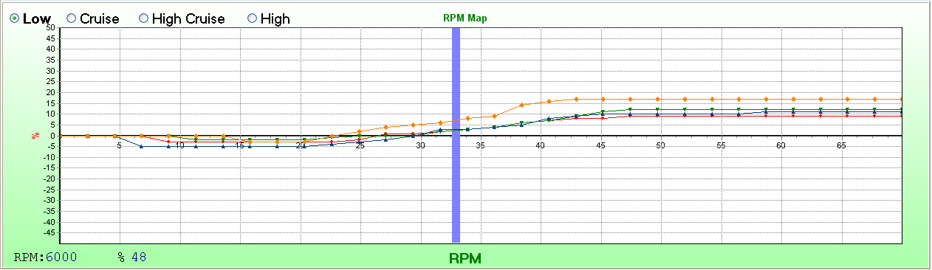
Set main jet slider till the lambda reaches 0,45Volt which is Stoich or lambda 1. This will ensure that the graphs are evenly spaced over the zero line. You can press the Q & A keys for 1 increment or the W & S keys for 10 increments.
Now stop and punt the gearbox in neutral. Let the engine idle and adjust the idle jet till the engine run at just higher than Stoich or 0.45Volt. If you decrease the idle jet by 3 increments the engine should go lean and start to labor. Use the D & C keys for 1 increment or the F & V keys for 10 increments.

10.4.4 Other Adjustments
Now do the idle adjustment. The ECU comes with the Lambda maps disabled and they are quite useful for tuning the ECU with real-time feedback.

10.5 Accelerator Pump Setting
Because fuel mixture is calculated, the ECU will automatically cater for fueling required during acceleration. The ECU uses an external MAP sensor which is situated close to the engine. The vacuum signal is therefore direct and fast. Vacuum is calculated before every injection cycle. Any changes in vacuum are immediately catered for in the next injector pulse. If you go to the vacuum map and press the throttle quickly, you should not be able to see the bar move to the right. If it is sluggish you will have a flat spot. This is normally the result of too long or too thin vacuum line or too small port at the manifold. Setting these values too large will only waste fuel and gain nothing. So the norm is to tune from lean to rich till the flat spot is gone.
- Select TPS or MAP. Setting both comes later with more experience.
- Set the Max RPM. Normally 1500 to 2000 RPM’s.
- Select a percentage enrichment starting with 10% increments. Normally 40 to 50%.
- Select sensitivity by starting with 10 (least sensitive) and work towards 1 (most sensitive). Normally 2 to 4.
- Kick the accelerator pedal in and release. Listen and feel for the flat spot. Sometimes it sounds like a flat spot but it is actually the noise of the vacuum being eliminated at the throttle. Rather look at the RPM’s and feel for a jerk pulling off.
- Increase the sensitivity towards 1 and repeat point 5 till you are satisfied. You may also increase the enrichment till the desired results are achieved.
- Always look at the exhaust for black smoke indicating too much fuel. You can also use the air/fuel (lambda) gauge to indicate correctness.

10.6 Fuel Cut-Off Setting
Here is something the carburetors did not have. On the ECU you can cut the fuel supply to the engine completely when decelerating or with downhill driving. This makes for a bit of fuel saving especially in urban driving. This is done with 2 settings. Both conditions have to be met to activate the fuel cut feature.
- The vacuum signal must be lower than this value to activate the feature. Use a value just smaller than neutral idle vacuum at working temperature.
- The RPM’s must be higher than this value. Start with a value around 500 RPM higher than idling RPM.
- There is a dead band implemented in the calculations to prevent hunting. Try to find the best setting which brings the fuel back the moment that the engine goes from negative to positive force on the drive train. This will prevent jerking when the engine comes to life.

10.7 Cold Start Setting
First finish the normal tuning of the engine. The main jet setting will affect this setting as well. For cold starting and running the engine requires a richer fuel mixture and extra air flow. On certain engines it may require as much as 50% enrichment on a cold day. Otherwise it will not have enough power to run.
- Let the engine cool down overnight. Go to the correction maps. The bar for water temperature should indicate the outside temperature. If it is out of calibration it is not critical. Normally it is calibrated to be accurate around working temperature. As long as the sensor follows a constant graph you can still effectively set up cold starting.
- Start the engine and decrease the dot on the right hand side of the temperature bar. If you hear the engine loose RPM or the vacuum signal increase (move to the right), raise the dot with 3%. Wait till the temperature increase and pass over to the following dot. Do the same here. Keep on till the engine is on normal operating temperature. At around 60°C the correction map should be zero if the calibration is correct.
- A test to see if the mix is correct, is by pressing the accelerator pedal in not too fast, to see if the engine has a flat spot. If so increase the dot slightly.
- Remember you may see black smoke but it is normal for a cold engine as it requires a lot of fuel to run.
- If the engine has idle control, the ECU will raise the idle set point with 100RPM’s for every 19% of fuel enrichment. This means that you don’t have to add extra air to raise cold RPM’s.
- If the engine does not have idle control, you can open a solenoid air valve to the intake by using one of the GP outputs. This way the engine will idle a bit faster till it reaches a certain temperature and switch the valve off.
- The ECU will also lengthen the prime pulse during starting by the same % that the bar is set at.

11. Fault Finding

11.1 Faults and Remedies

11.1.1 The ECU yellow LED does not come on
- The ignition wire does not have 12Volt
- There is a short on the 5 Volt output from the ECU. The magnetic crank or distributor sensor, TPS and MAP sensor use 5 volt. Check the wiring.

11.1.2 The Software does not connect to the ECU with the USB to RS232 Converter
- Pin 1,4,6,7,8 & 9 must be broken out to operate. See RS232 Computer to ECU interface
- The Baud rate must be set to 19200 in the Device Manager.
- No Driver for this Device installed – The USB converter must have a driver CD which has to be installed first.
- Too high Comp Port allocation for the driver. See Changing the USB Comport in Windows Device Manager
- Faulty USB converter.

11.1.3 The engine does not start for the first time
- Go through the Startup Procedure to ensure ECU operation is correct.
- If you crank the engine and it does not want to start, disconnect the high tension leads at the plugs one by one and see if there is spark on the plugs. If not:
  - Check if the green LED on the ECU flash while cranking. If not check the crank or distributor signals. Gaps of magnetic pickups may be too large.
  - Check if sensor polarity is correct.
  - Check if the fuel and Coil relays pull in at ignition on. If not check that the numbers on the relays are correctly wired.
  - Test if the coils have positive supply +12 Volt when cranking the engine.
  - Test the coil resistance from the 10 way connecter to see if open circuit.
  - Test the coil to see if faulty.
  - If distributor type check the spark at the coil HT pole.
- If there is spark, take out one of the spark plugs. If it is dry it means there is no fuel. Check for:
  - Ensure the fuel pump is running during cranking.
  - Test the fuel pressure by loosening a bolt on the fuel rail somewhere. Hold a rag over the joint to prevent spillage. Keep a fire extinguisher close by.
  - Check TPS calibration to ensure flood control is not activated.
  - Ensure that the injectors was checked and serviced if the engine stood for a long time.
  - Put your fingers on the injectors and feel if they pulse during cranking.
  - If not, check the software injector time bar for milliseconds signal. It should be more than about 5 milli-seconds during cranking.
  - If it shows zero milliseconds, check the map calibration, TPS calibration, fuel cut off function settings.
- If the plugs are wet it means there is fuel. Check the following:
  - It may be that the start fueling was too much and the plugs were flooded. Dry them and try again. You can also push the throttle in completely and crank the engine till it tries to start or the plugs become dry.
  - It may be that ignition timing is setup incorrectly. Then firing occurs at the wrong time and failing to ignite the fuel mix. Check again the timing setup for the specific engine.
  - The plugs may be old or dead. Replace.
- If the engine tends to stop cranking suddenly, check the following:
  - It may be that the timing is too fast. Reduce timing by 10 degrees. Add more teeth if a crank gear are used.
  - If there is a magnetic crank or distributor sensor, check that positive and negative wires are not switched around.
  - If more than one coil is used, check for incorrect wiring or firing order.

11.1.4 Engine Backfires during Cranking
- The engine backfires through the intake.
  - Faulty ignition timing or firing order. Check again the timing setup for the specific engine.
  - If there is a magnetic crank or distributor sensor, check that positive and negative wires are not switched around.
  - If more than one coil is used, check for incorrect wiring or firing order.
  - Check if the RPM bar jumps erratic in the PC software. If it does, the gap of the magnetic sensors may be too large or the signal is too weak.
- The engine backfires through the exhaust.
- Too lean fuel mixture. Increase by 10 on a time on the main jet.
- Water temperature sensor or compensation map incorrect.
- Some of the plugs may be old or dead. Replace.

11.1.5 Engine start but it stalls directly afterwards
- Check the map sensor in the fuel map field is operating. The red bar should be on the right hand of the Graph. If it is on the left side, it may need calibrating or it may be faulty or a wire fault.
- The fuel mixture may be too lean. Try to enrich using the main jet slider.
- The temperature sensor may be faulty causing the cold engine to give a warm signal to the ECU. Thus leaning the mixture out.
- Incorrect Fuel Cutoff settings. A symptom will be that the milliseconds bar on the real time block will jump to 0.
- Incorrect Engine Limiter settings

11.1.6 Engine start but is very rich
- Check the map sensor in the fuel map field is operating. The red bar should move to the left of the screen. If it is standing on the right it is faulty or wiring fault.
- The main jet or idle jet slider is too high. Try lowering them to the values it came with. Main 138 and Idle 70.
- Check if the water temp sensor is working. If not it will keep on enriching the mix as if for a cold engine.
- Some of the plugs may be dead, and then the engine looses manifold vacuum resulting in enriching the other pistons.
- Fuel maps set to too high values. Lower the values.
- Fuel pressure regulator regulates too high. Measure the pressure. It should be between 2.5 and 3.5 bar.

11.1.7 RPM signal very erratic.
- Incorrect magnetic trigger polarity.
- Interference on pickup. See also Precautions.

11.1.8 Engine start but do not rev up
- Check the map sensor in the fuel map field is operating and calibrated. The red bar should move to the right if the throttle is pressed.
- Too lean mixture. Try increasing the main jet value.
- Incorrect rotor fazing or timing. Check with a timing light.
- Incorrect magnetic trigger polarity.
- Check the micro fueling and boost limiter blocks and see if the settings there are correct. A symptom will be that the milliseconds bar on the real time block will jump to 0.

11.1.9 Idle Control does not work
- Check first if it is wires correctly as indicated on the drawing. If it is an idle valve, make sure the diode is intact. If it is a stepper controller, make sure the sequence is wired correctly. It may close instead of opening.
- Faulty TPS setting. Make sure the TPS is calibrated correctly. It must go from 0 to 100% over the full range.
- Check the idle control settings according to the explanation.
- Make sure that the throttle idle position is set correctly. The idle valve can only close as much as this setting.
- Check if the idle valve or stepper motor is not stuck. The idle valve can be pulsed with 12Volt to see if it opens and the stepper normally vibrates when the ignition is switched on. It may still be stuck even if it vibrates. So take the stepper off and see if it opens.
- If the green LED on the stepper idle controller is on during idle, it means that the idle computer does not receive the RPM pulse from the ECU. Recheck the wiring. The green wire must be connected to GP out 2 except for the Lexus computer where it is connected to the RPM output.
- If the green LED on the idle controller flash it means that the idle computer tries to adjust the RPM but nothing happens. The idle motor itself is sticky or wired incorrectly. Open it up and clean and lubricate. With the long shipment on ships it corrodes on the inside. The wiring to the idle motor may be incorrect. The airway of the idle motor is blocked.
- The USB converter or RS232 serial cable may interfere with the RPM output signal. Break out pin 1,4,6,7,8 & 9. See ECU interface.

11.1.10 Auto Gearbox does not shift
- Check to ensure correct wiring connection to the ECU.
- The USB converter may interfere with the RPM output signal. Break out pin 1,4,6,7,8 & 9. See ECU interface.

11.1.11 Spark plugs does not last
- Too rich fuel mixture.
- Wrong temperature plugs – use non resistor plugs.

11.1.12 Flat Spot when accelerating
- Other vacuum line tied into the Map sensor line.
- Restricted vacuum line.
- Too long vacuum line.
- Too small port for Map sensor on intake manifold.
- Incorrect setting of fuel maps or main jet.

11.1.13 Engine does not want to rev up
- The Fuel Cut-Off settings are wrong.
- The magnetic crank or distributor sensor’s negative and positive wires are changed around. The gap may be too large.
- Rev limiter is set too low
- Incorrect setting of fuel maps.
- Fuel pressure or flow rate to low. Dirty fuel filter.
- Faulty fuel pump.

11.1.14 Engine lack power, idle erratic, or runs lean
- The fuel pressure is erratic. This may be due to the pump sucking air on the in feed which causes cavitations and loss of pressure. This happens more frequent when the engine is hot.
- Injector positive is wired incorrectly. It does not have its own supply direct from the battery via relay 1.
- Incorrect setting of fuel maps.
- Fuel pressure or flow rate to low. Dirty fuel filter.
- Faulty fuel pump.

11.1.15 ECU cuts during driving – Interference
Interference or feedback is caused by the following reasons:
- Earth wires incorrect. Tie the black wires of the harness to the ECU enclosure. Tie a 2.5mm or thicker wire from the ECU enclosure to the body as an earth strap if it is not screwed directly onto the body.
- Screened cables of the sensors must be connected close to the sensors to ensure maximum screening.
- No screen wire must be connected to the engine. Only to the TPS, Map sensor Temperature sensors and lambda sensor if specified by the drawing. Don’t connect it with the engine ground.
- Faulty High Tension sparkplug wires.
- Incorrect spark plugs – use non resistor spark plugs.
- HT lead run too close to sensitive input wires.
- The Ignition Positive wire is used for high current devices that generate voltage spikes. Connect all coils. Injectors and idle controls etc via relay circuits from the fuse box supplied.
- Poor voltage supply to the ECU.
- Large relays do not have decoupling diodes and induce spikes on the ignition wire. Install free running diode supplied according to drawings.
- Incorrect alternator wiring. The main charge wire (thick positive) should be connected at the battery positive terminal rather than the vehicle harness. The battery acts as the smoothing capacitor.
- Battery earth straps are not adequate. Earth straps should go from the battery negative to the body and also from the battery negative to the engine.
- Incorrect rotor fazing. The spark has to jump a gap in the distributor inducing spikes on the pickup device.

12. Specifications

These specifications are for the advance ECU combinations. This means that not all may be applicable to the standard and intermediate ECU. See the Introduction different models for variation.

12.1.1 Inputs
2x Magnetic inputs or 2x Hall or Optic inputs or combination of the 2 Groups
1x Map sensor input 0 – 5V
1x Water Temperature Input – 2K NTC Resistance Sensor
1x Air Temperature Input – 10K NTC Resistance Sensor
1x Lambda Input 0 – 1 V
1x General Input – Selectable for Pot Input, Launch Button or Battery Voltage Correction
Software RS232 Connection
Programmer Connection

12.1.2 Outputs
6x 7A current Outputs to Ground (coil + injector drivers)
1x Fuel Relay Output 2A to Ground
1x RPM Output 2A to Ground
2x General Purpose Outputs 2A to Ground
5V Output for TPS & Map Sensor and Magnetic Pickups

12.1.3 Crank & Cam Angle Sensors
The ECU can sense any crank or cam sensors. Popular types are 60-2, 36-1, 36-2, Nissan Optic, Toyota 24+TDC, Rotary, Spitronics Optic and lot more. These are program specific, and are combined with the type of ECU firmware loaded by the Agent. Some sensors may not be incorporated in programs before but can be done on request. A fee may be charged for customized software by the Hour. Note that Magnetic and Hall or Optic sensors have different input connection and thus different harnesses. No difference in the software is necessary.

12.1.4 Load Sites
Dynamic Timing Map – 100 RPM divisions – 1° intervals 0 to 45°BTDC
Vacuum Timing Map – 32 intervals through Map Sensor Range – 1° intervals -15 to +15°
Fuel Vacuum Map – 64 intervals through Map Sensor Range – 1% intervals -50% to +50% Correction
Fuel RPM Map – 3 Maps – 32 intervals through RPM Range – 1% intervals -50% to +50% Correction
Water Temperature Correction Map – 24 intervals 0 to 120°C – 1% intervals -60% to +60% Correction
Air Temperature Fuel Correction Map – 24 intervals -20 to 100°C – 1% intervals -50% to +50% Correction
Air Temperature Timing Correction Map – 24 intervals -20 to 100°C – 1° intervals -50° to +50° Correction
Battery Voltage Correction Map – 16 intervals 8 to 16V – 1% intervals -50% to +50% Correction

13.Firmware Programmer

The firmware programmer allows the agents or users to change the Firmware program in the TITAN ECU for different engines. This is also used for upgrading to the latest version of the manufacturers firmware. The programmer is bought optional and not a requirement. It is very useful if the agent is far from the manufacturer. The firmware software is free as it is developed. Read the Precautions below to prevent damage.

13.1 NB! Precautions
- Note however that you may not program firmware into an EMU or ECU or TCU if it was not written for that specific electronic hardware. The setup of the micro processors is different and you may connect inputs to outputs that will damage the processor or the electronics. E1 Firmware is for EMU and E2 Firmware is for TITAN ECU.
- A Type 3 or Standard ECU can only take T3 firmware programs. If you load T11 or T15 in, the Yellow LED will flash twice when you switch it on and will not allow you to save the data maps.
- A Type 11 or Intermediate ECU can take T11 and T3 firmware programs. If you load T15 in, the Yellow LED will flash twice when you switch it on and will not allow you to save the data maps.
- A Type 15 or Advance ECU can take T15, T11 and T3 firmware programs. This will allow the user any combination as this ECU is the top of the range.
- Never press the button in the Programmer Software. This will erase the ECU ID Code and then it will not work. The Yellow LED will flash three times when you switch it on and hang the processor. This ECU will have to be reprogrammed by the manufacturer.
- Always disconnect the 10 Way output harness from the ECU. When the programmer is connected all the outputs are switch to the high state which means that coils and injectors will be switched on. This may damage the coil drivers or coils and fill the engine with fuel.
- Follow the Startup Procedure to make sure that the right firmware and settings is loaded to prevent damage.

13.2 Installation

On the CD in the Firmware Programmer File run the setup file mcu_ide.exe to install the software program. If you do not have the programmer software you may download the latest version from the internet at the following link:
http://www.silabs.com/Support%20Documents/Software/mcu_ide.exe
Follow the onscreen instructions till you are asked for the following. Click on Custom and uncheck Examples and Utilities.
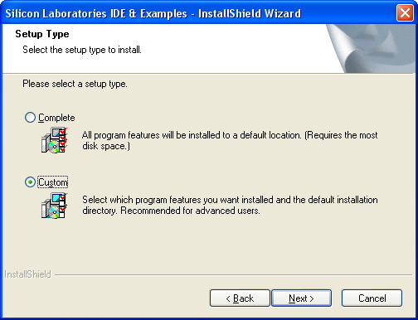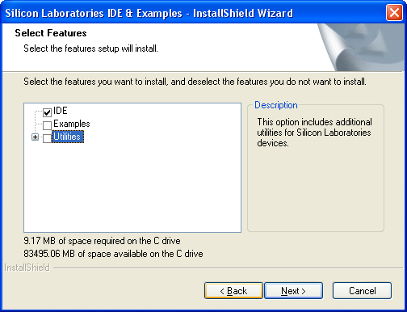
You will not need these and they will only take up unnecessary disk space. No harm if you install the complete programmer. Connect the USB programmer to the PC only and start the program at the start button, activate Silicone Laboratories and click on Silicone Laboratories IDE.
Now click on Options, Connect Options and select USB Debug Adapter and also C2 interface. Click OK and you are all set to use the Programmer.
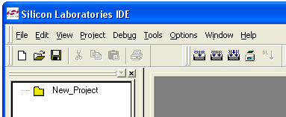
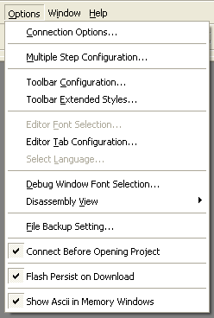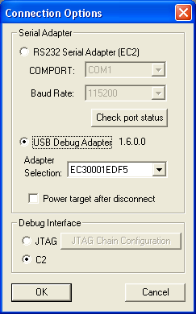

13.3 Operation

To program the TITAN ECU first connect the Programmer to the ECU Com Port. Connect only the 12 Way connector and earth the ECU. Switch the ignition on. Click on the button to connect.
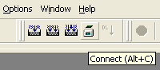

The download button will become active, click on it.

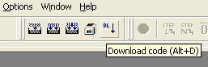

Now use the Browse button to select the correct HEX file on the hard disk or CD. Do not at any stage press the Erase all code space button.

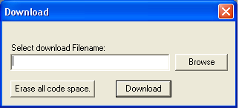

Select the Files of Type to be Intel Hex (*.hex) then go to Look in: to search for the correct file.

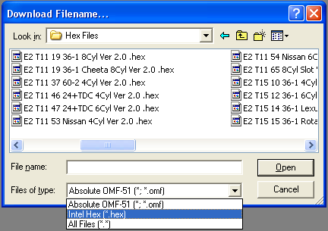

Click Open when it is selected.

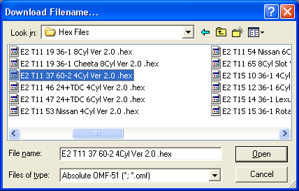

Click Download to program the ECU.

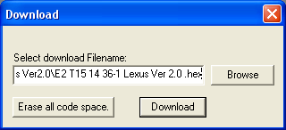

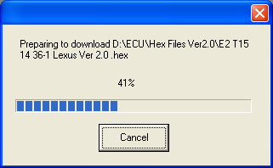

Click the disconnect button when it is finished and switch the ignition off. Disconnect the programmer and connect the USB to RS232 Converter cable. Do not connect the 10 Way cable before you run through the startup procedure. This will ensure that load the right firmware and not to damage the ECU.

