Fixing floating point error
Access the control panel in Windows 7
- Click on the Start Button and click on Control Panel
Access the control panel in Windows 8
- Press the Windows logo button on the keyboard and “Q” together.
- When the “Charms” menu appears, click on Settings
- Click on Control Panel
From here, Windows 7 and Windows 8 are the same.
Open the control panel
- If the Control Panel view is by category, then first select “Clock, Language, and Region”, otherwise continue to the next step
- Select “Region and Language”. The following screen will be displayed:
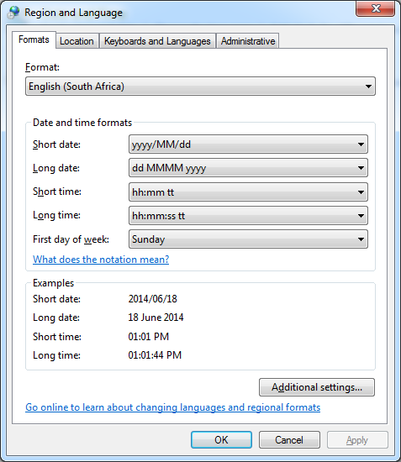
- Click on “Additional settings…”. The following screen will be displayed:
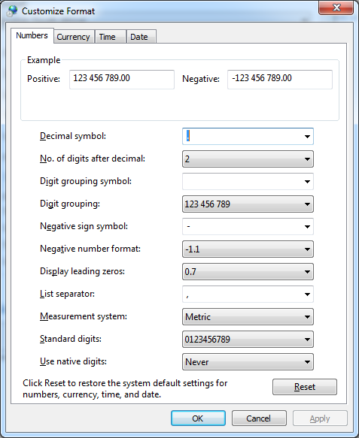
- Change the “Decimal symbol” value from a comma to a point.

